**HTML assertions**

Add a thread group

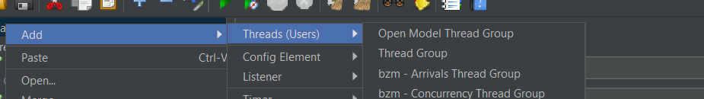

Add a sampler request

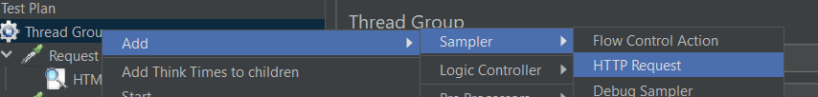

Add html assertion to that sampler

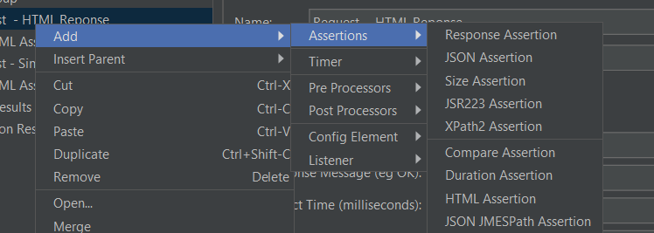

It allows you to validate the response from the sampler is html type or not

Add listener to view the result

