**Response assertion**

Response assertion is used to validate the response received from a sampler and it allows you to define specific criteria or patterns that the server response mustmeet

Add thread group



Add a sampler request



Add a response assertion

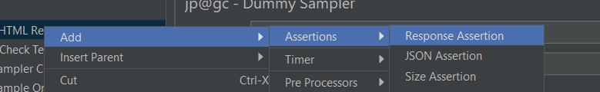

Listener to view the result

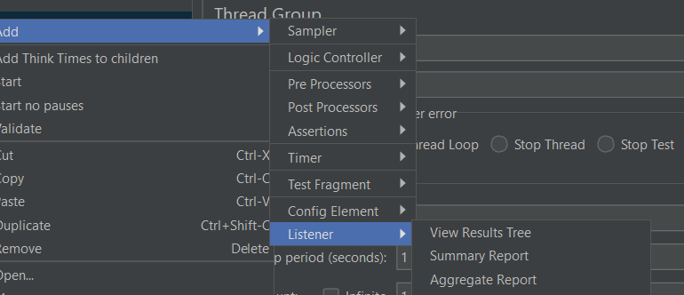

Result

