**Increasing loads**

Open Jmeter

And add a thread group

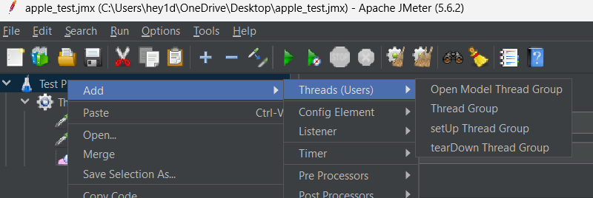

Under thread group add the http request

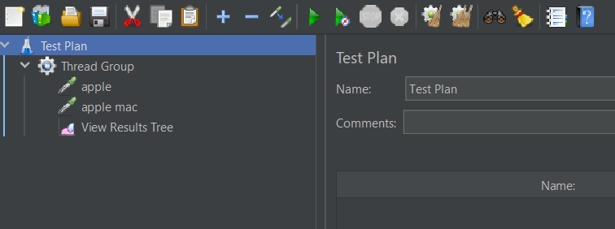

Added a result tree to see the output of the threads

You can configure the thread count, per second threads and number of loops

When you run the thread groups you can see the output in result tree

