**SMTP sampler script**

To use smtp we have to download javamail far file and paste it in lib/ext

Then add thread group in jmeter and add smtp sampler

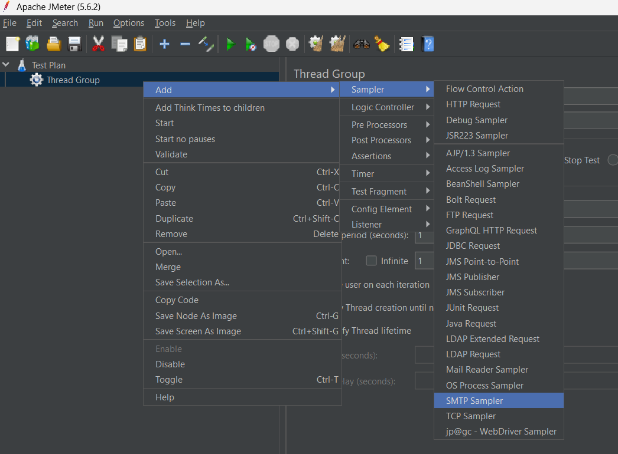

Add from and to address

Go to google account, under security got to app passwords and create a new one

Copy the key and add it as password in auth.

Make sure to select starttls

When you run the tests you can see a new mail in your gmail

