**JDBC sampler script**

To use jdbc sampler script you need to download jdbc java connector jar file and paste it in lib/ext folder.

Create a thread group in jmeter and add jdbc connection configuration

Add the database details

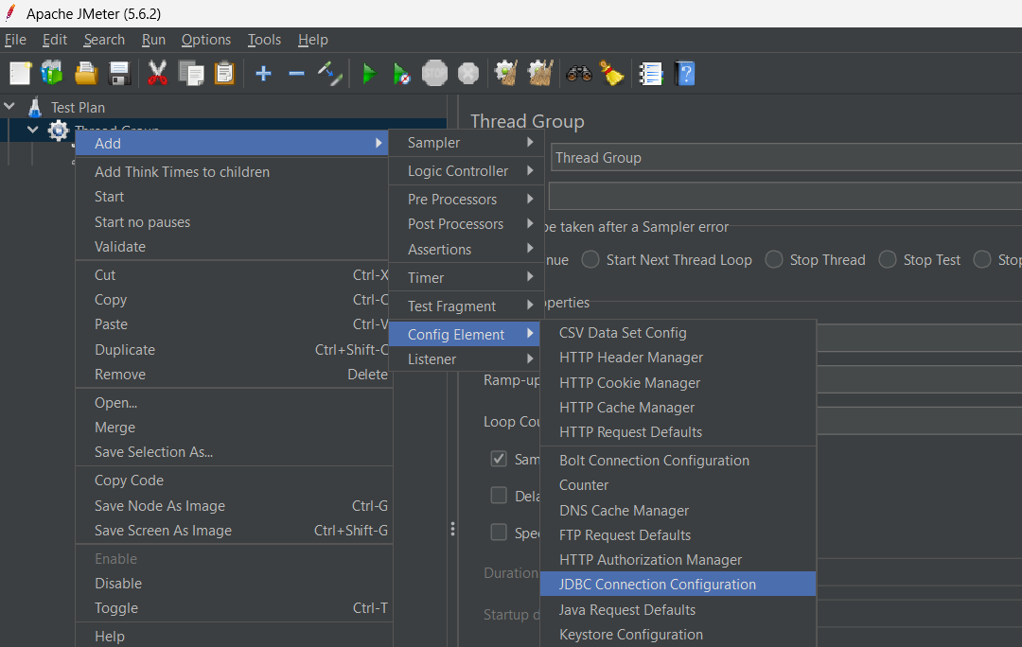

Add the database url

After the connection we perform sql statements with the help of jdbc request.

You can write sql queries to fetch reocords, update, create, and delete them

