**JUNIT sampler script**

Export the junit java file to jar file by right clicking on java file and select export

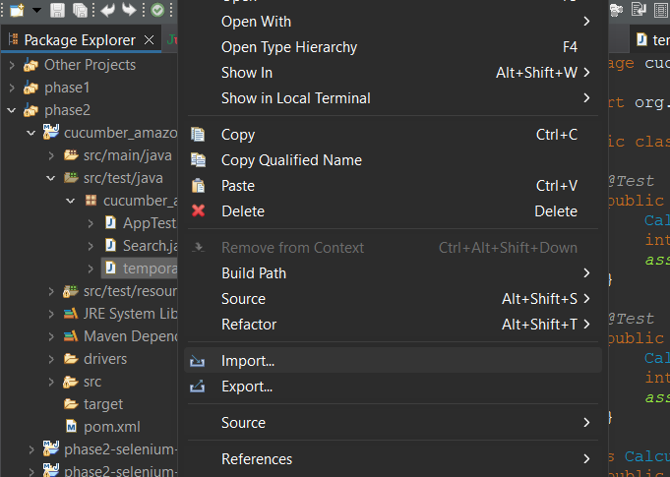

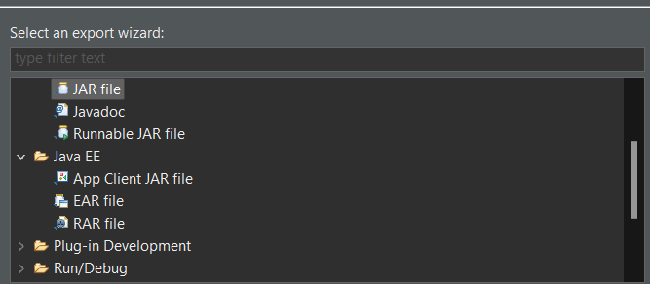

Copy the jar file to lib/junit

Restart jmeter and add thread group and junit sampler

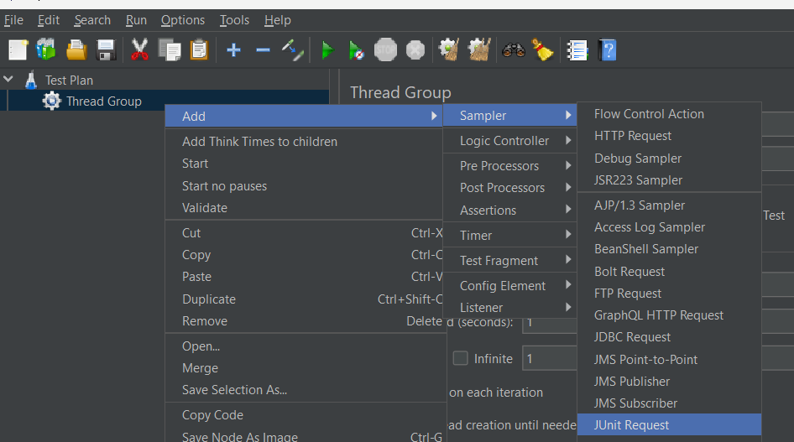

Runt the test plan and see the output by adding a listener

