**Load and Scalability with JMeter**

Add thread group in jmeter test plan

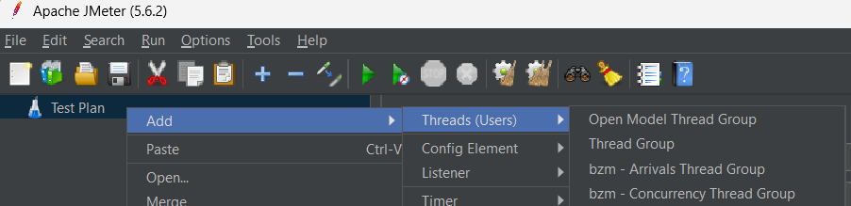

Add a http sampler request and add a url in it

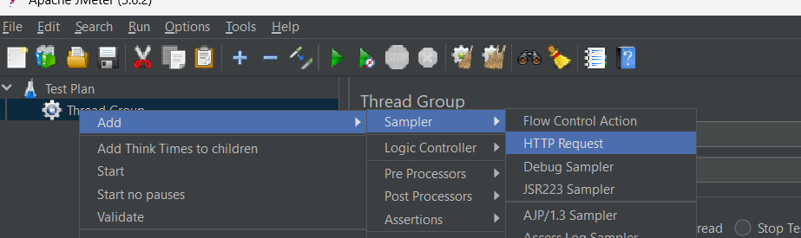

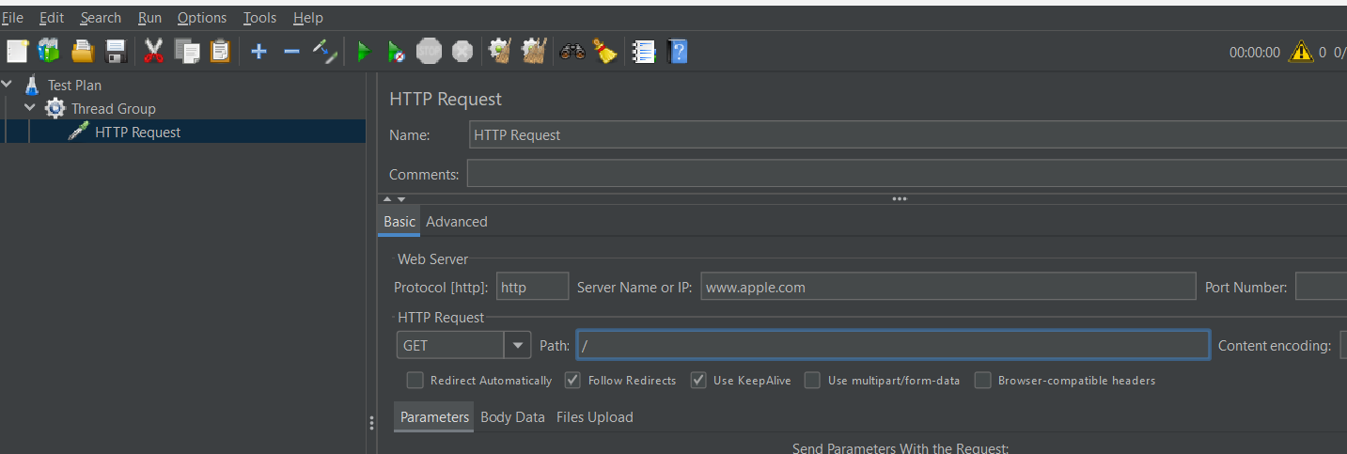

You can control number of loops, number of users and time to perform load and scalability on a server

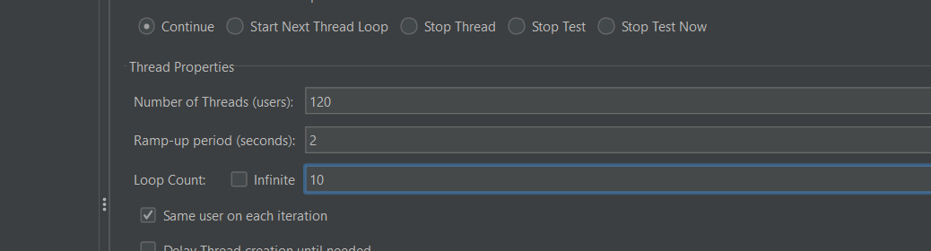

Add a listener to see the output of the test plan

