**Integrating with selenium web driver: script**

Open jmeter and go to options>plugin manager and install selenium webdriver support plugin

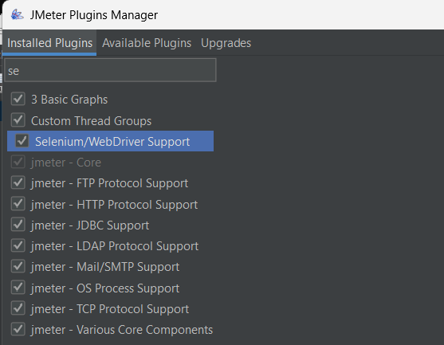

Create a thread group

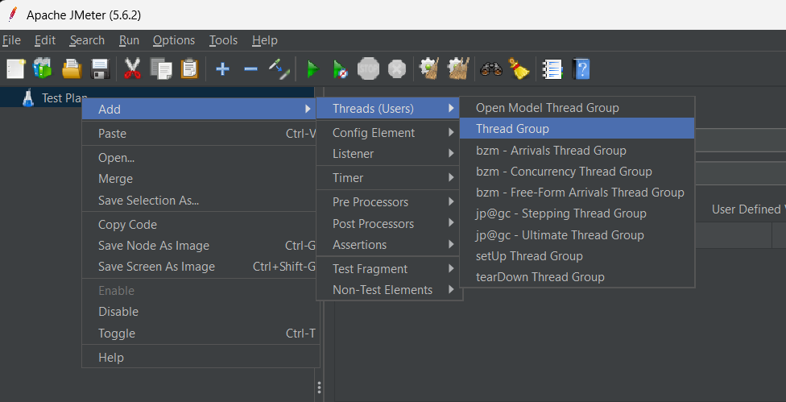

Click on Add -> Config Element -> jp@gc Edge Driver Config.

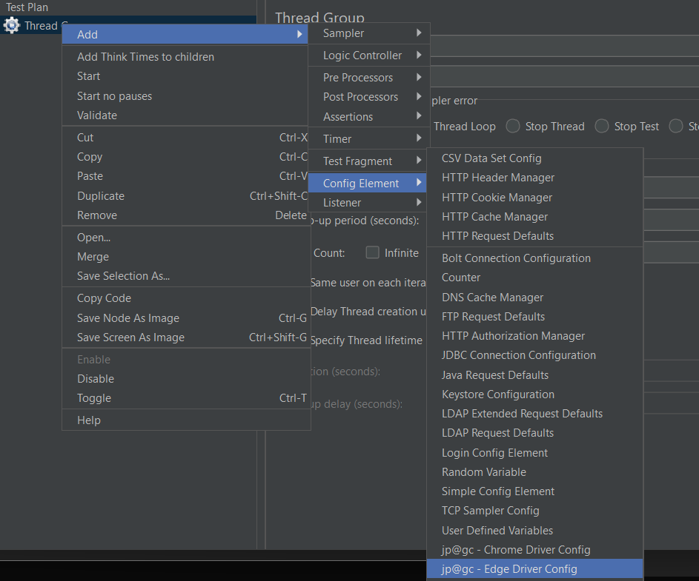

Click on Add -> Sampler -> jp@gc WebDriver Sampler.

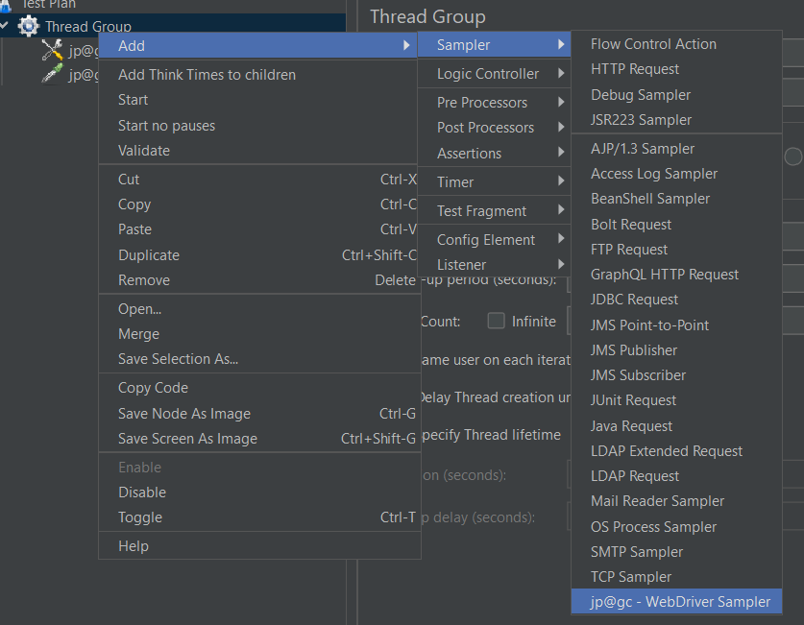

Enter the driver path and provide url

Add listener to see the output