**Running tests with gradle**

Install gradle extension in eclipse marketplace

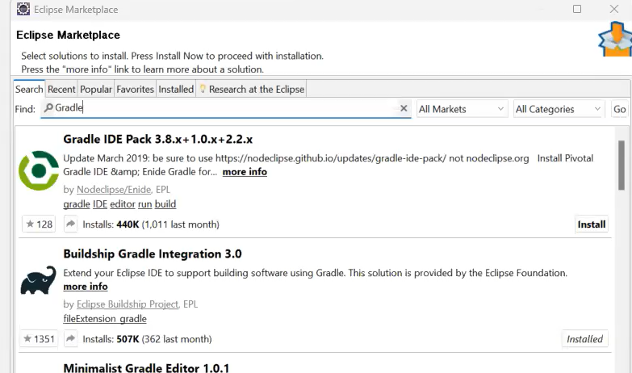

Create a gradle project by clicking on new >project >gradle project

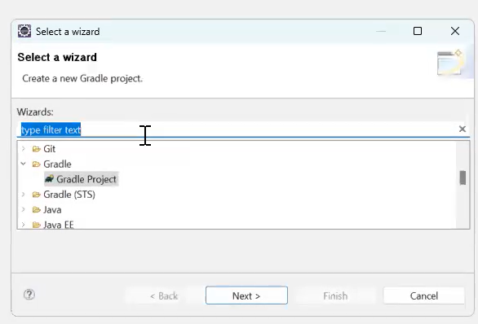

Add Junit dependencies in build.gradle file

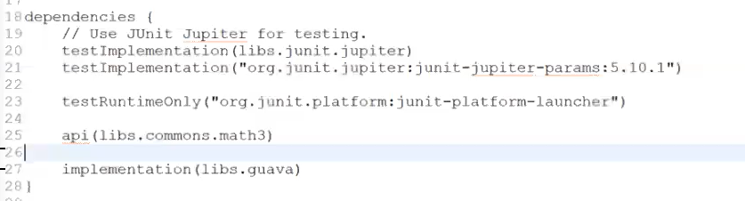

Right click on java program where you have the tests and click on run as gradle test

