**Postman setup**

Download postman from - <https://www.postman.com/downloads/>

If you have an account login. Otherwise, create and account

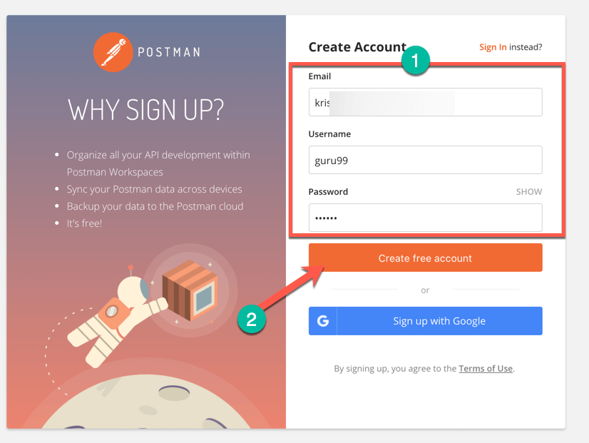

Select the required workspace tools

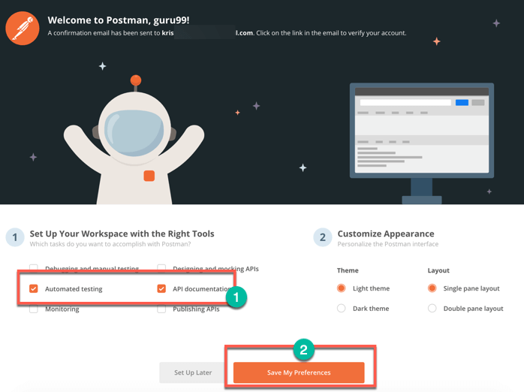

Now you will see a dashboard of postman where you can see workspaces, collections….

