**Environments**

Environments are used to create variables

You can use different variables by creating different environments and using them

Create a request in your workspace

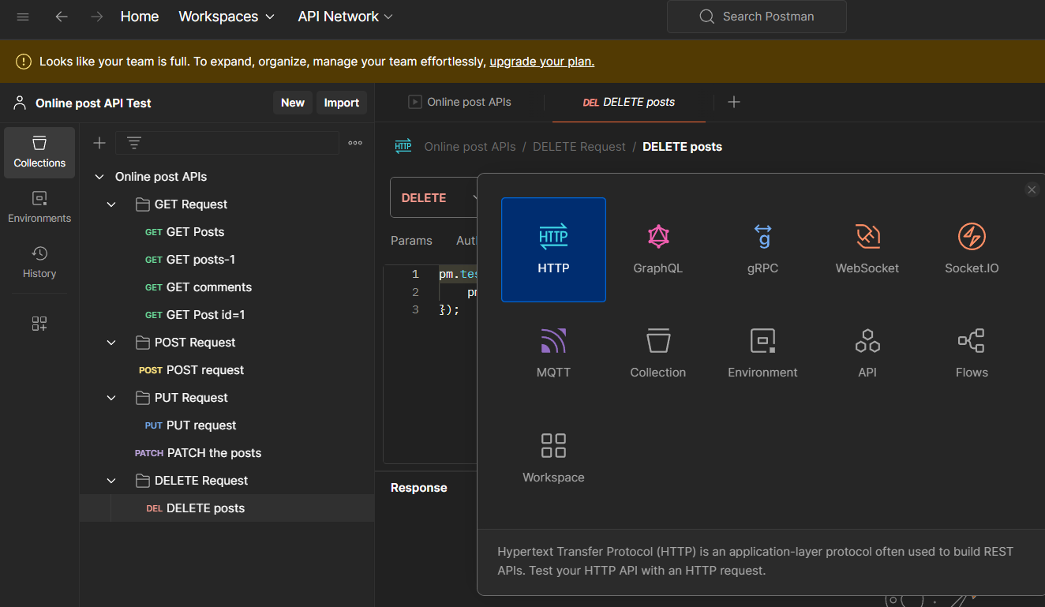

Create a new environment and create varables

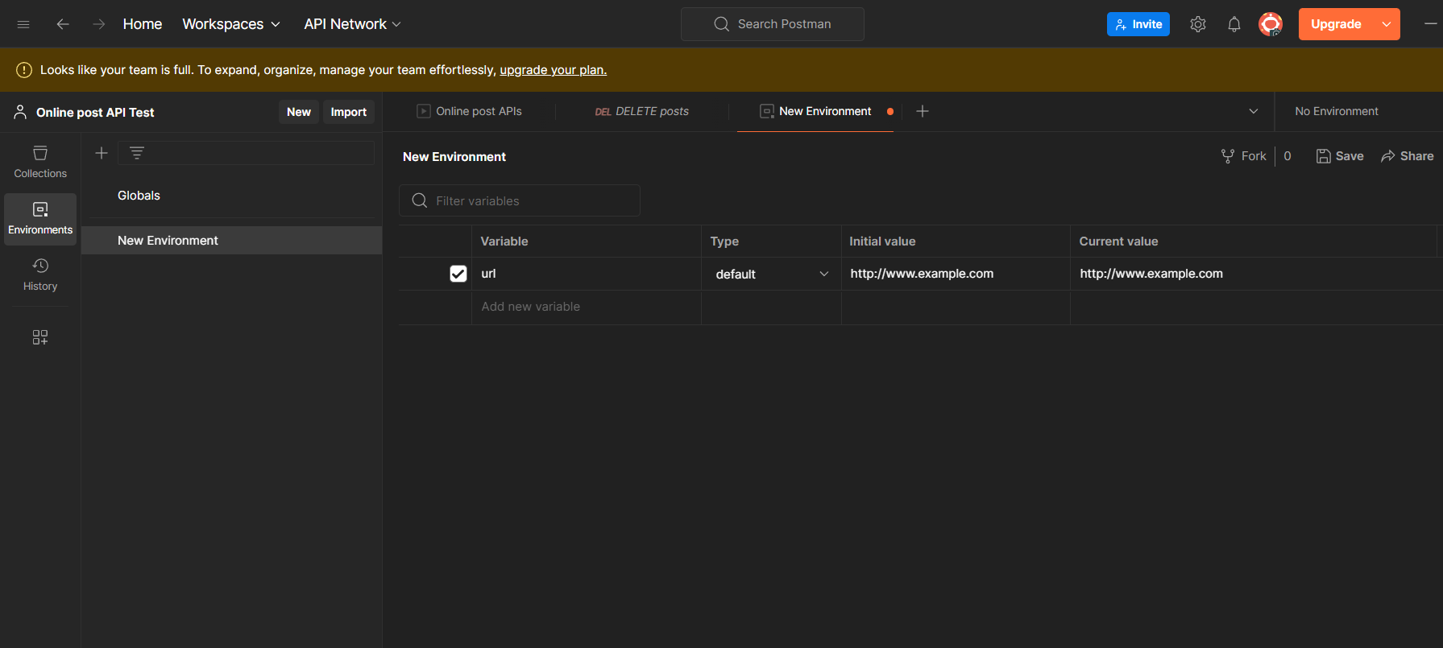

url variable is created in new environment

use the variable

