**Test Scripts**

Create a request in your workspace collection

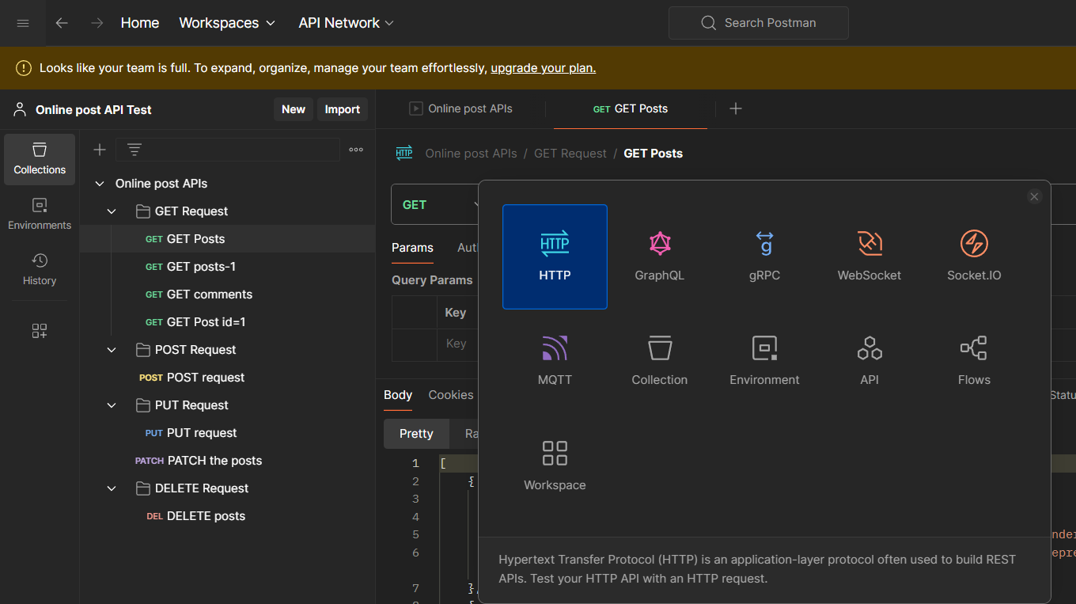

In your request got to the test tab and you can see some test snippets at right side

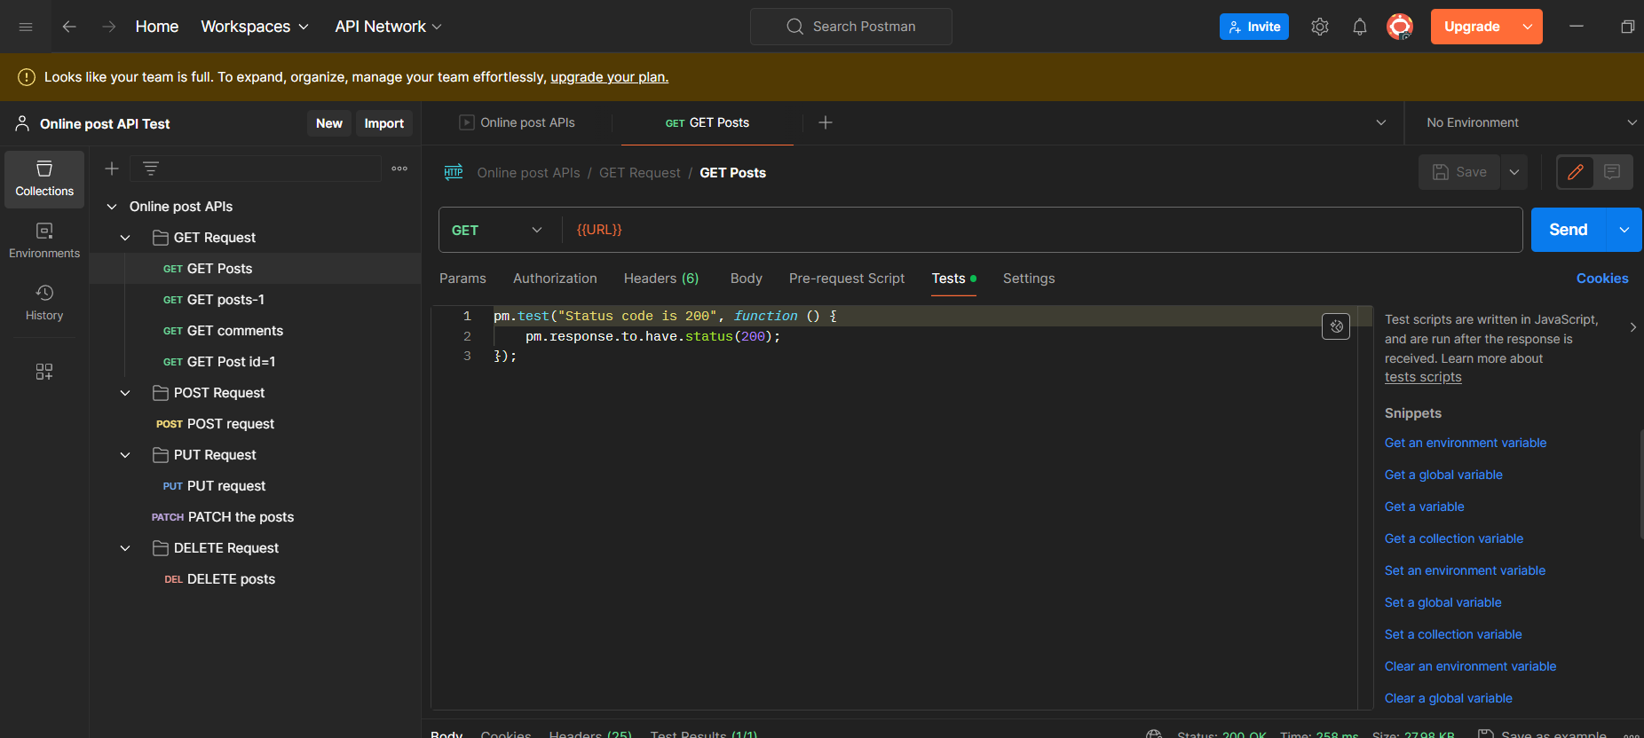click on status code :code is 200. So that a new test will be created for you

Now click on send

A new test result will be displayed

