**Postman with Jenkins**

Open Jenkins and create a project

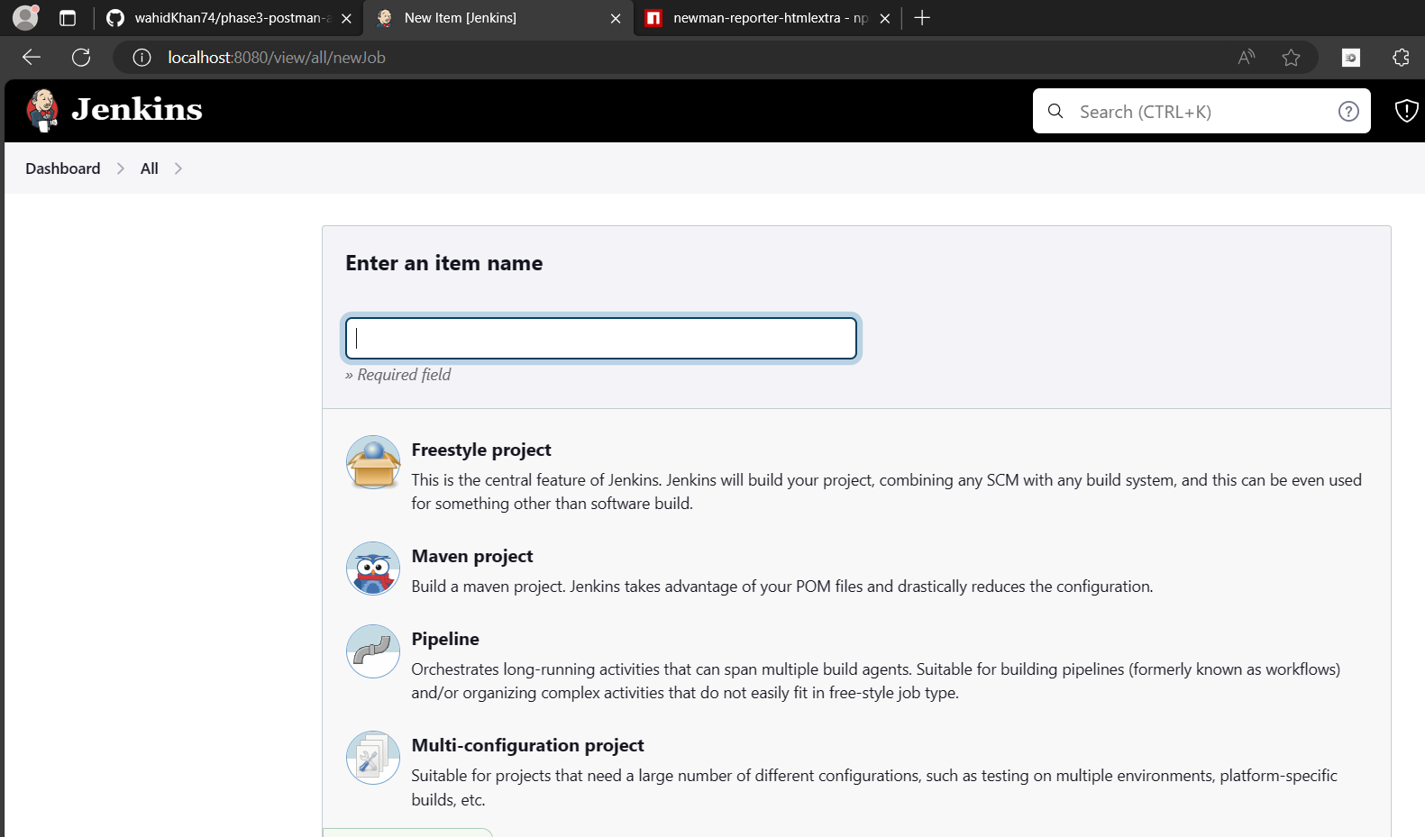

Insrall nodejs plugin

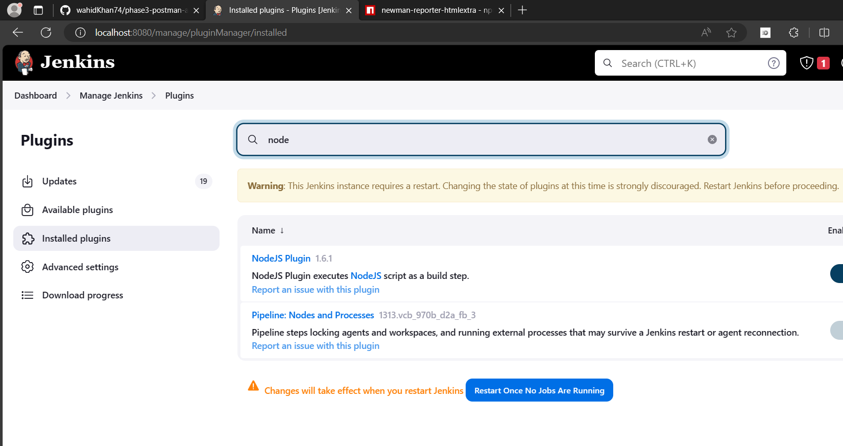

Push the postman files to github

Add github to your Jenkins project

Add nodejs installation

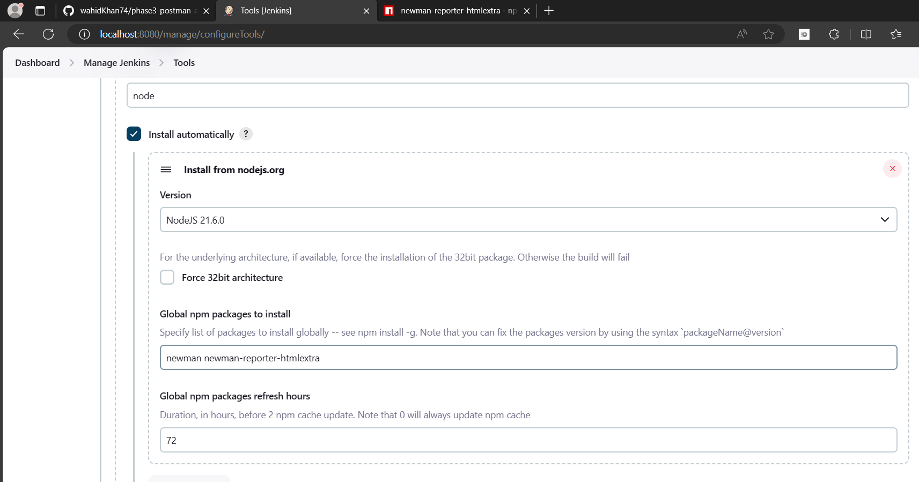

Under build environment add nodejs path

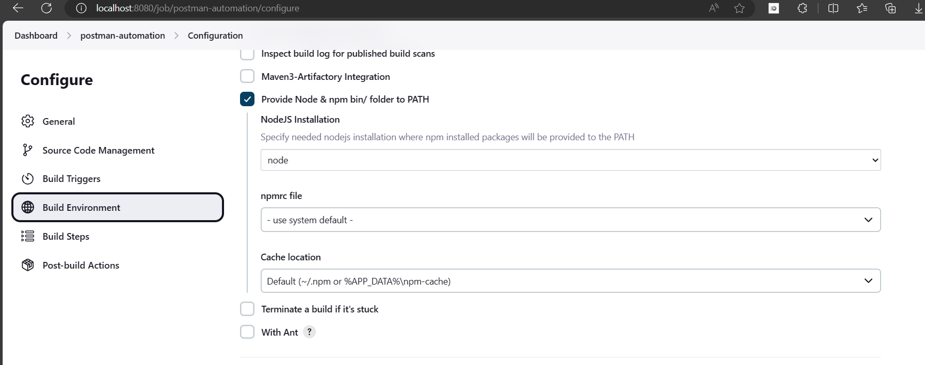

In build steps add windows batch command

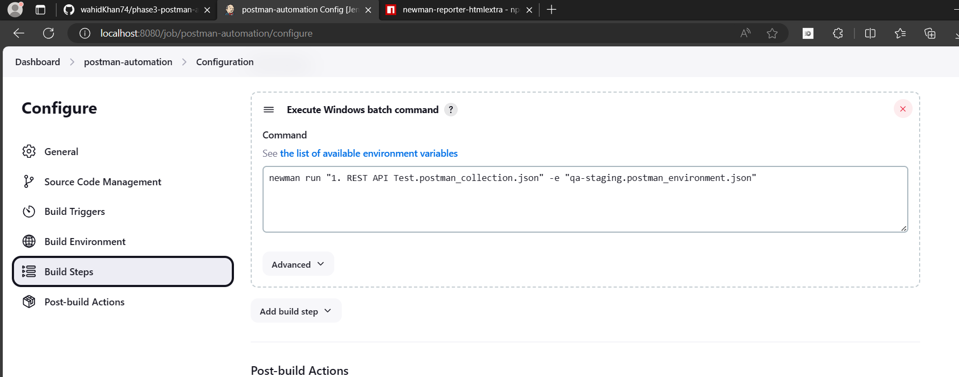

Click on build now and you can see the output

