**Workspaces**

Work spaces in postman are used create multiple collections

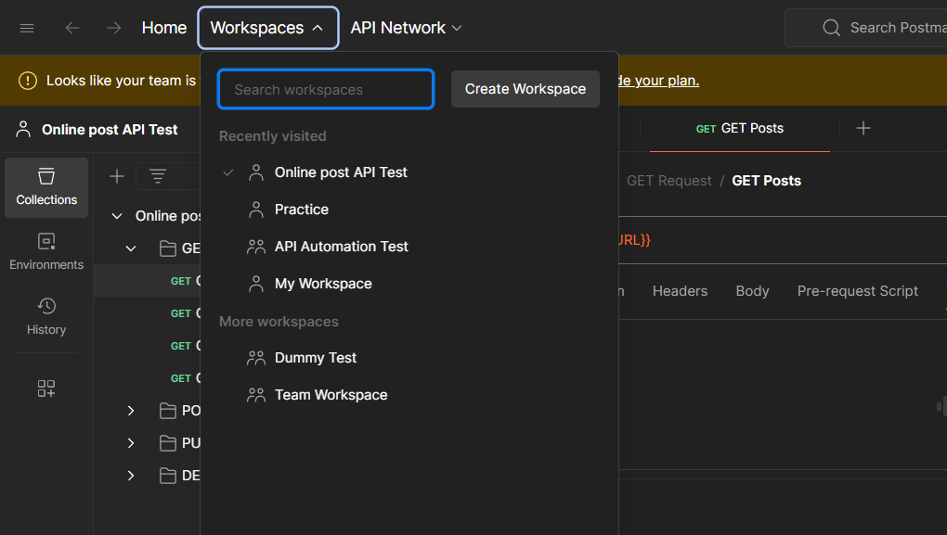

You can create multiple workspaces for different projects

Click on create workspace. Select what type of workspace you wish to create

And add name and description to it. Click on create

