**Monitors**

Monitors in postman are used to monitor the collections in a workspace

To create a monitor click on three dots beside the collection name

And click on collection monitor

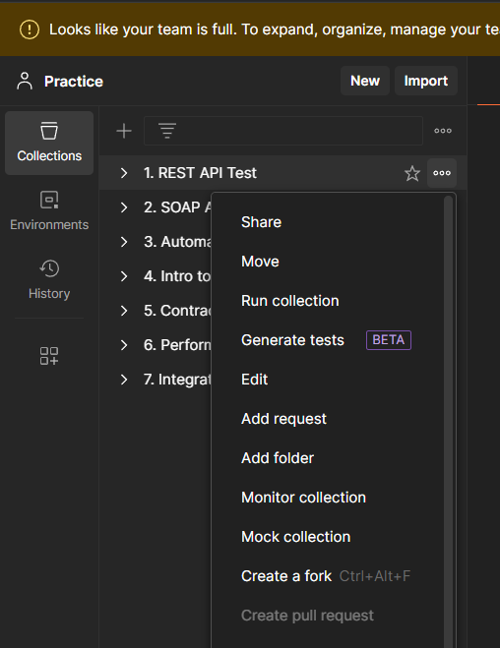

Add a name and click on create a monitor

Now the tests run everyday or for the time specified by you and display the result as healthy or unhealthy and the details of the run

