**API Documentation**

**Documentation helps you to understand the collections and the requests in detail**

**Click on the collection name in collection tab**

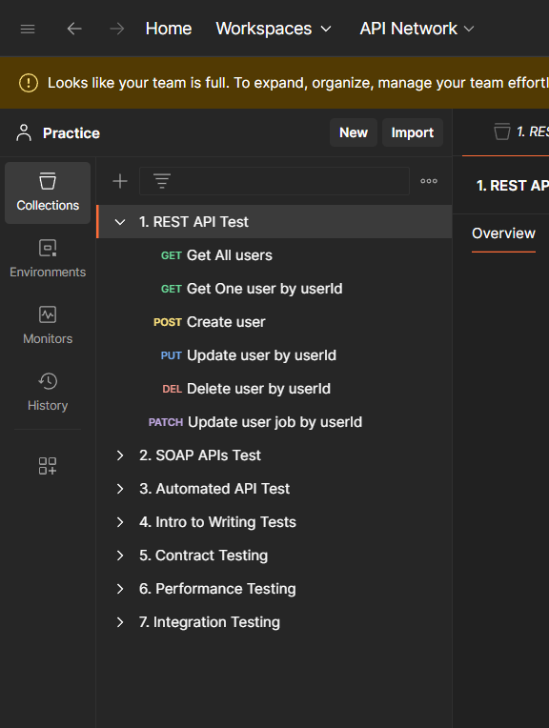

**Then you can see the overview of the collection which is a document**

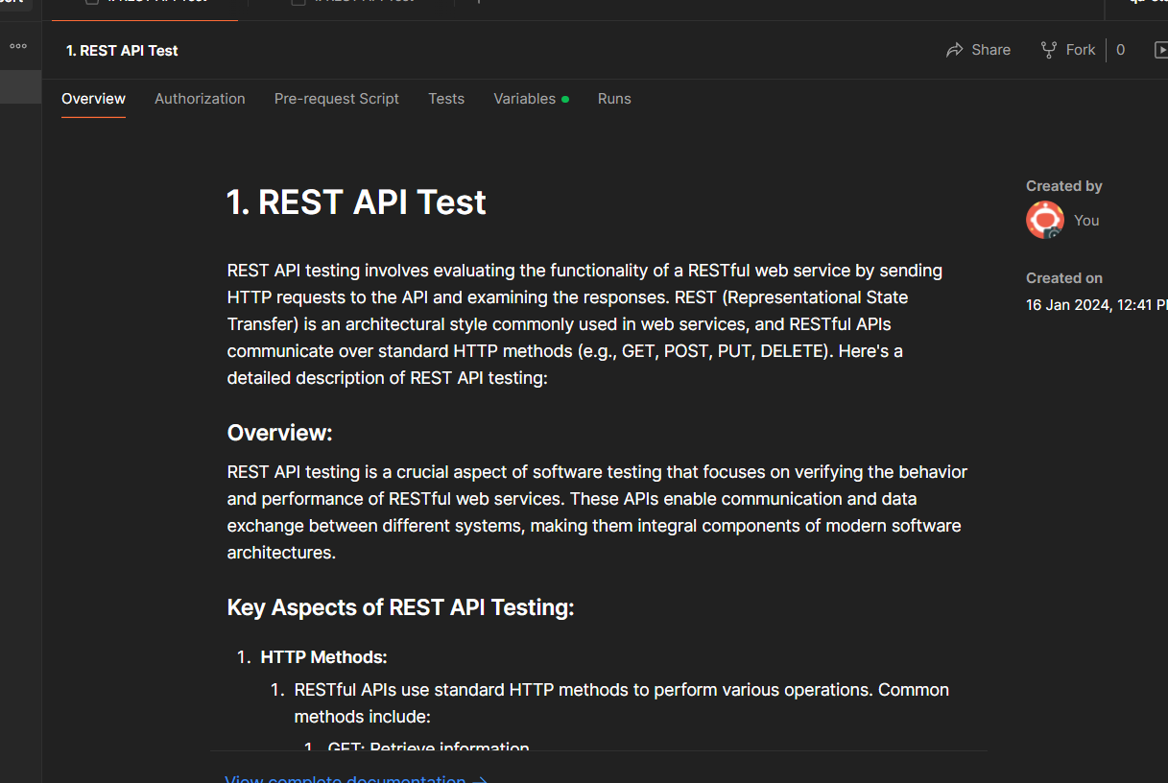

**If you want to edit the documentation double click and start editing**

