**Fetch data from csv and json**

Add data in notepad and name it as .csv file

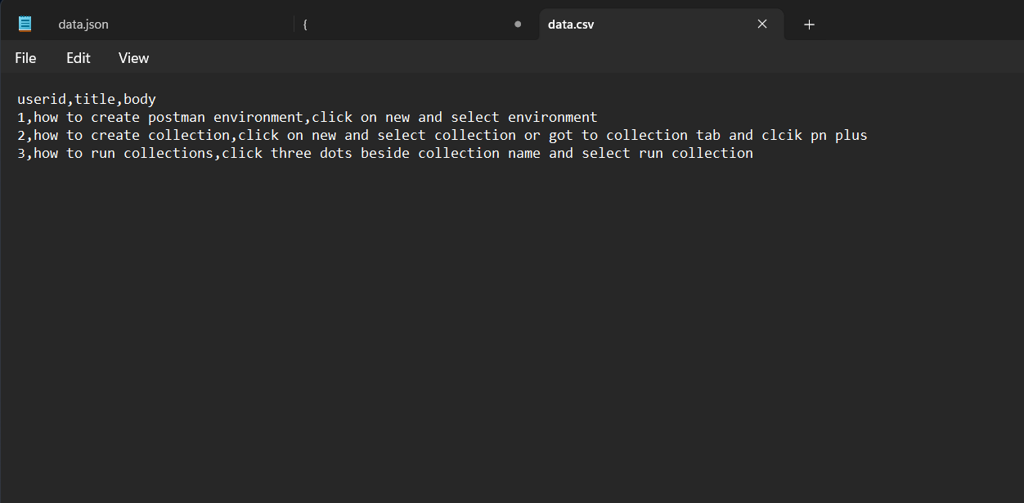

Create a request in the collection

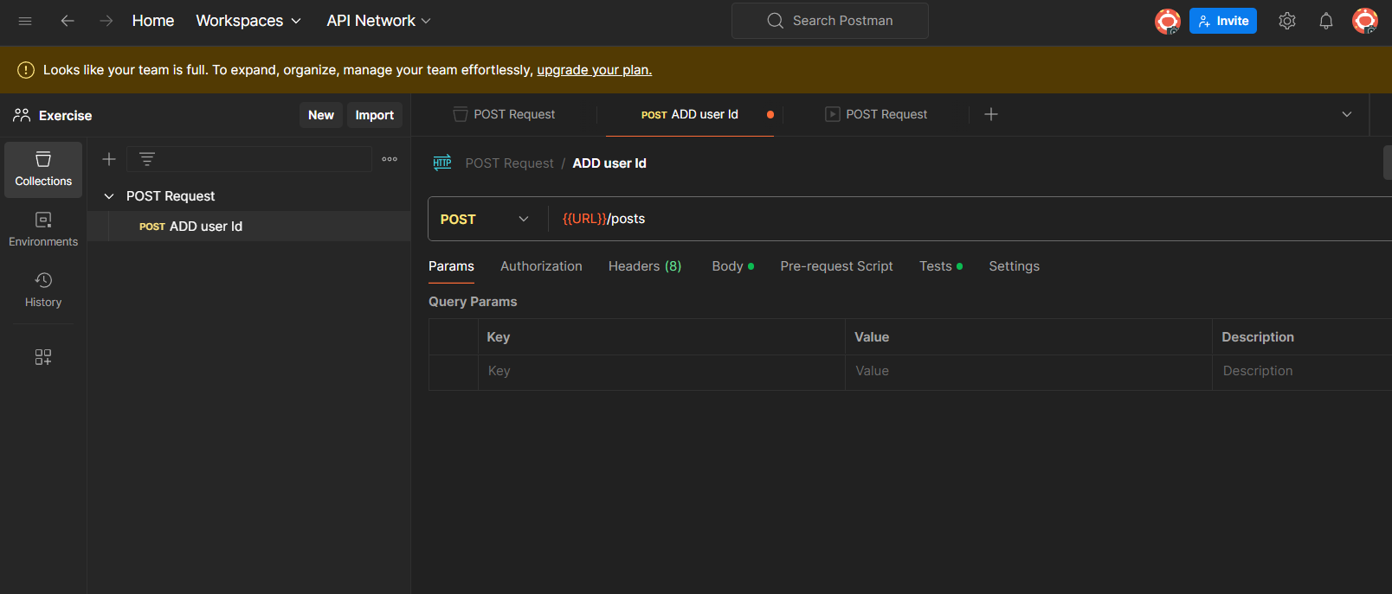

Run the request using collection runner

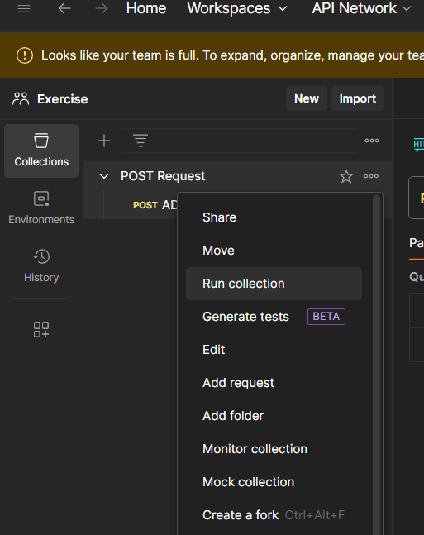

And select the csv file, click on run post request

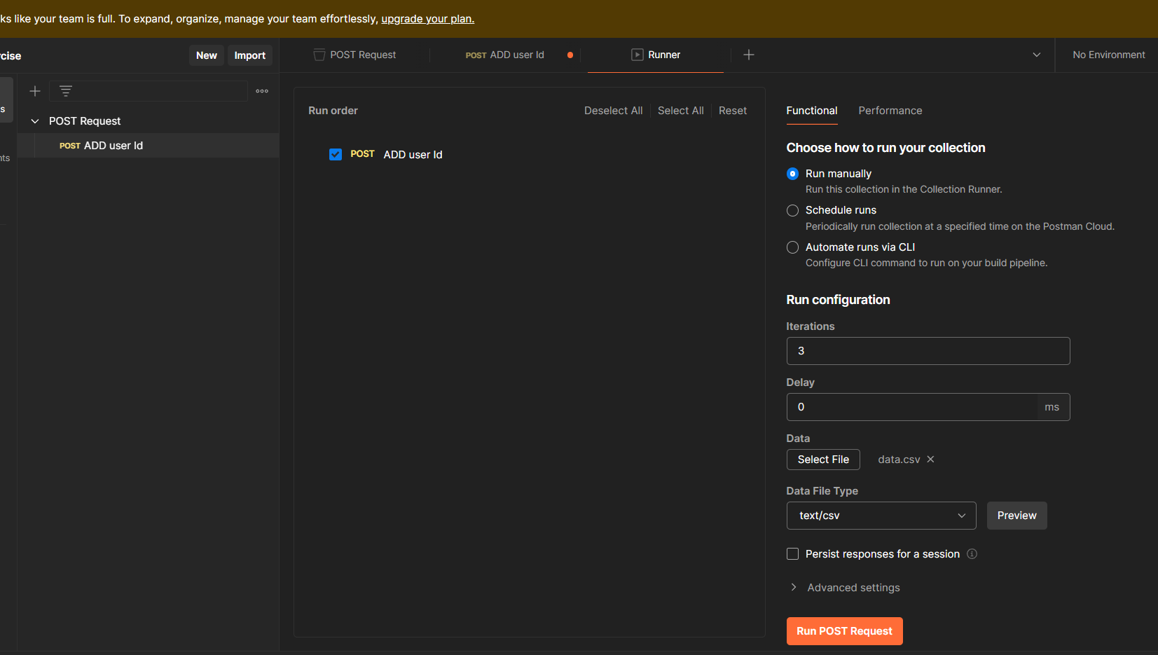

Result

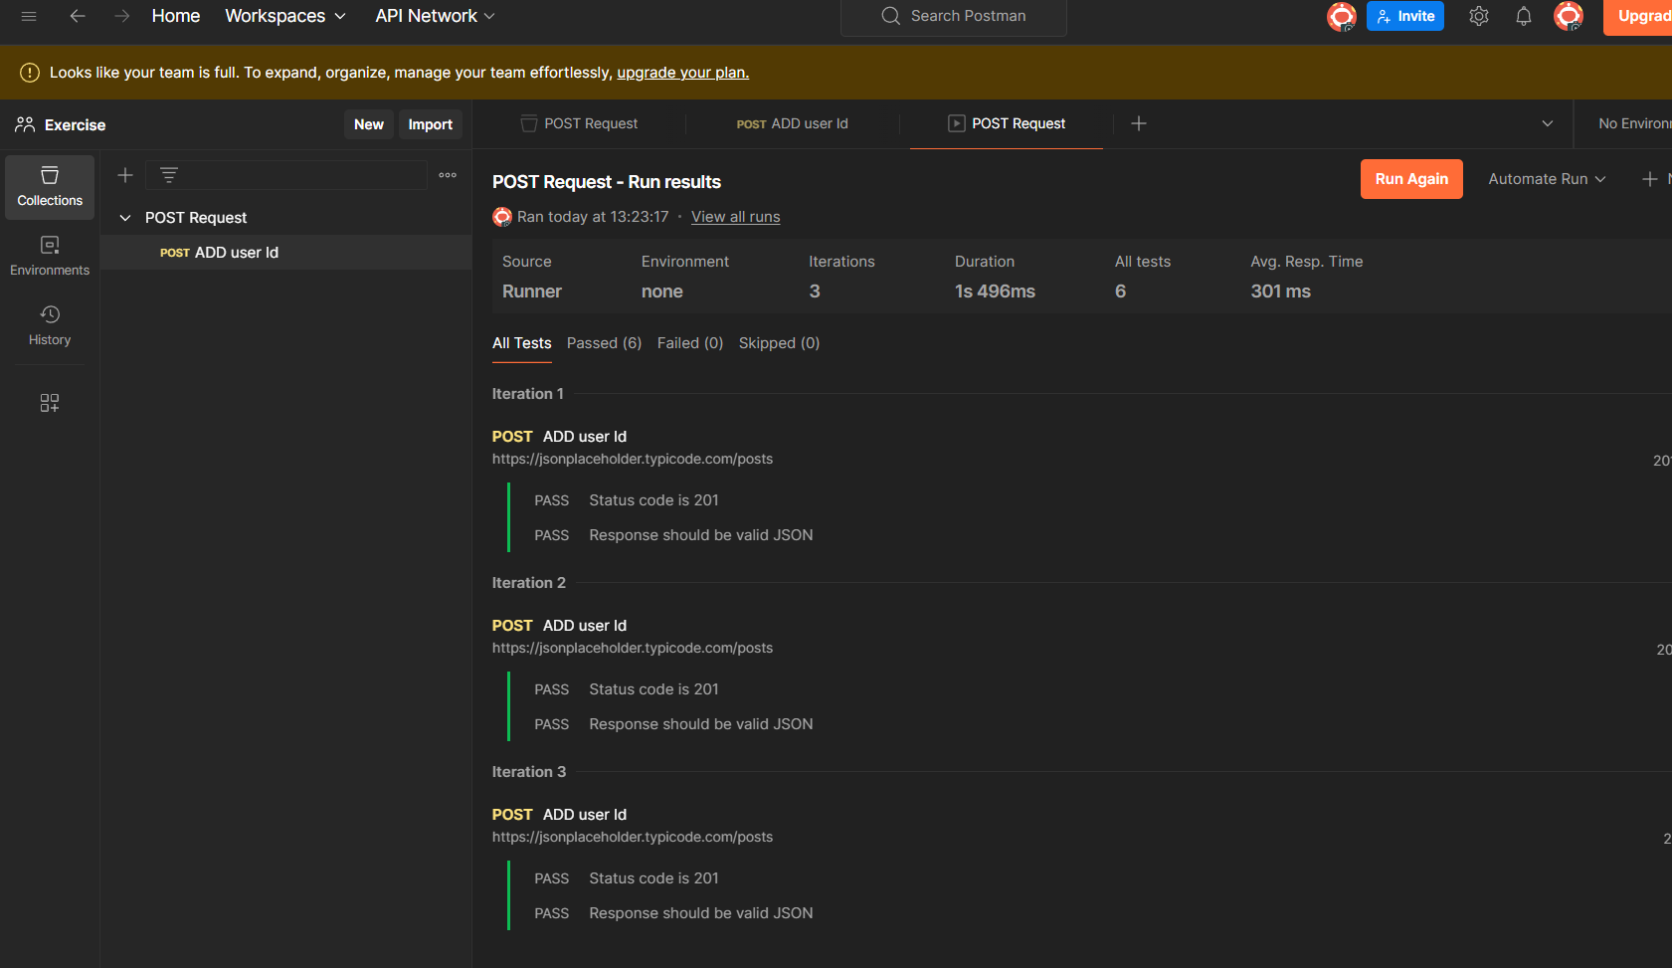

Same for the json file create a json file add data to it and select the json file and click on run to see the output