**Run collection remotely with url**

Click on collection, go to three dots and select share

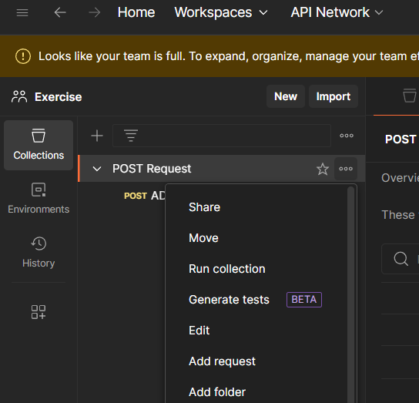

Now copy the link so that you use the url to run collection remotely on another machine

In different machine go to command prompt and run the following command

Newman run <copied url>

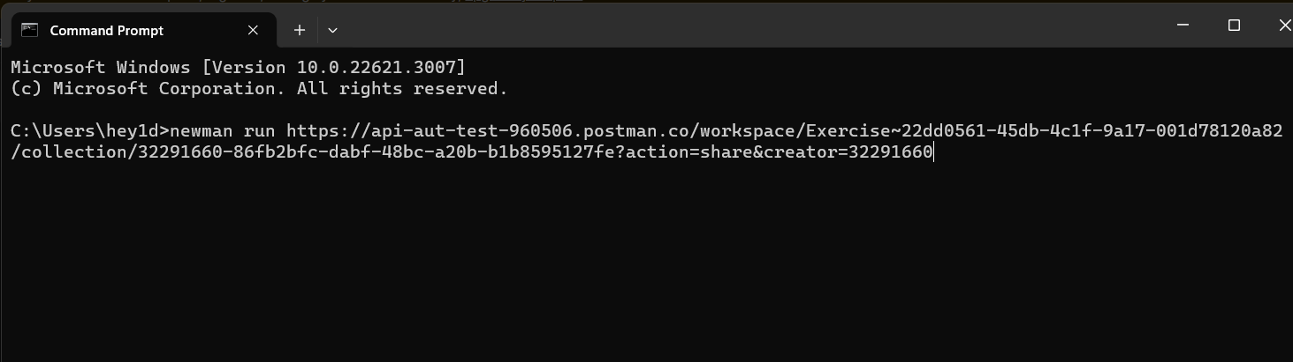

result

