**First API request**

Create a new workspace

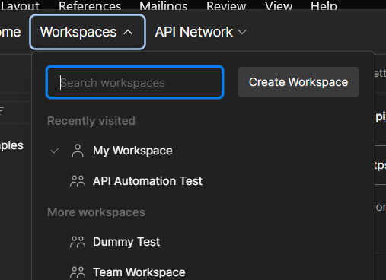

Click on new and select http to start a new request

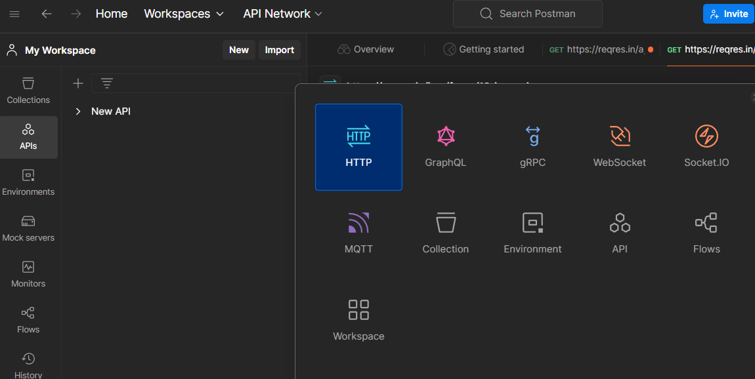

You will see a new request created add the below url and click on send. You will see a json as an output

<https://reqres.in/api/users?page=2>

