**Postman with SOAP**

Adding SOAP request with postman workspace

In the workspace create a new request.

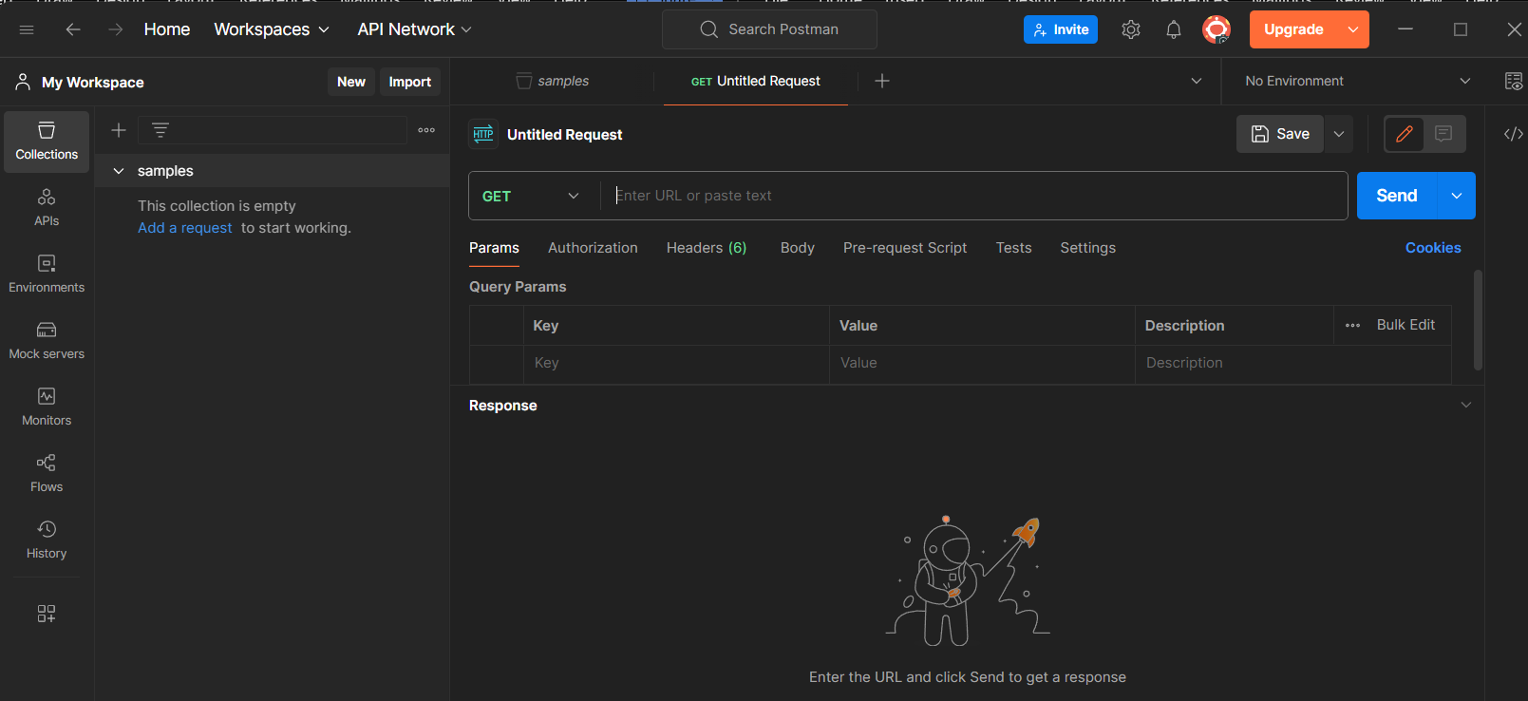

Paste the below url and set the method as post

<http://webservices.oorsprong.org/websamples.countryinfo/CountryInfoService.wso?WSDL>

Set body as raw and text as XML

Add the following code in the body section

<Envelope xmlns=”http://schemas.xmlsoap.org/soap/envelope”>

<Body>

<capitalcity xmlns=”http://www.oorsprong.org/websamples.countryinfo”>

<sCountryISOCode>IN</ sCountryISOCode >

</capitalcity>

</Body>

</Envelope>

Go to tests tab and click on status code: Code is 200

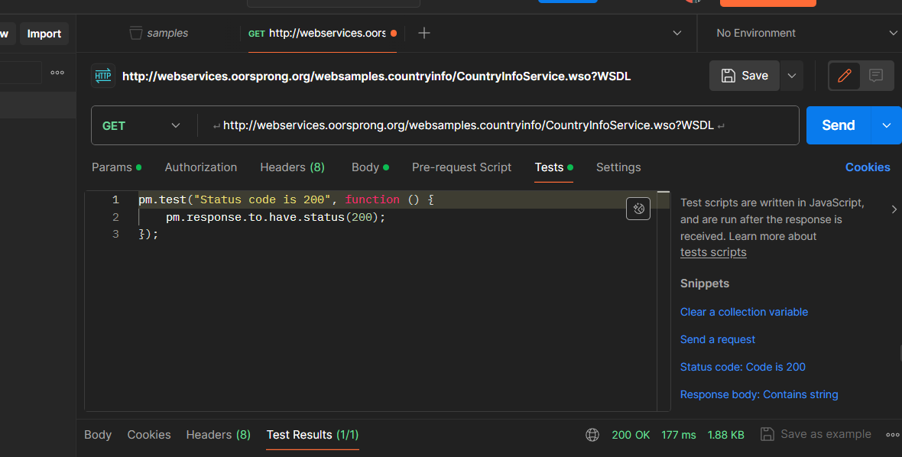

Click on send again then you will see test results as pass

