**Working with GET Requests**

Create a request in your workspace

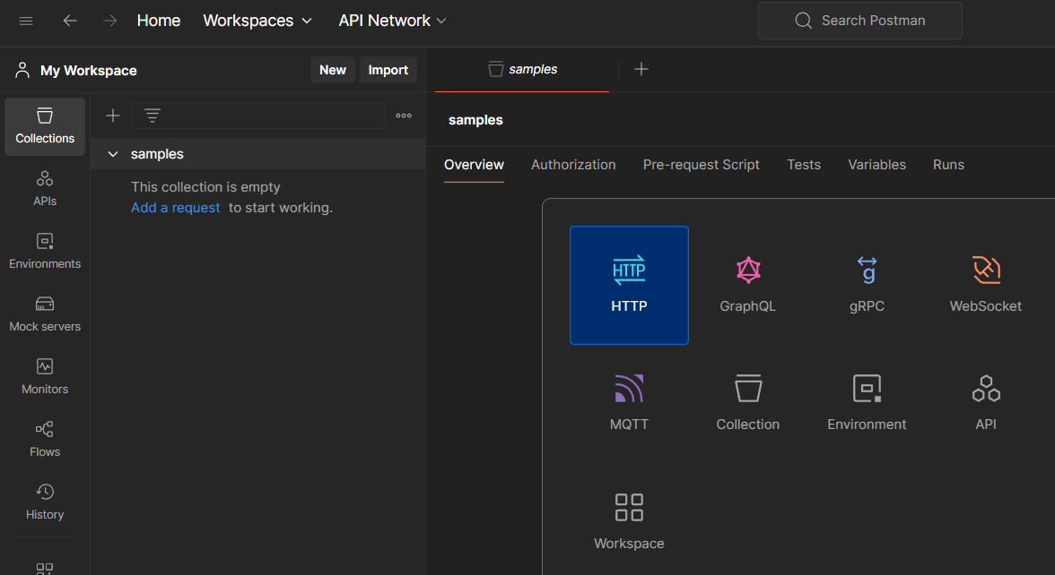

Let us take a sample url and click on send

[**https://reqres.in/api/users/2**](https://reqres.in/api/users/2)

set the request method as GET

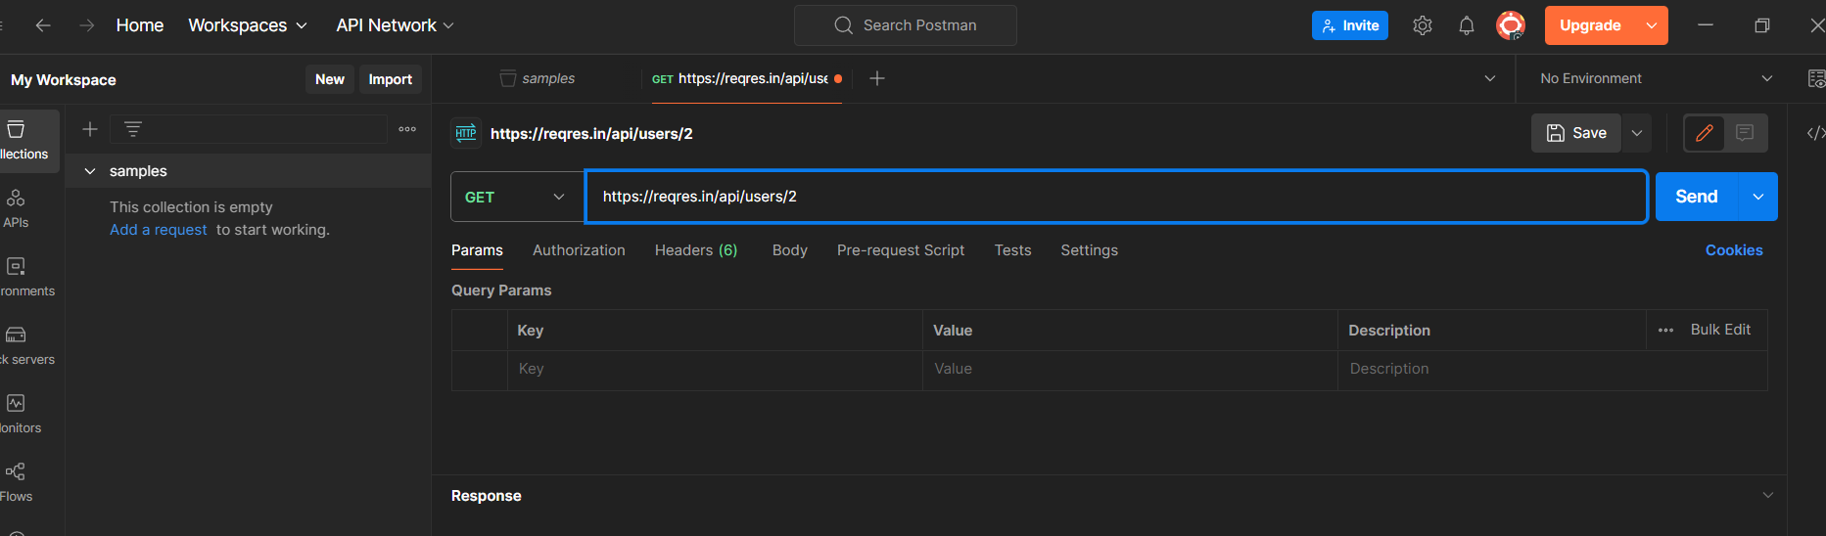

You will see a 200 OK message and a json output.

There may be cases where the Get request will be unsuccessful. It can be due to an invalid request URL or missing authentication.

