**Working with POST Requests**

Create a new request in your workspace

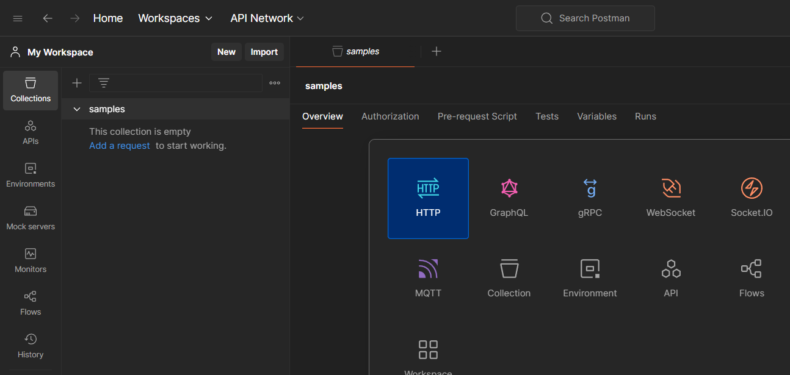

Let us take a sample url and use post method and click on send

<https://reqres.in/api/users>

under body tab add the json formatted details which we nee to add

{

"name": "morpheus",

"job": "leader",

"id": "463",

"createdAt": "2019-08-28T10:51:59.088Z"

}

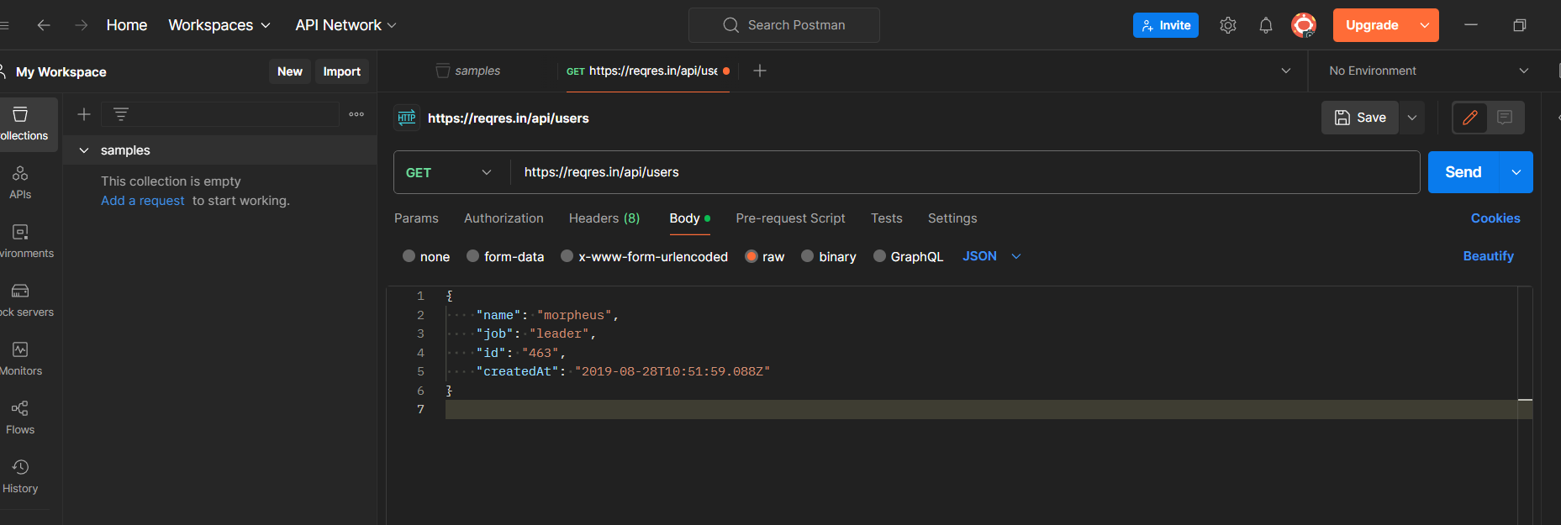

Click on send and you see the output as

201 created

