**Parameterize Requests**

Create a http request in your workspace

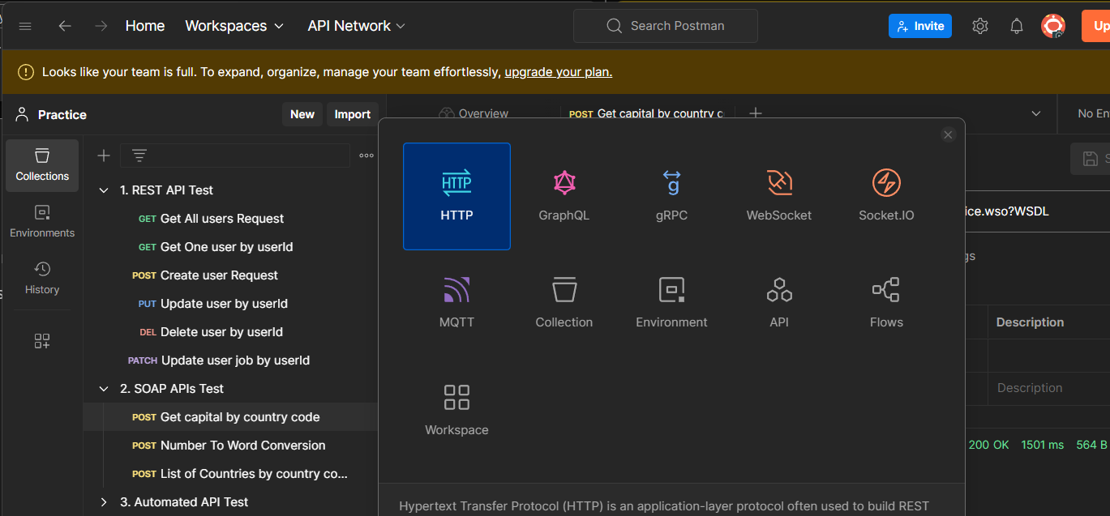

Let us take a sample url and set the method as GET

https://reqres.in/api/users?page=2

under environments section you can add global variables

create a variable with name URL and value as <https://reqres.in/api> and save it

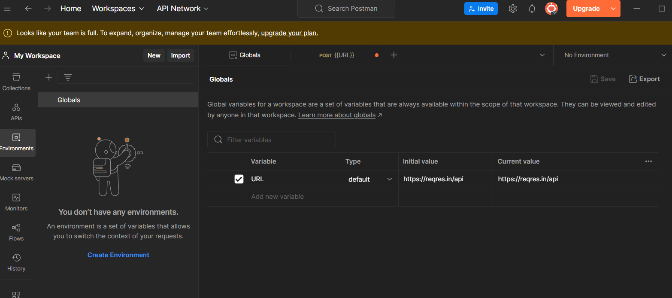

now you can use the url variable

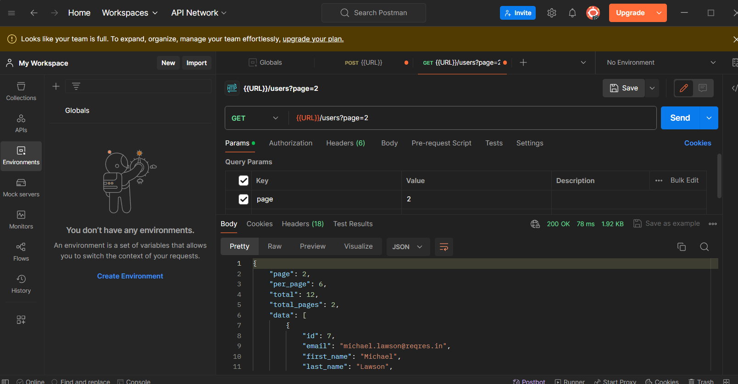

You can see the code as 200 OK and a JSON output