**Create a Collection**

Under the collections tab create a new collection

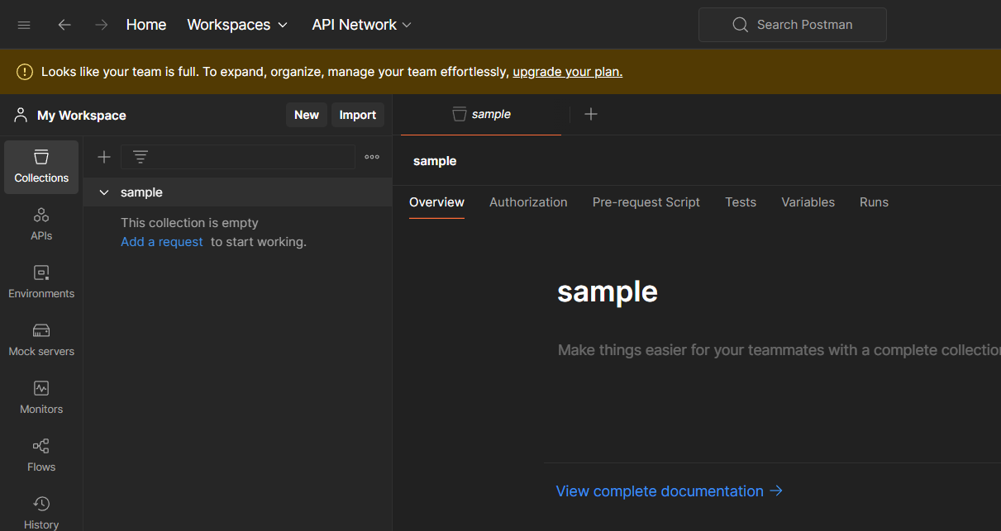

Now create a request using the three dots beside the collection name

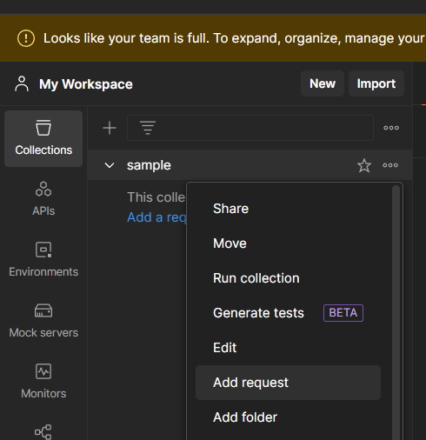

Add a sample url and click on send

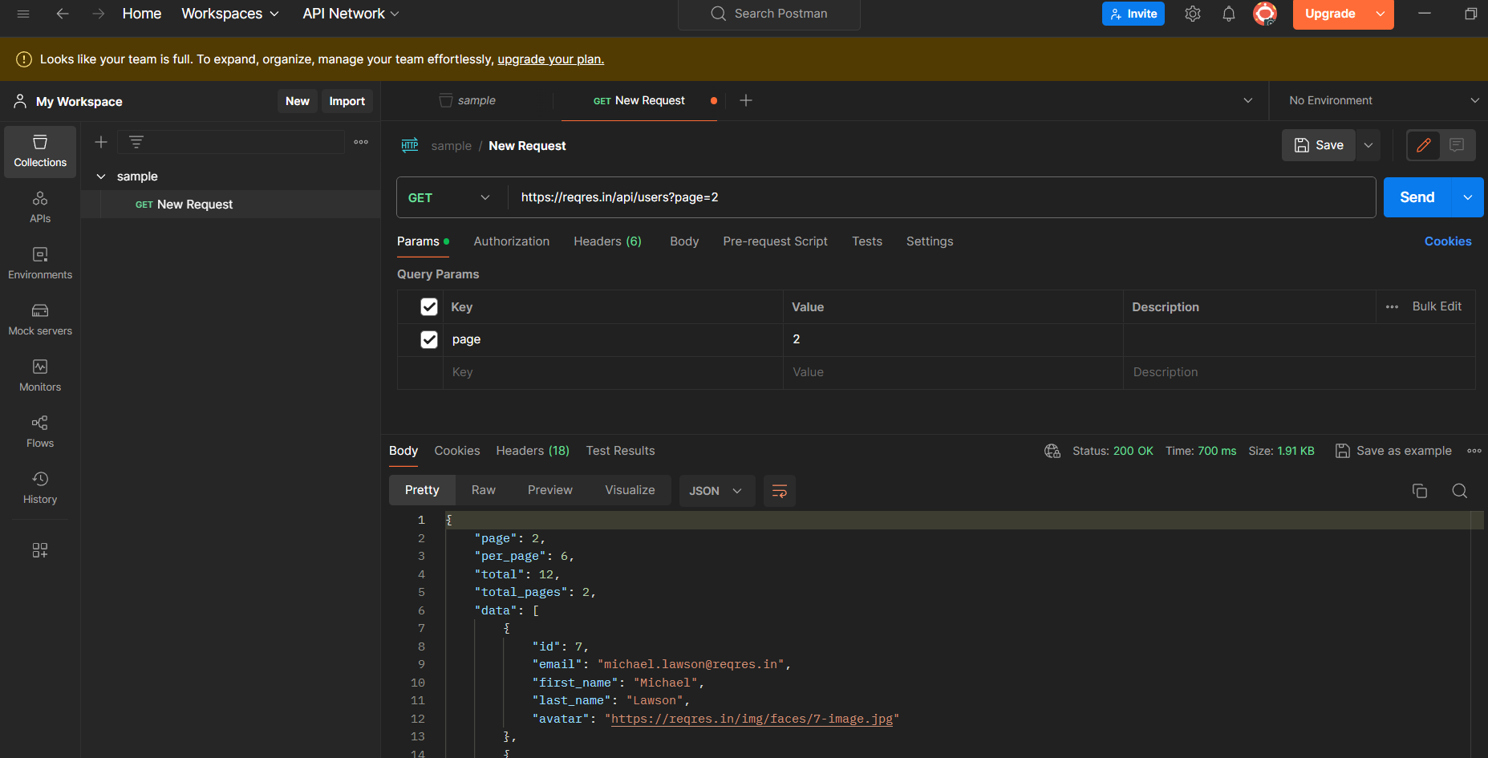

You run the collection by clicking the three dots and select run collection

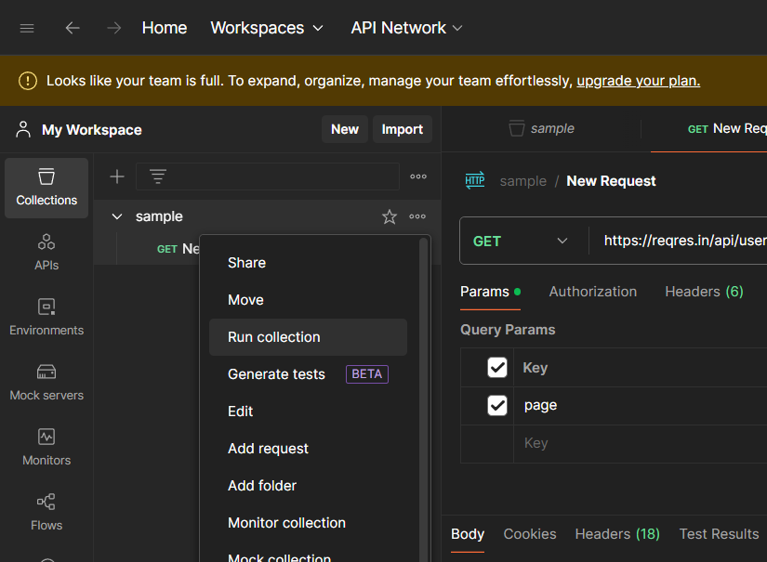

After you run the collection you will see the output as follows

