**Run collection with collection runner**

Let us run previous created collections using a runner

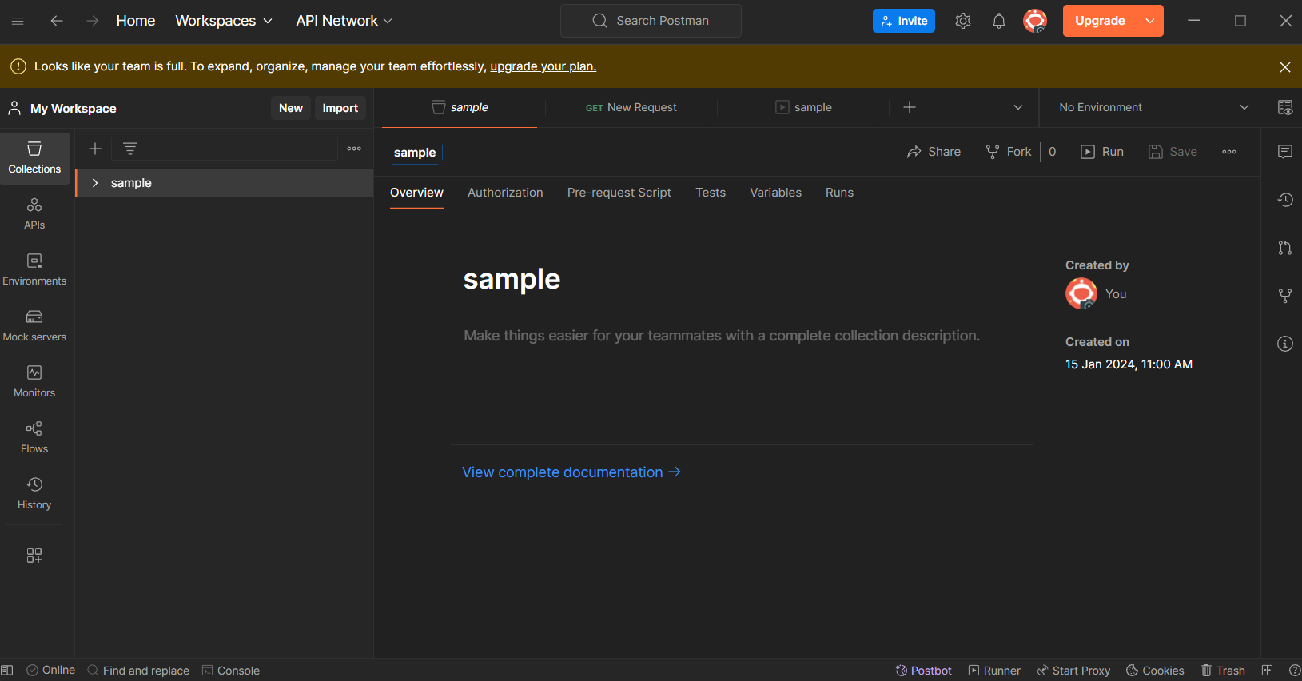

Click on runner. You can find it at bottom

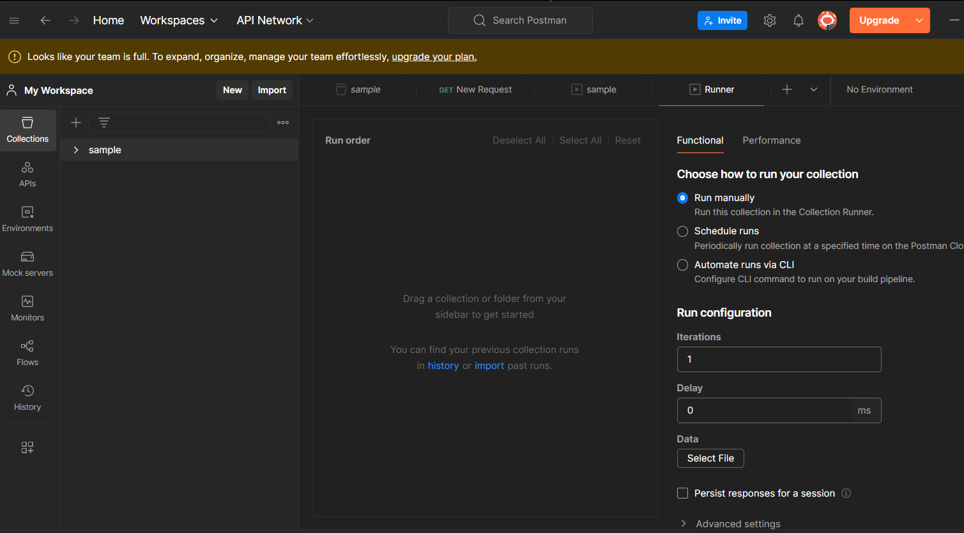

Drag the collection and click on run sample

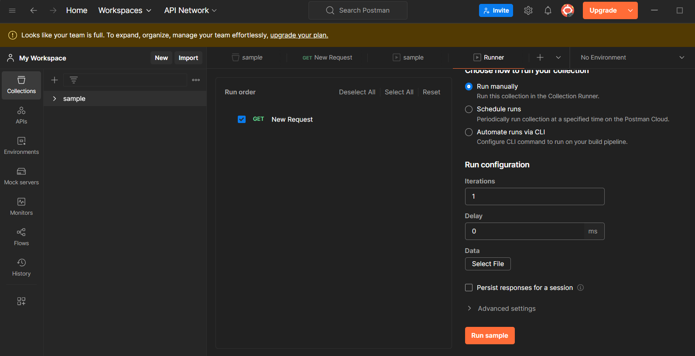

You will get the output as

