**Variables**

**Create a request in your workspace**

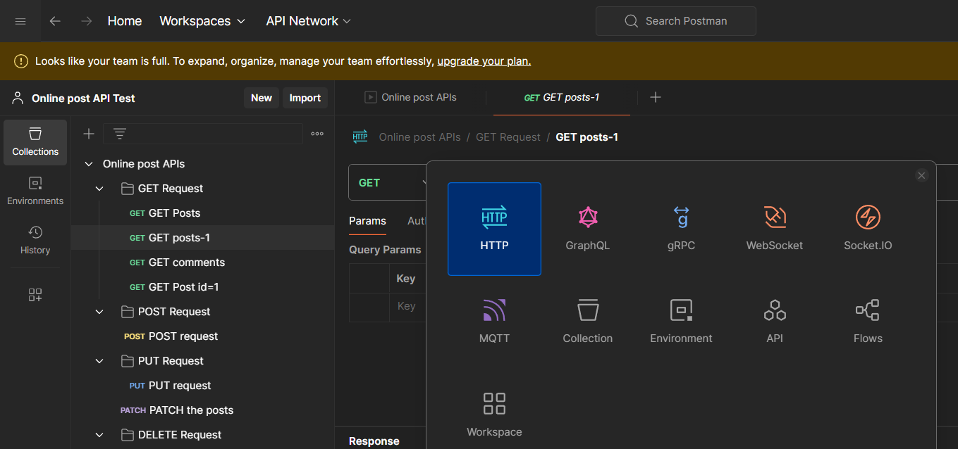

**Once you click on your collections. Got to variable tab and add a variable to it**

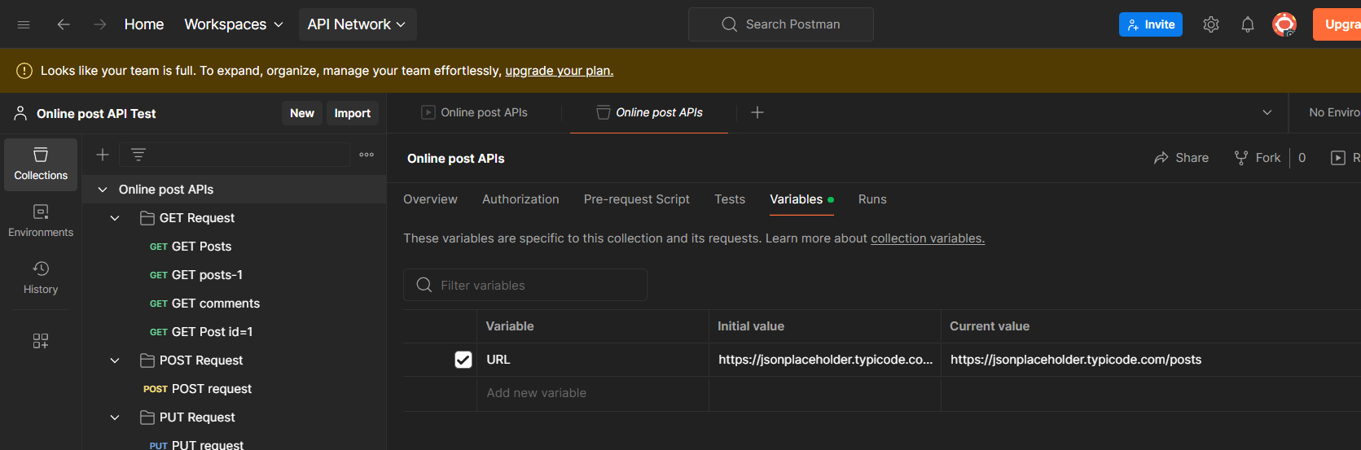

**Use the variable in the request and click send**

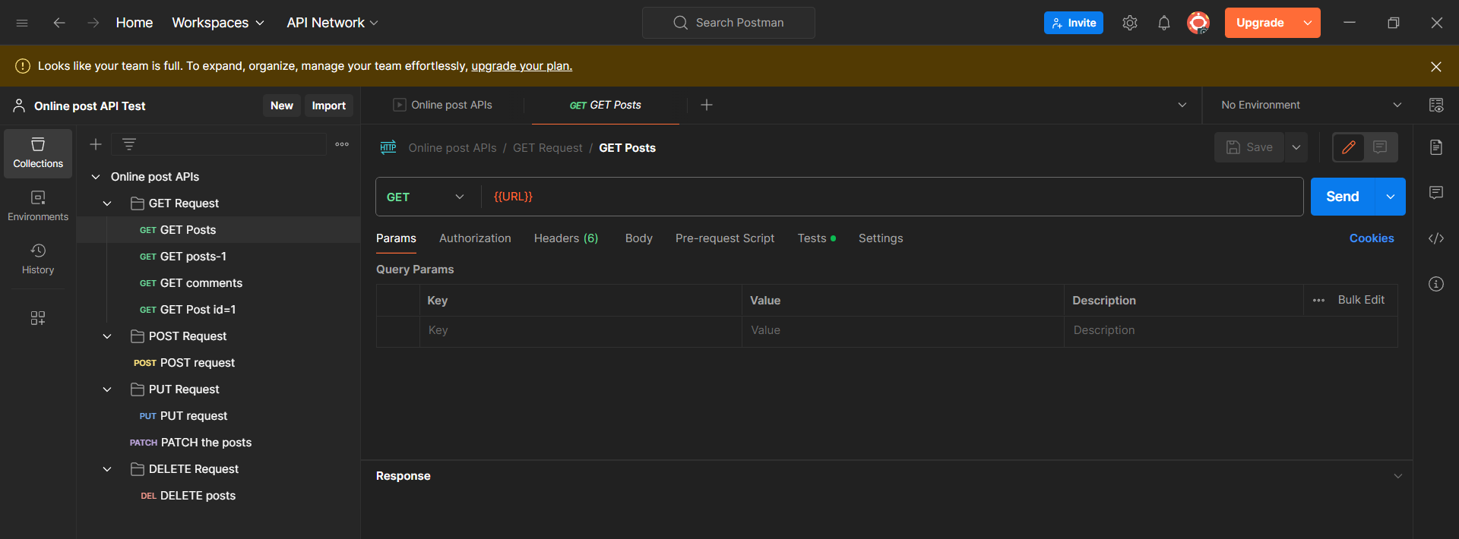

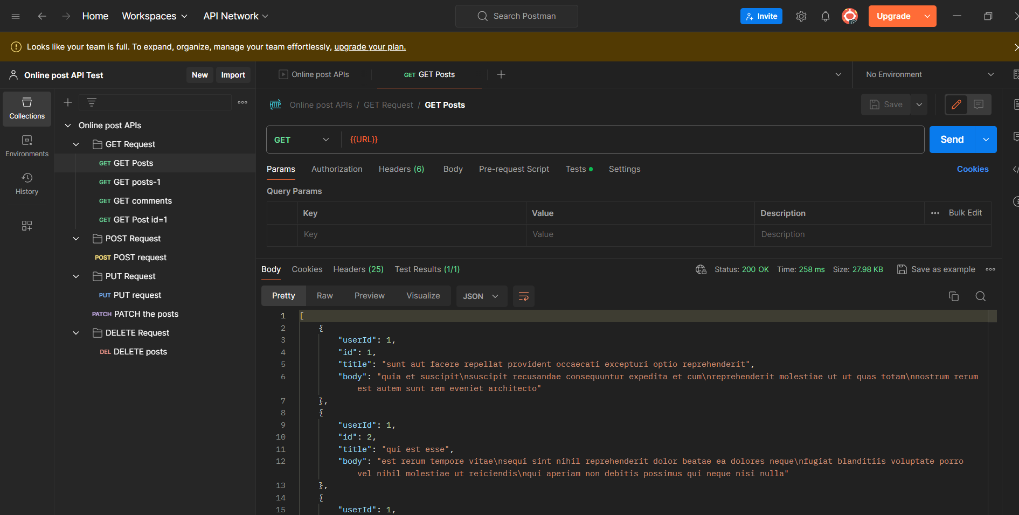

**You can see the result as 200 ok**