**Apache POI Configuration**

**Installing apache poi**

* We need to create a maven project by clicking on file>new>maven project
* Add the required dependencies in pom.xml file
* The dependencies we require are:
  + Apache poi
  + Apache poi-ooxml

Then save the file so that the jar files will be downloaded.

The dependencies in pom.xml file will be as follows

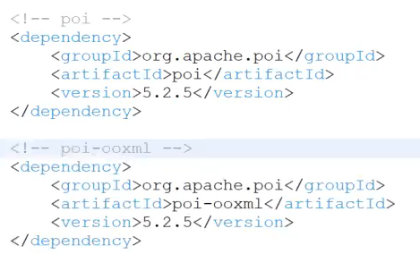

You can find the dependencies in maven repository website by clicking the link

[Maven Repository: Search/Browse/Explore (mvnrepository.com)](https://mvnrepository.com/)

Search for apache poi and apache poi-ooxml and copy the dependency, paste it in pom.xml file.