**Configure Selenium grid using JSON**

* Download selenium server.jar file and copy it to the desired location.
* Open CMD in that location and enter the following command to see the selenium grid UI which opens in the browser.
* “java -jar selenium-server-4.16.1.jar standalone”
* After entering the command you will be redirected to the browser and the output will be as follows.
* 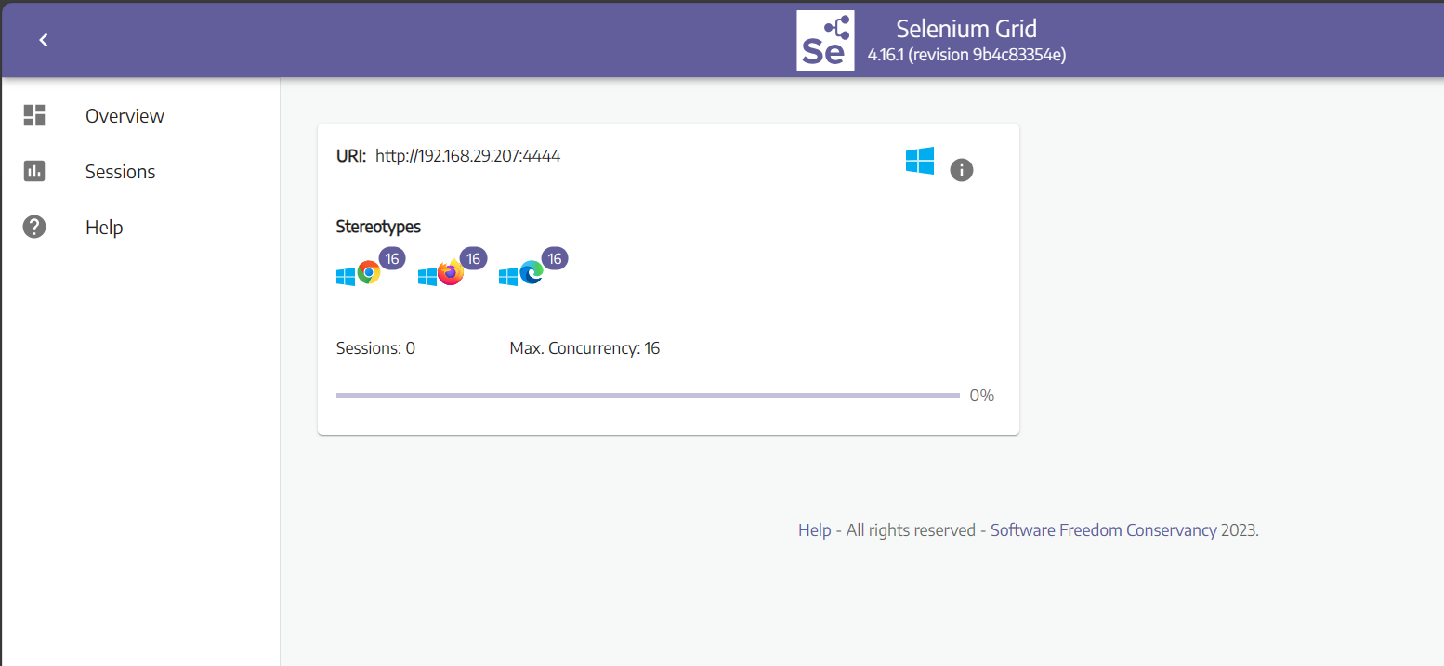

**Configuring grid hub**

* open cmd in that location and type the following command
* “java -jar selenium-server-4.16.1.jar hub”
* Then enter url <http://192.168.29.207:4444> in the browser. You can see the grid console page
* 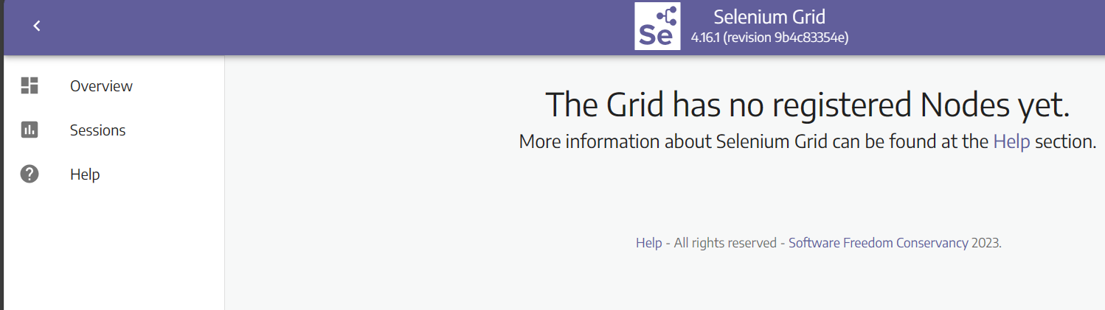
* Currently there are no nodes in that hub

**Configuring grid node**

* To create a new node, open CMD and enter the following command.
* “java -jar selenium-server-4.16.1.jar node”
* New node will be created and your hub will show the node
* 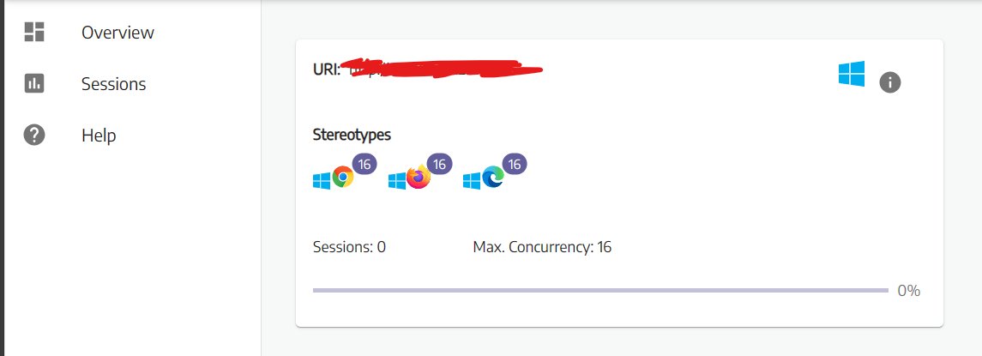

You can also give the port number to the node

“java -jar selenium-server-4.16.1.jar node –port 5566”

Then another node will be created in port 5566