**Set up JDBC Environment**

* **Create a dynamic web project by clicking new>dynamic web project and enter the name and click on next>finish.**
* 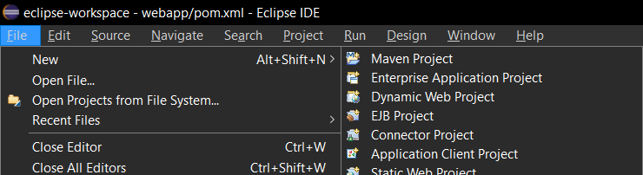
* **If it is not visible you have to install it by going to help>install software>select web xml java ee and click finish.**
* 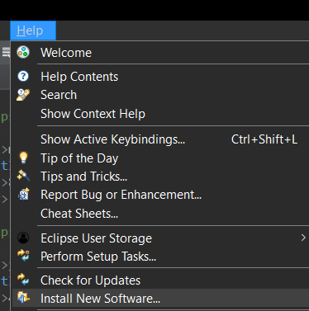
* 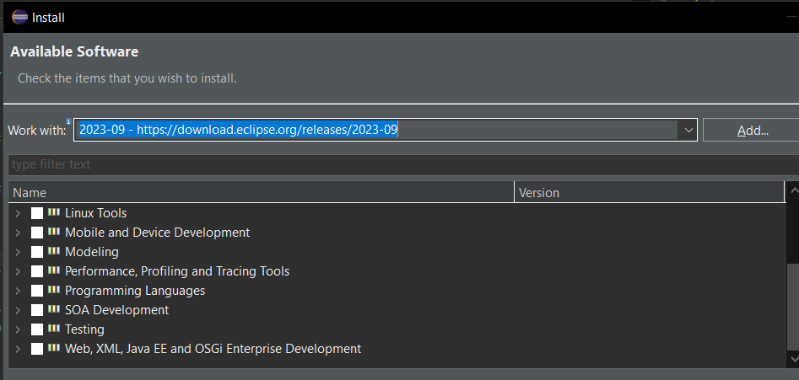

**So after that you need to covert dynamic web project to maven project**

**By right clicking on the project and go to configure and select convert to maven project**

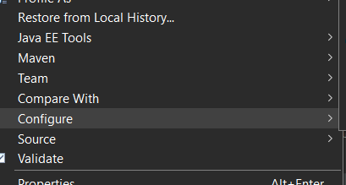

**Use of maven is to add the required libraries easily.**

**To add jdbc got to the maven repository site and search for mysql connector java, copy the dependency and paste it in pom.xml file.**

