**Demonstrate Connection, Statement, and ResultSet in JDBC.**

**Statement**

* **In JDBC statement is used to execute queries.**
* **There are two other types besides statement**
  + **Callable statement**
  + **Prepared statement**

**Callable statement – It is used to access stored procedures in database**

**Prepared statement – used to execute sql statements**

**First we set the statement as null**

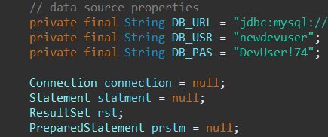

**We then create a statement and execute it**

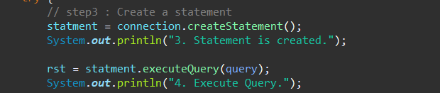

**Connection**

* **In JDBC connection is used to connect the code with the database**
* 
* **Here we define the database name, user name and password of the database**
* **Finally we need to close the connection**
* 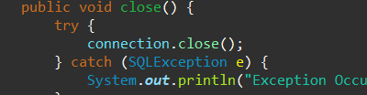

**ResulSet**

* **resultSet is used to store the result of the query that is executed**
* **there are three methods in resultset**
  + **get method**
  + **update method**
  + **navigational method**

**Get method – is used to view data of the columns in current row**

**Update method – is used to update the data of the column in current row**

**Navigational method – helps to move the cursor to the next row**

