Demonstrate stored procedures and exception handling in JDBC.

**Stored procedure**

* **Stored procedure act as a function to execute a query**

**First we need to create a procedure**



**Then we need to call the procedure with some parameters**

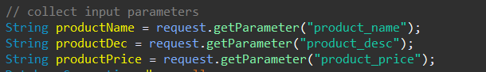



**Exception handling**

* **It is very important to handle the exceptions**

**Every part of the code is placed inside try catch block so that we can see where the exception is happening**

**Let us take an example**

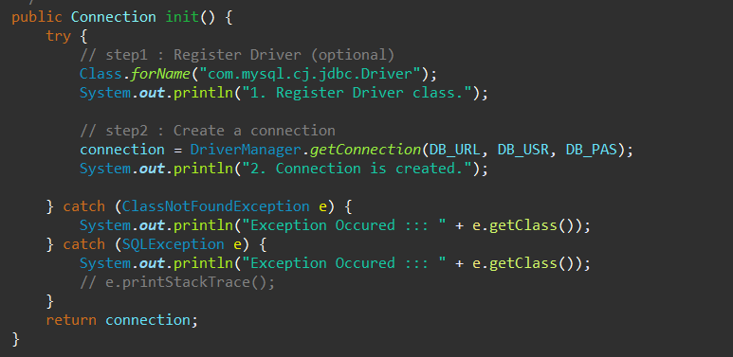

**Here we initialize the connection in try and catch blocks.**