**Demonstrate database record handling using JDBC.**

**Record handling means performing insert update and delete actions by using statement in jdbc**

**Insertion – we take inputs from user and perform insert operation**

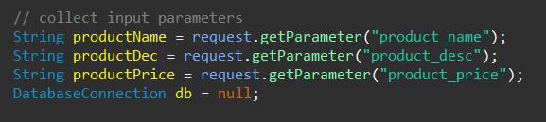

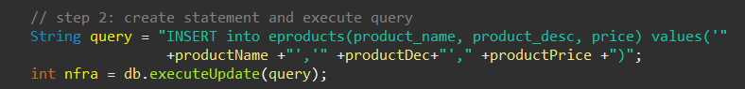

**Update – we take inputs from user and update the existing data**

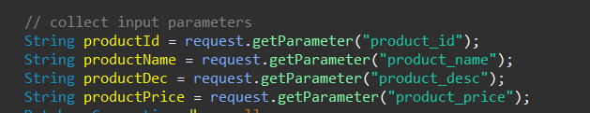

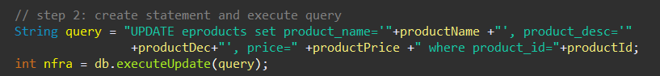

**Delete – we take the id of the data which we want to delete from the user and delete the record**

