**Demonstrate Transaction Management in JDBC.**

**Transaction management**

* **In transaction management by default auto commit is enabled which commits the changes every 5 seconds by default.**
* **We can change the time interval.**
* **But setting the auto commit to false will let you make commits for the changes manually**
* 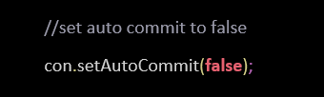
* **Now we need to commit manually**
* 
* **Setting auto commit to false help you to commit multiple transactions in an instance of time.**