**Microcontroller**

* Raspberry Pi 5

**Sensor Module**

* 1 × Raspberry Pi Camera Module V2.1 (8MP 1080p, CSI interface, supports 1080p30 video and 8MP still images)

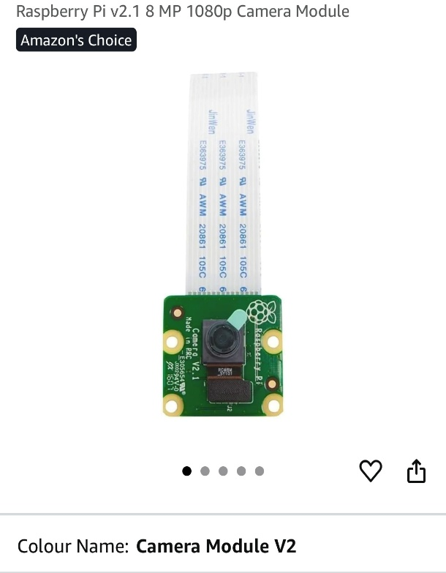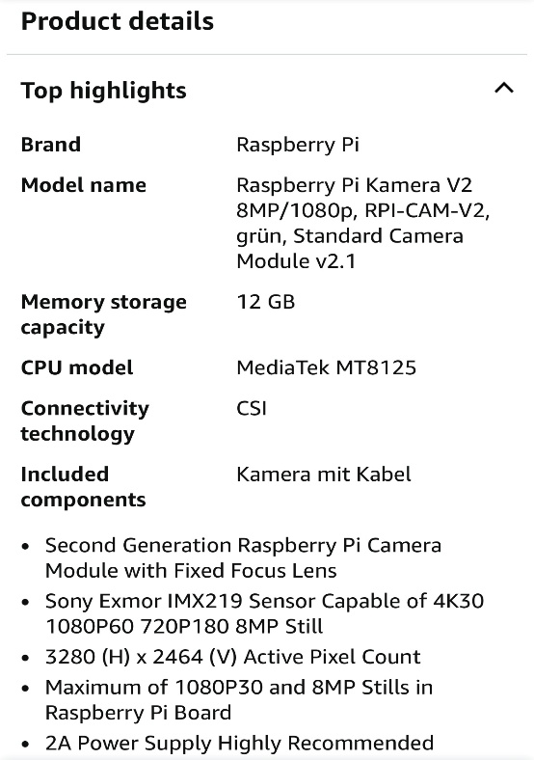

* 1 × CSI FPC Flexible Cable (22-pin to 15-pin adapter)

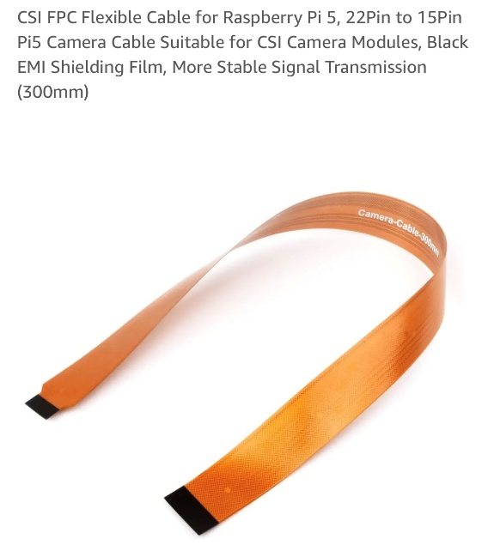

* 3 × HC-SR04 Ultrasonic Distance Sensors (measurement range: approx. 2cm–400cm, digital I/O interface, Trig/Echo)

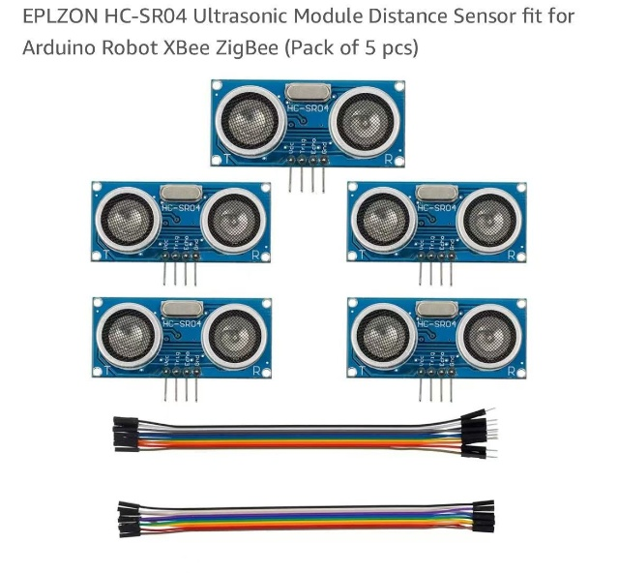

**Note:**

* Raspberry Pi 5 uses a 22-pin 0.5mm pitch CSI interface, while the Camera Module V2.1 uses a 15-pin 1.0mm pitch standard CSI interface. A 22-pin to 15-pin CSI FPC flexible adapter cable is required for physical connection.

**Driving & Mobility Module**

* 2 × L298N Motor Driver Modules (dual H-bridge DC motor controller, supports forward/reverse and PWM speed control for 2 DC motors)

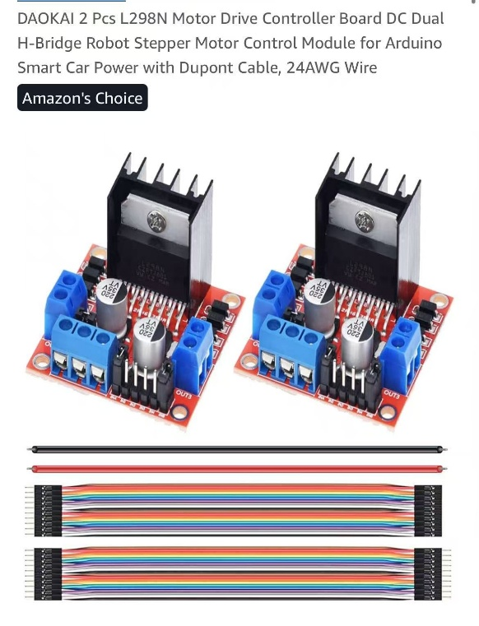

* 1 × 4-Wheel Smart Car Chassis Kit (includes transparent acrylic chassis plates, 4 × DC gear motors, 4 × rubber wheels, metal standoffs, and mounting hardware)

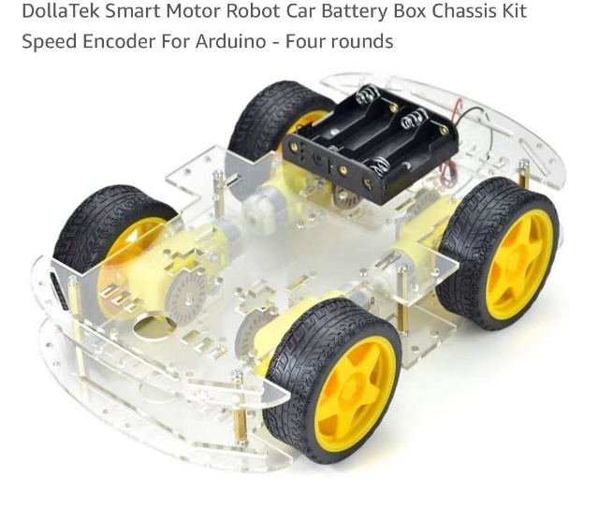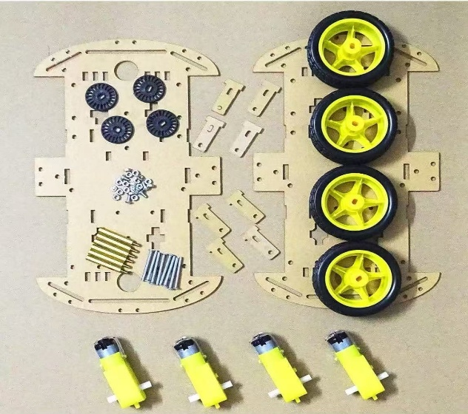

**Note:**

* Each L298N module independently controls 2 DC motors; two modules are used to control the front and rear motor groups.
* Gear motors are standard TT DC gear motors (6V operating voltage, approx. 1:48 reduction ratio, ~200rpm no-load speed).

**Structure & Assembly**

* Dupont jumper wires (2.54mm pitch)
* Hot glue gun