**Proposal: Website Design and Development – Hunter Games**

**Introduction:**

Gaming is more popular than ever these days, and that trend isn’t likely to stop anytime soon. That also means there’s a great opportunity if you know how to make a website and tailor it to gaming specifically, be it a gaming blog or a streamer’s website. Depending on which games you want to focus on, you might even set up your server people can play on.

Just like the games themselves, gaming websites come in a lot of shapes and sizes.

**Proposal Details:**

I intended to propose to design, develop, and maintain the website and online gaming system of **Hunter Games**. I am proposing a comprehensive package that includes designing a cutting-edge website for the **Hunter Games** complete with all its web pages and sub-pages, fast-loading web pages, clear visuals, and basic search engine submission and optimization.

Upon the start of the project, I will design the sample website layouts for my teacher’s approval. Once approved, we will start developing the website using modern web techniques.

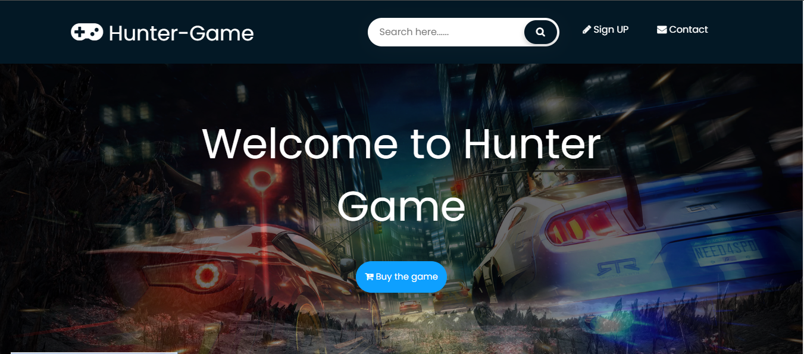

***Web Development Timeframe*** – the time period for developing the website will range from 3 to 6 weeks, depending on the number of pages

***Payment Terms*** – We require a 30% downpayment upon the start of the web design project, and the remaining 70% upon completion of the project.

***Revisions*** – We could make revisions to your website after the design has been completed. We work closely with all our clients in making sure their websites are up-to-date.

***Pricing* -**Please see the attached price quotation for pricing details.

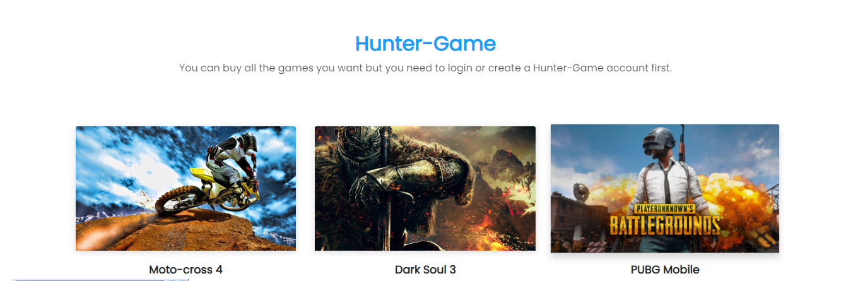

**Company Profile:**

     I am a freelancer 3rd-year student at the American College of technology-based in Addis Ababa City, Ethiopia. I enable individuals and businesses to acquire and create their unique identities and brands on the internet by offering domain registration, web hosting, email hosting, web design, dedicated servers, and complementary products and services. Our mission is to give our valued customers outstanding support and reliable hosting with many features at an affordable price

**Support Staff:**

I and my team are dedicated professionals. Each employee receives extensive technical and customer service training to ensure that you always receive friendly and accurate responses. All representatives have an extensive technical background in handling websites and managing networks. They have been also trained in the languages of HTML, Javascript,

PHP, ASP, and more.

**Motivation:**

My motivation is to create a space where gamers can communicate u upload their gameplay and share their projects and console each other