Smart Quiz Analysis System with Generative AI Integration

1.Hüseyin Emir Gölemen
Computer Engineering
Kastamonu University
Kastamonu, Turkey
emirgolemen173@gmail.com

Abstract— This study was conducted to demonstrate that modern tools of today can be rapidly and practically integrated into education in place of traditional methods. An autonomous educational analysis system was developed using n8n for workflow management and generative AI integration. The system combines data collection via forms, JavaScript-based logical evaluation, and the delivery of personalized feedback using large language models. Student responses are processed in real time, and the resulting data is stored in a cloud-based database. AI-powered analysis results retrieved from the database are automatically delivered to students via email in a short time.
Keywords— automation, artificial intelligence, n8n, personalized feedback, educational technologies, use of AI in education
I. Introduction
Just as other fields are affected by today's digital transformation, education is no exception. The need for learning processes to be fast, practical, easy to navigate, and personalized makes the integration of technology into education inevitable. From an educator's perspective it is clear that traditional methods are proving insufficient in the face of increasing data volume and diverse new learning needs. As a result, turning to next-generation technology tools has shifted from being a preference to a fundamental requirement for educators.
However, continuing to collect and evaluate educational data through traditional methods leads to time loss and various operational bottlenecks[2][10]. Collecting student information and responses through standard forms and analyzing them manually results in significant time and workforce loss, while also preventing the delivery of immediate personalized feedback to students[19]. Delayed feedback or lack of information about which topics students are struggling with reduces their potential, lowers their motivation, and prevents the formation of an efficient learning environment[4].
To find an innovative, fast, scalable, and dynamic solution to these problems, this study designed an autonomous educational analysis system integrating workflow automation and generative AI (GenAI) technologies[1].
The system processes raw data collected on an open-source workflow automation platform (n8n) that provides automatic data flow and process orchestration between different systems and applications, first passing it through a JavaScript-based logical evaluation filter, and then using Large Language Models (LLM) to generate meaningful and personalized academic feedback unique to each student[17]. The data obtained at the end of this process is securely stored in a cloud-based database (Notion). The analysis results in this database are automatically students' email addresses are automatically delivered in a timely manner.
The aim of this paper is to demonstrate the extent to which the developed autonomous architecture can replace traditional assessment methods in education. The study explores how modern digital tools and AI integrations can practically contribute to educational processes, while examining the analytical convenience the system provides for educators and its contribution to individual student development.
II. System Architecture and Methods
In this system, the process of collecting, processing, and converting student data into personalized feedback and delivering it to the user has been modeled within an end-to-end autonomous architectural framework. This architecture consists of four main components: the data collection module, the workflow automation system, the AI-based content generation layer, and the data storage/notification mechanism.
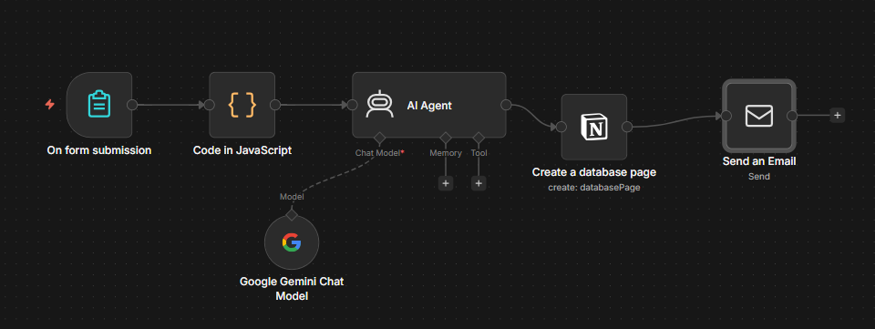
Figure 1. The n8n-based end-to-end autonomous workflow architecture covering the entire process from form data collection to personalized email delivery.

Data Collection Layer
The first stage of the system is the data collection layer. This stage consists of the form interface used to collect student responses and performance data. At this stage, as the data collection interface the n8n platform's built-in "n8n Form Trigger" tool was used without the need for an external service. The main advantages of preferring this form tool are:
- Seamless Data Transmission: Data is directly incorporated into the workflow without the need for API or Webhook integrations.
- Low Latency: Since data is not processed on third-party servers, trigger times are reduced to milliseconds.
- JSON Compatibility: Data received from the form reaches the system instantly in JSON format, eliminating the need for additional data parsing in subsequent steps.

Workflow Automation with n8n and JavaScript Evaluation
At the center of the project is n8n, a node-based automation platform that connects different applications and APIs[1],[3],[6]. Before raw data from the form is sent directly to the AI model, it is subjected to JavaScript-based preprocessing using the 'Code Node' within n8n (Figure 2). The JavaScript algorithms written at this stage normalize text-based responses from the form using functions such as trim() and includes(), calculate a success score by checking answers with logical conditions (if/else), and generate a list of 'missing topics' based on incorrectly answered questions. This process converts raw data into a structured context format, enabling the AI to produce more specific and consistent feedback for the student.

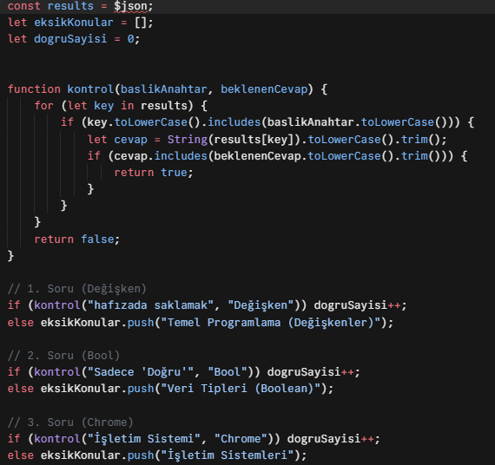
Figure 2. The code block running on the n8n "Code Node" that filters form data with logical conditions to create a structured context for the AI model.

Generative AI (GenAI) Integration
Student data processed and structured by JavaScript is transferred to the Large Language Model (LLM) via the AI Agent node within n8n[5]. In this study, Google Gemini 2.0 Flash was used as the model[8]. Custom 'Prompt Engineering' was applied to the integrated model, enabling it to assume the role of an ‘Engineering Coach.’ By analyzing the number of correct answers and the list of missing topics derived from the code layer, the model generates a motivating, fully personalized academic feedback text that identifies the specific areas in which the student is deficient and explains how those deficiencies may be remediated, rather than simply assigning a grade[11].

Cloud-Based Database and Automatic Feedback
These customized feedbacks and student performance data generated by AI are saved to a cloud-based database using Notion API integration for future academic analyses and student progress tracking. Simultaneously with this saving process, n8n's email node is triggered. The detailed AI report and the student's score are instantly delivered via SMTP protocol to the student's personal email address provided in the form. Thus, the manual analysis and feedback process that could take days with traditional educational methods has been made completely autonomous, reducing it to seconds[7],[15]. The main advantages of choosing a Cloud-Based Database at this stage:
- High Accessibility: Hosting data in a cloud environment provides secure access to data independent of time and location.
- Cost Efficiency: Eliminates the need for local server installation or physical storage hardware, minimizing infrastructure costs.
- Dynamic Reporting and Management: Flexible platforms like Notion allow real-time filtering of collected metrics and the creation of customized tracking dashboards to monitor student progress.

III. Results and Discussion
Following the testing processes of the developed autonomous educational analysis system, positive findings were obtained regarding operational efficiency and pedagogical feedback quality. The results demonstrate that the system makes significant contributions to educational processes in terms of speed, cost, personalization, and scalability. The system operated autonomously without human intervention across all stages from data collection to final email delivery. This reveals that processes can be managed more effectively and sustainably, especially in large-scale educational environments.
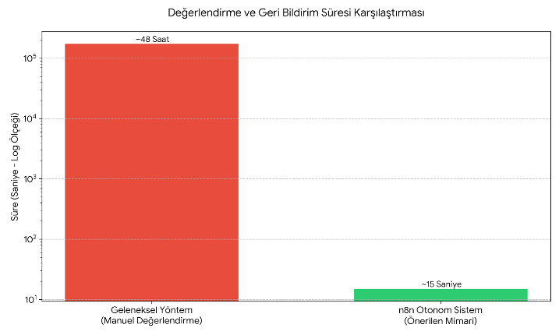
Figure 3. Feedback Times

A. Accuracy of LLM Outputs and Pedagogical Style Review
In tests conducted to verify the functionality of the system, the accuracy and style of outputs generated by the Gemini 2.0 Flash model were examined[14][18][20]. As seen in Figure 4, the system did not merely present the student's exam result as a numerical data point; it identified specific topics where the student made errors (e.g., Data types, loops) in the manner of an 'Engineering Coach' and provided improvement suggestions.

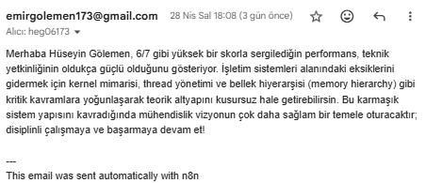
Figure 4. An example of a personalized feedback email generated by the n8n autonomous system and delivered via SMTP protocol.

B. Data Management and Traceability:

The automatic transfer of all analyzed data to a structured database on the Notion platform has enabled long-term and systematic monitoring of students' development processes.

Figure 5. The structured database view of student performance data and AI analysis results on Notion.

C. AI and Feedback Quality:

The integration of logical filters created with JavaScript minimized the hallucination risk of the Gemini model and ensured that the generated texts were entirely based on the student's actual data[16]. Rather than merely scoring, the model produced high-quality pedagogical texts that motivate the student, directly identify areas of weakness, and offer improvement suggestions.

The developed system has certain limitations. First, the current evaluation mechanism is limited to multiple-choice and short-answer questions and cannot evaluate multi-step engineering problems or coding tasks. The second limitation is that the pedagogical feedback generated by the Gemini 2.0 Flash model has not undergone systematic human evaluation, making it difficult to verify the consistency and pedagogical quality of the feedback[12][13]. Finally, since the system depends on the external service infrastructure of n8n and Notion API, potential outages or changes in API policies at these services could threaten the system's continuity.

IV. Evaluation
This study demonstrated to what extent traditional and manually conducted analysis processes in education can be made efficient with modern automation tools and generative AI technologies. The developed n8n-based autonomous system successfully completed data collection, logical evaluation, and personalized feedback processes within seconds without requiring human intervention. The most notable output of the system is its ability to not only present statistical data but also offer pedagogical and technical development suggestions to students in the manner of an "Engineering Coach."
The JavaScript-based preprocessing layer used in the system minimized the risk of errors when AI models interpret technical data, and a sustainable tracking mechanism for educators was established through Notion integration. Results show that this and similar hybrid architectures reduce the administrative burden on educators, enabling them to focus on higher-quality mentoring activities.

V. Future Work
In the next phase of the study, strategic improvements are planned to expand the scope of the existing autonomous architecture and enrich the user experience:
- Interface and Performance Analysis: It is aimed to visualize data through a student panel interface to be integrated into the system and to comparatively test the academic analysis performances of different Large Language Models (LLM)[9].
- Multimodal Feedback and Dynamic Content: It is envisioned that the feedback mechanism will be supported not only with textual content but also with graphical analyses, dynamic YouTube educational videos targeting specific learning outcomes where the student made errors, or relevant PDF document pages included in "smart recommendation packages."
- Early Warning System and Mentoring: An "early intervention module" that sends automatic notification emails to academic advisors for students who fall below the defined achievement threshold is planned, aiming for proactive monitoring of student development.
- Security and Authentication: To enhance data integrity and security, a One-Time Password (OTP)-based authentication layer through institutional email addresses prior to form access is planned to be incorporated into the system.

References

- I. Nakavisute and T. Sincharoonsak, "Optimizing the Automation Process with n8n," TPM--Testing, Psychometrics, Methodology Appl. Psychol., vol. 32, no. S8, pp. 1786–1793, 2025.
- D. S. Ramos, I. Chaparro, J. Padilla, R. Casallas, J. C. Cruz, and L. H. Reyes, "Integrating Generative AI with the Dialogic Model in Education: The Cognitive-AI Synergy Framework (CASF)," Preprints.org, 2025.
- R. Katırcı, H. Çelik, and N. Gön, "Yapay Zekâ Ajan Mimarileri: Orkestrasyon, Bilgiye Erişim ve Otonom Karar Alabilme," J. Sustainability, Manage. Econ., vol. 1, no. 2, pp. 372–394, Jan. 2026.
- M. Rakhmetov, A. Sadvakassova, G. Saltanova, B. Kuanbayeva, and G. Zhusupkalieva, "Evaluation of an AI-Based Feedback System for Enhancing Self-Regulated Learning in Digital Education Platforms," Electron. J. e-Learning, vol. 23, no. 4, pp. 126–141, 2025.
- H. Parmaksız, "Ajan yapay zekâ: Otonom sistemler, sürdürülebilir etki ve akademik evrim için çok boyutlu bir çerçeve," Journal of Sustainability, Management & Economics, vol. 1, no. 2, pp. 105-128, 2025.
- P. Venkiteela, "n8n: An Open-Source Workflow Automation Platform for Enterprise Integration and AI-Driven Orchestration," International Journal of Computer Applications, vol. 975, p. 8887, 2026.
- A. R. Amir and S. M. Atif, “Evaluating workflow automation efficiency using n8n: A small-scale business case study,” arXiv preprint arXiv:2602.01311, 2026.
- A. Mangalur, K. Hegde, C. Badachi, M. Aamir et al., “Transforming student evaluation with adaptive intelligence and performance analytics,” arXiv preprint arXiv:2503.04752, 2025.
- I. Aytutuldu, O. Yol, and Y. S. Akgul, “Integrating LLMs for grading and appeal resolution in computer science education,” arXiv preprint arXiv:2504.13557, 2025.
[10] N. Tokel, "Yapay Zekâ Destekli Dijital Öğrenme Ortamlarının Öğrenci Başarısı ve Motivasyonuna Etkisi," EFE Akademi, pp. 73–86, Jan. 2026.
[11] E. D. Lindsay, M. Zhang, A. Johri, and J. Bjerva, “The responsible development of automated student feedback with generative AI,” in Proc. 2025 IEEE Global Engineering Education Conference (EDUCON), 2025, pp. 1–10.
[12] E. Ortega-Ochoa, J.-M. Sabaté, M. Arguedas, J. Conesa, T. Daradoumis, and S. Caballé, “Exploring the utilization and deficiencies of generative artificial intelligence in students’ cognitive and emotional needs: A systematic mini-review,” Frontiers in Artificial Intelligence, vol. 7, p. 1493566, 2024.
[13] M. Lundgren, “Large language models in student assessment: Comparing ChatGPT and human graders,” arXiv preprint arXiv:2406.16510, 2024.
[14] W. Xie, J. Niu, C. J. Xue, and N. Guan, “Grade like a human: Rethinking automated assessment with large language models,” in Proceedings of the International Conference on Research in Adaptive and Convergent Systems, pp. 1–8, 2025.
[15] M. Qian, H. Ji, and L. Li, “Empirical validation of a generative AI framework for personalized education assessment,” Scientific Reports, 2026
[16] S. Guo, E. Latif, Y. Zhou, X. Huang, and X. Zhai, “Using generative AI and multi-agents to provide automatic feedback,” arXiv preprint arXiv:2411.07407, 2024.
[17] I. Kuzminykh, T. Nawaz, S. Shenzhang, B. Ghita, J. Raphael, and H. Xiao, “Personalised feedback framework for online education programmes using generative AI,” arXiv preprint arXiv:2410.11904, 2024.
[18] L. J. Jacobsen and K. E. Weber, "The promises and pitfalls of large language models as feedback providers: A study of prompt engineering and the quality of AI-driven feedback," AI, vol. 6, no. 2, p. 35, 2025.
[19] T. Heinrich, S. Baily, K.-W. Chen, J. DeOliveira, S. Park, and N. C.-H. Wang, “AI-assisted grading and personalized feedback in large political science classes: Results from randomized controlled trials,” PLOS ONE, vol. 20, no. 8, p. e0328041, 2025.
[20] G. Byun, S. Rajwal, and J. D. Choi, “LLM-as-a-Grader: Practical insights from large language model for short-answer and report evaluation,” arXiv preprint arXiv:2511.10819, 2025.

