Networked Data Lab project 3: Unpaid Carers in Liverpool and Wirral

Final report March 2023 (updated May 2023)

Networked Data Lab, Merseyside and Cheshire ICB, Liverpool City Council, Wirral Council, and the University of Liverpool

*Authors: J. O’Brien, B. Barr, and R. Piroddi*

*on behalf of Liverpool and Wirral Networked Data Lab*

Liverpool: Tim Caine, Helen Duckworth, Annmarie Jacques

Wirral: Matthew Gilmore, Lee Kirkham, Beverley Murray

**INTRODUCTION**Networked Data Lab phase 3 (NDL3) focuses on developing insights from health data analysis of unpaid carers’ needs for health and well-being, social services, and community support. Recent reports into unpaid carer roles have recently revealed that one in five of the UK’s adults (10.6 million people) are now supporting a relative, close friend or neighbour because of chronic illness, mental ill health, dementia, disability or older age (Carers Week, 2022), involving a ‘turnover’ of around 4.3 million unpaid carers each year either commencing or leaving their role (Petrillo, Bennett and Pryce, 2022). The number of people providing 20+ hours per week has risen by 42% across the UK since October 2020, while the number providing 50+ hours has increased by 30%. Census 2021 revealed an increase on 2011 census in carers providing 20-49 hours of support (1.9%), and 50 hours or more (2.8%).

Unpaid carers experience detrimental effects to their health and well-being, resulting from the demands of their caring role. Carers are 16% more likely than non-carers to live with multiple long-term health conditions (LTCs), including arthritis and high blood pressure, as well as chronic pain due to strain and injury (Public Health England, 2021). In Between 2017-2019 around half a million people gave up work to become a carer, contributing to the 4.6 million people who have left work or reduced working hours for this reason (Carers UK, 2019). The burdens of unpaid care also mean carers are less likely to engage in health-promoting physical activity, due to constraints on time and caring routines, or because of fatigue (Horne, et al., 2021).

*Integrated care strategies*The analysis presented in this report seeks to shed light on the patterns and impacts of unpaid care specific to the Liverpool and Wirral region. The experiences of carers have been incorporated into the Liverpool City Council and CCG Integrated All-Age Carers Strategy. Liverpool’s strategy is based on a support pathway involving identification of need, information services, assessment of need, allocation of resources, and specialist support provision. In Liverpool, 26,368 people (all ages) were providing more than 20 hours of unpaid care a week in 2021, including 14,955 people doing so for more than 50 hours a week.

Wirral Borough Council (WBC) published a strategy document, ‘Caring for our Carers’ (Wirral Borough Council, 2013), along with a detailed profile of carers in the borough (Wirral Intelligence Service, 2018). This profile reveals that around 42,000 or 12.6% of Wirral residents have a caring role. Individuals who self-identify as carers are distributed unevenly across the borough. WBC has recently commenced a review of this strategy (Wirral Borough Council, 2022). Wirral’s strategy focuses on development of information and services, understanding carers’ roles, and supporting carers’ involvement and empowerment.

Unpaid carers can receive support directly, as in the example of respite from their caring role, or indirectly, as in the example of their cared-for person receiving additional support. Direct support can include the provision of information about available benefits, about personal budgets, managing the cared-for person’s financial affairs, crisis planning, and introductions to support groups.

In order to improve support for unpaid carers, hospital trusts across Merseyside and Cheshire have launched an integrated Carers Passport[1]. Liverpool City Council has also launched a strategy plan to support carers from an early stage of intervention (Liverpool City Council, 2022)[2]. In summary, these seek to:

* Raises awareness of the carer role
* Provides support to carers
* Recognises the importance of carers in patients' lives
* Provides tailored information to managers and key healthcare professionals
* Support access to work and education
* Prevent excessive or inappropriate care for young adults

*Research questions*

The study presented in this report has responded to a set of research questions, which might help to improve our understanding of carers’ needs and contexts.

* How many adults are registered with GP or social services as a carer?
* Have these changed over time?
* How likely are people to become a carer based on gender, ethnicity, age, or deprivation?
* Do carers tend be concentrated in certain areas?
* What delays in receiving support to carers face?
* What health issues do carers deal with?

**METHODS**

An aim for the current research is to improve understanding of the patterns and impacts of unpaid care in Liverpool and Wirral, which could help to better target carers’ needs in line with integrated strategies. We sought to achieve this by conducting analysis on primary and secondary health data for the entire Liverpool and Wirral population (detailed below), which includes cohorts of those registered by their GP or flagged by Adult Social Care (ASC) as having caring responsibilities.

We made use of open Office for National Statistics (ONS) data: age, sex, ethnicity and LSOA of residence were extracted from these records for the analysis. Denominators for look-back analyses were taken from ONS population estimates for each year of the study period (2016-2021). We also linked to individual and household data an small area-based contextual measure, specifically the Index of Multiple Deprivations (IMD 2019), based on Lower Super Output Area (LSOA), which represent discrete residential populations of around 1500-3000 individuals.

As data were not integrated between the boroughs at source, some indicators available from Liverpool sources were not available from Wirral sources (specifically, ‘event types’ for carers’ interactions with services were not available for Wirral). Data from Wirral and Liverpool sources were integrated to produce unified indicators and variables (Figure 1).

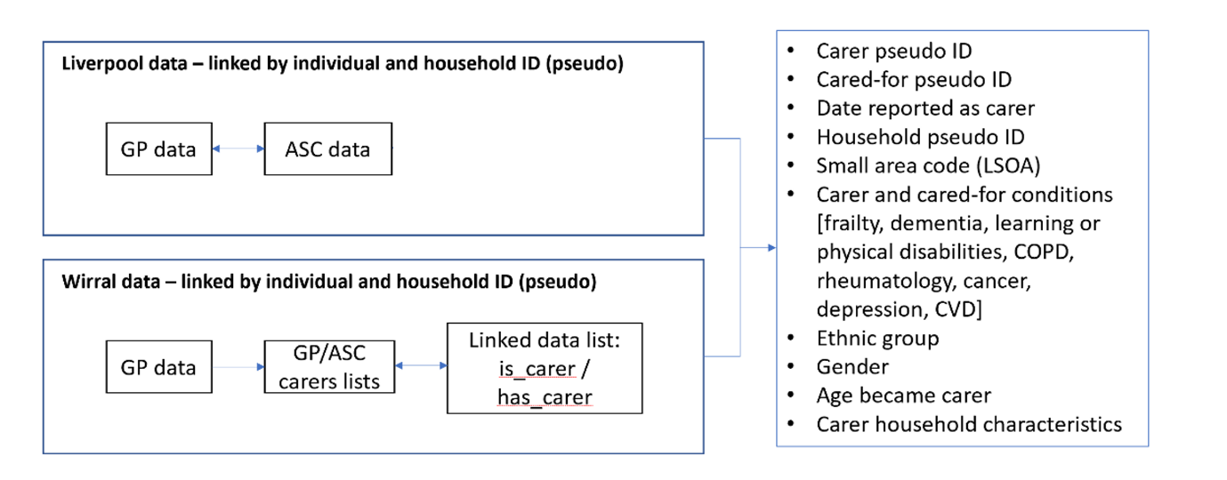

*Figure 1. Workflow for the integration of data from Liverpool and Wirral sources*

Further issues for data integration related to terminologies for ASC service codes having been modified during the study sample time period (2016-2021). Furthermore, a additional list was provided for analysis that detailed those individuals who had placed a request for support within the study period (not all of these individuals were subsequently designated as a carer). For this reason, cohort inclusion was based on either:

* An assessment that led to designation as a carer
* An ASC action made (with the request being prior to the study period)

A typical ASC workflow for carers is presented below (Figure 2). In order to maintain consistency in recording carers, the codes were modified as ‘Request or contact’, ‘Service or plan’, with ‘Assessment’ and ‘Review’ remaining unmodified.

In the local analysis we sought to understand how contextual factors interact to affect the likelihood of a person becoming a carer. Given the non-normal structure of the data, we opted to fit a General Linear Mixed Model, which allows us to consider how any set of fixed-effect variables (for example, household composition, health conditions of household members, deprivation levels, and so on) might be associated with the response variables of being a carer or not.

**CONSULTATION**

*Patient and Public Involvement and Engagement (PPIE)*

The analytic design for research also responded to a public engagement initiative with people who provide caring roles. Participants represented diverse perspectives of age, gender and ethnicity, and types of care. Some participants were also involved in a separate qualitative research project (funded by Liverpool City Region and commissioned by the Brain Charity[3]), leading to enriched feedback for our research design.

In May 2022 and January 2023, NDL L&W researchers joined participatory workshops with a group of public advisors, who were adults each with caring responsibilities. Several key themes were drawn from these engagement activities, which helped to define NDL3 research questions:

* Care can be provided socially through family or community networks
* Care in ethnic minority contexts is sought through ‘mother tongue’ services
* Caring roles can lead to back and other injuries, resulting in chronic pain
* Caring roles impact on the time available for exercise or other beneficial activities
* Many people with caring responsibilities do not seek out support
* Caring relationships can ‘hit crisis’ when the carer becomes unwell or injured

*Local Authority consultation*

Consultation with local authority business leads in adult social care provided valuable advice on the how support to carers is organized. The majority of ASC work in this area relates to four event types of activity (Figure 2). This provided us with valuable insight from which we structured analysis for waiting times (outlined below).

**Contact or referral**

when the carer has expressed a need for help, or where he or she is registered as a service user

**Assessment** of the degree of needs, determining why a person has expressed need for help

**Actions** are put in place. These can be either direct in support of carer, or indirect via support for the cared-for

**Review or re-assessment** after 12 months, or else unplanned review due to emergency

**Iteration** where a carer’s needs have to be reassessed, then Step 4 loops back to Step 2, and fresh Actions may be put in place.

*Figure 2. Adult Social Care workflow for unpaid carers*

**RESEARCH DESIGN**

Our analytic design for research responded to the Health Foundation’s integrated statistical plan (itemised below).

The analysis followed five sections, involving descriptive statistical analysis of carers at individual, household and areal levels.

*Analysis 1*

* GP cohorts by age group, gender, ethnic group
* Age band and gender by national IMD
* Regional distribution by LSOA
* Time since last carer flag
* Carer LTCs
* Linked is_carer / has_carer

*Analysis 2*

* Look-back counts by age group and gender

*Analysis 3*

* Look-back incidence (new carers for each year of the study period)
* Look-back prevalence (all carers with an event for each year of the study period)

*Analysis 4*

* Total days between Request or contact, and Service or plan

*Local analysis*

* Regression analysis of factors associated with becoming a carer (or not) with general linear models

**Commentary on research design**

The data made available for the research provided key indicators for carers at individual, household and small-area levels. These were however uneven among the boroughs engaged with the research, as Wirral did not include ‘event type’ variables for ASC interactions. The GP data also included uncertainty in terms of ethnic-group identifiers, with 120,000 having ethnicity ‘Unknown’ (equivalent to 27.4%), compared to 438,000 for which ethnicity is known. However, we were able to run analysis based on ‘known’ ethnicity variables. Among carers (Table 1), 15% were designated with ethnic group ‘Unknown’, representing an improved level of recording among this cohort, compared to the general population

|  |  |
| --- | --- |
| White | 20247 |
| Asian/Asian British | 329 |
| Black/Black British | 317 |
| Mixed | 354 |
| Other ethnic groups | 576 |
| Unknown | 2166 |

*Table 1. Counts of carers by ethnic groups (where recorded)*

Access to GP data provided rich individual-level data on carers and those they care for, from which we were able to derive household and small-area indices.

The public engagements with carers highlighted some critical issues for our analysis. For example, we were strongly advised to produce analysis of carers’ mental health. We were also advised to consider the environmental contexts in which carers undertake their roles, which affect their access to services and health-promoting activities. Although these themes were not included in the integrated plan for analysis, we seek to conduct additional research on carers’ environmental contexts, intended for publication.

A linked carers list was made available for analysis, which linked all unique GP+ASC carers (total 17,430) to those they care for (total 8,044) by their unique identifiers, as well as their household identifiers. Of those identified as having a carer, 5271 were also in the GP+ASC cohort.

**RESULTS**

**Cohort populations**

**Liverpool + Wirral**

* Cohorts: GP registered and/or ASC flagged
* Age range > 17 years
* Index date = earliest date at which carer’s needs are known (self-reported or registered)
* Study date range: Jan 2016 – Dec 2021

**Total carers**

|  |  |  |  |
| --- | --- | --- | --- |
|  | **GP registered** | **Not GP registered** | **Total** |
| **ASC flagged** | 1136 | 8327 | 9463 |
| **Not ASC flagged** | 16209 | 0 | 16209 |
| **Total** | 17345 | 8327 | 25672 |

*Table 2. Totals cohort sizes (includes 1,562 carers who died during the study period)*

**Note on headline counts**

3145 carers do not have a complete GP record

**Analysis 1**

Numerators in Analysis 1 are total carers (GP or ASC registered) grouped by gender, age group at which they became a carer, and ethnic group where this is known.

Denominators in Analysis 1 are the total GP population for Liverpool and Wirral where ethnic group is known, or ONS population estimates for mid-2020

Figure 3 shows that, while 80% of carers are White, those of BAME backgrounds are as likely to be designated a carer in proportion to their ethnic groups. BAME females aged 50-50 and males aged 80 and over are more likely than their White peers to be designated a carer. This is partially reflective of poorer health outcomes among minority groups (Cf. Raleigh and Holmes, 2021).

Numerator: carer counts by ethnic group, age group (minimum) and gender

Denominator: total GP population where ethnic group is known

Table: HF_carer_counts_table.csv*

*NOTE: all table headers are explained in Appendix 2

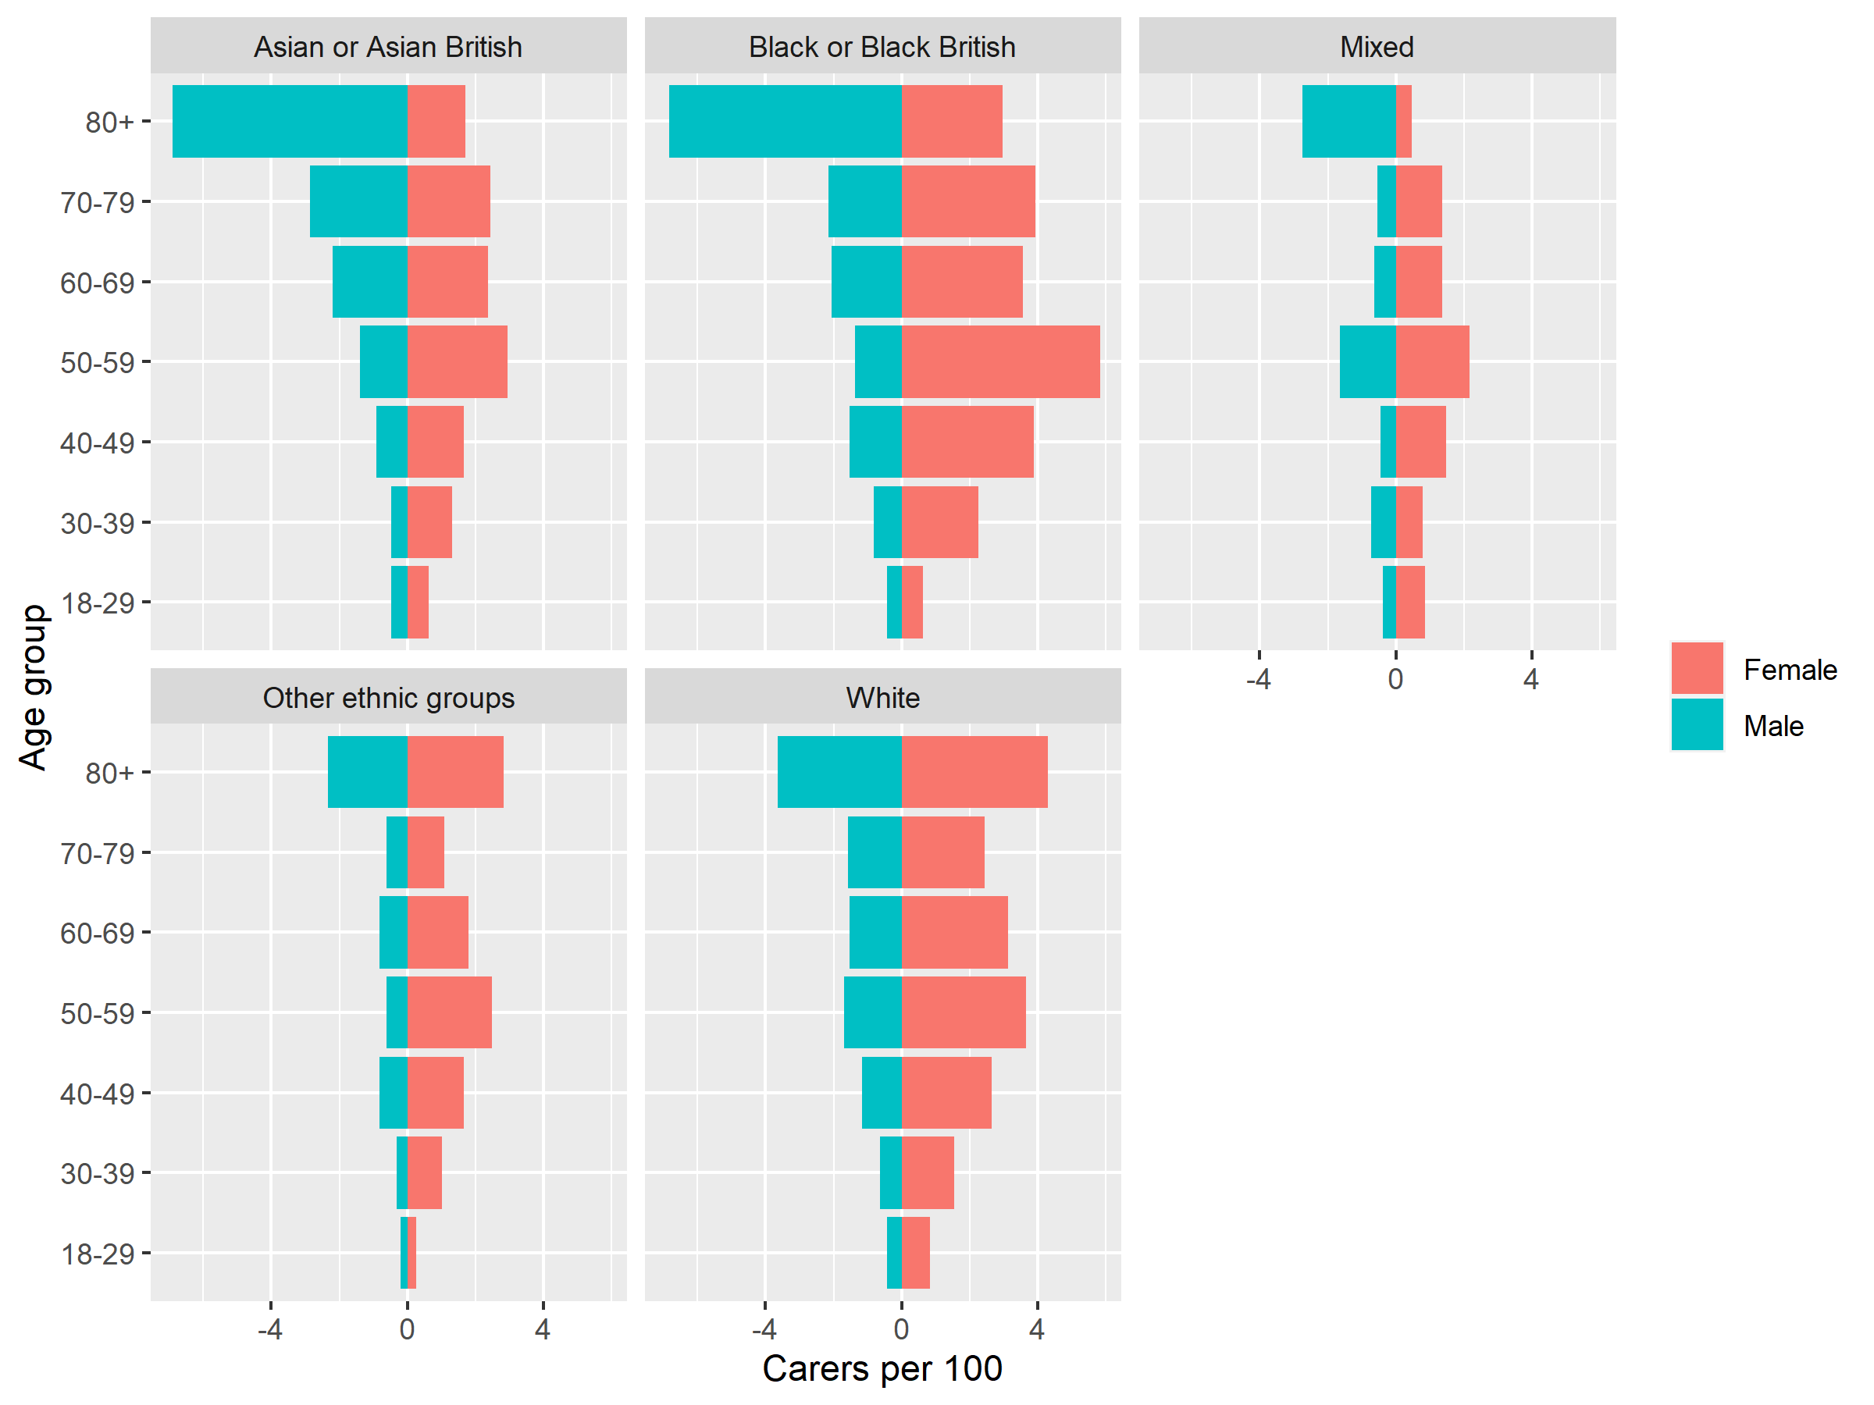

Figure 3. Carer rates by ethnic group and gender

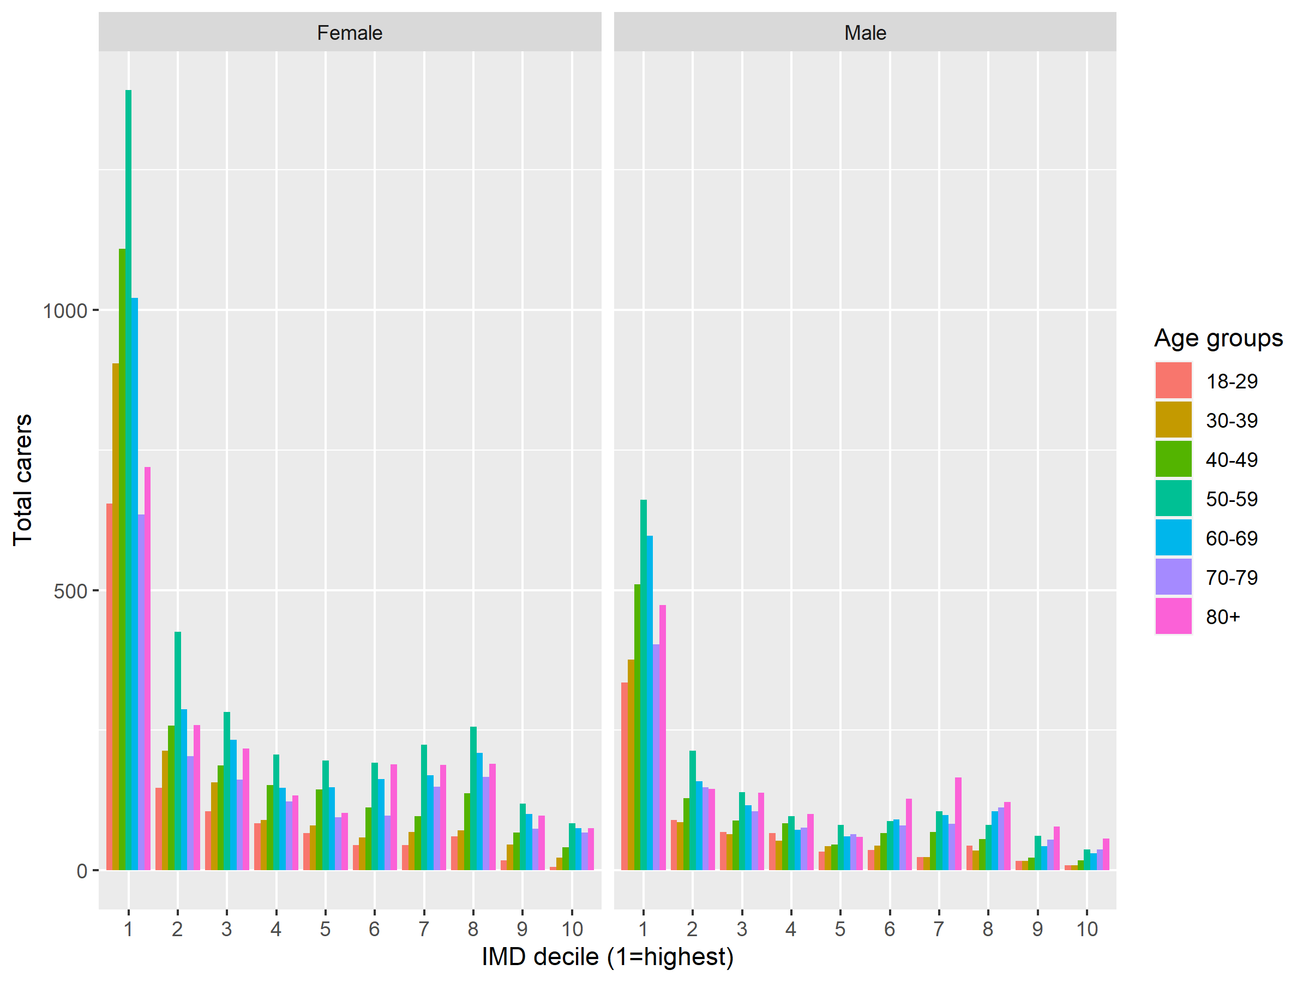

Figure 4. Carer counts by age group and IMD

Figure 4 reveals the greater share of younger carers in high-deprivation areas.

Numerator: carer counts by ethnic group, age group (minimum) and gender

Denominator: ONS population estimate for mid-2020  
Table: HF_carers_count_rates_age_groups_IMD.csv *

*NOTE: all table headers are explained in Appendix 2

**Analysis 2**

The totals of new carers for each year of the analysis were:



*Table 3: Look-back totals by cohort*

A note about the GP&ASC cohort is that the carer cohorts were limited to the January 2016-December 2021 period. However, some carers flagged with ASC may have been registered as a carer before January 2016, but the registration was not included in the cohort count. Hence, more ASC=flagged carers might be registered with GP that this cohort count would suggest.

Table: ‘look_back_totals.csv’

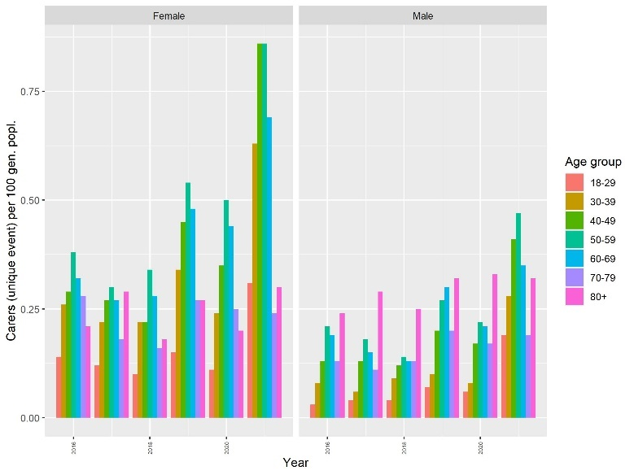

*Figure 5 Look-back rates for GP cohort by age group and gender*

Figure 5 shows the rates of carers who had a carer event for each year of the look-back analysis, and for each age group. As this reflects carer events, an individual carer can be counted in multiple years. A year-on-year increase in carers becoming registered with GP, reflected in all age groups. In particular there was a sharp rise in 2021 among female carers aged 40-69.

Numerator: counts of GP-registered carers

Denominator: ONS population estimates for 2016-2021

Table HF_look_back_age_gender.csv*

*NOTE: all table headers are explained in Appendix 2

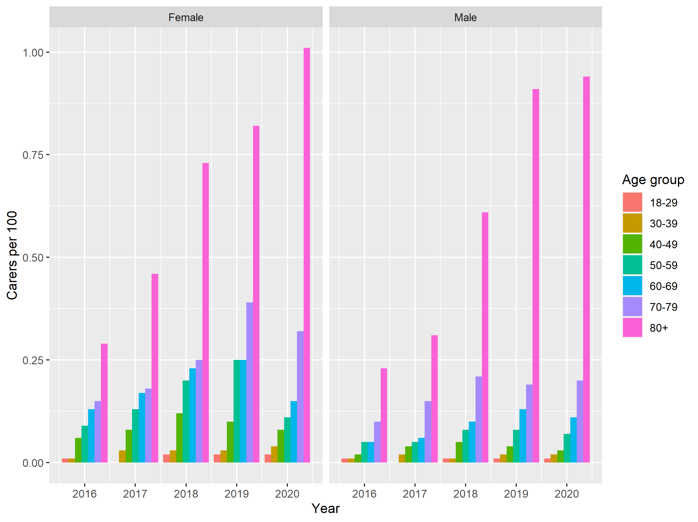

*Figure 6 Look-back rates for ASC cohort by age group and gender*

Figure 6 shows a year-on-year increase in new carers becoming known to ASC. This trend is reflected in all age groups, with a particularly steep increase among carers aged 80 and over for both females and males.

Numerator: counts of ASC-flagged carers

Denominator: ONS population estimates for 2016-2021

Table: HF_look-back- age_gender.csv

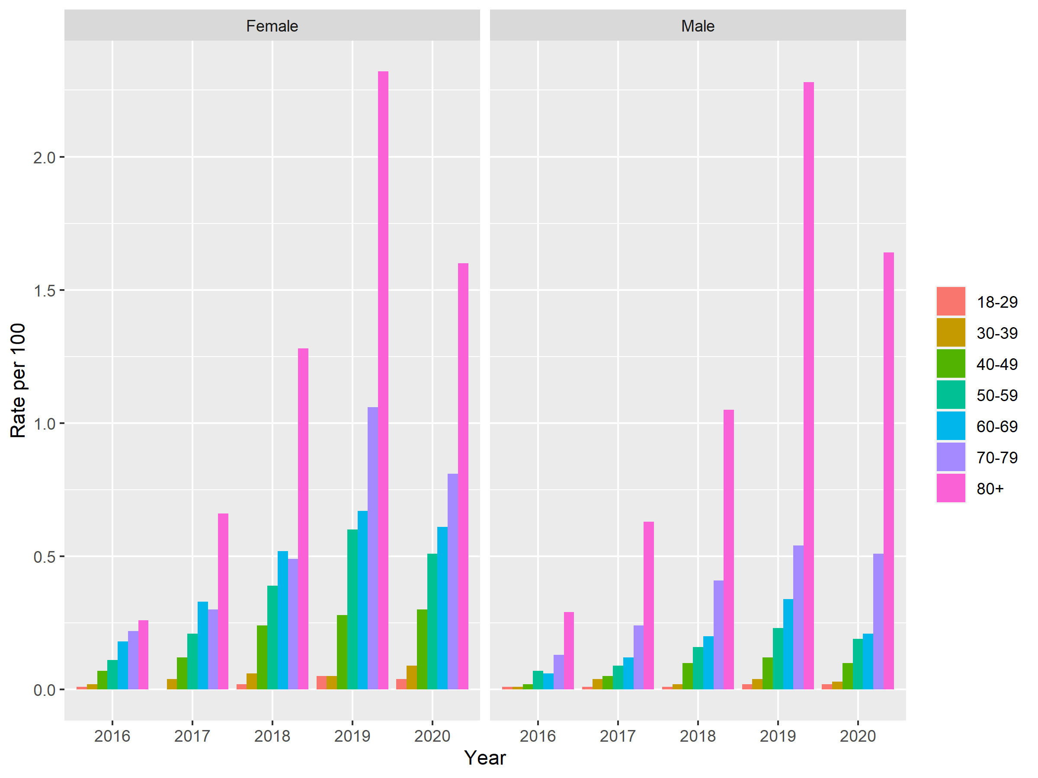

Figure 7. Look back prevalence by age group and gender

Figure 7 shows a year-on-year increase in prevalence (unique carers by event), by age group of carers at which they became known to services. Rates are based on event types for Liverpool ASC (which were absent from the data for Wirral).

Numerator: counts of unique carers by event (i.e. unique carers may be counted multiple times).

Denominator: ONS population estimates for 2016-2021 (Liverpool only)

Table: HF_look_back_prevalence_age_gender_LPL_ONLY.csv

**Analysis 3: Percentage of population who are carers**

A table of counts and percentages of the population who are carers by IMD, year and gender is available in HF_carer_imd_year_percentage.csv.

Note that that some values are greater than 100% - the reasons for this are not currently clear, but may relate to duplicate counting within IMD deciles.

Numerator: unique carers (who had an event) by year

Denominator: ONS population mid-year estimates

Table: HF_carers_count_rates_age_groups_IMD.csv *

**Geographic distributions**

Figure 9 shows higher densities of carers per 100 (general population) across Liverpool, compared to Wirral. This is pronounced in high-deprivation areas to the south and north of the city centre, as well as outer suburbs to the north and south. Some higher rates are found in Wirral inner and outer suburbs.

Numerator: counts of GP+ASC carers

Denominators: ONS population estimates mid-2020  
Table: HF_count_lsoa.csv*

*NOTE: all table headers are explained in Appendix 4

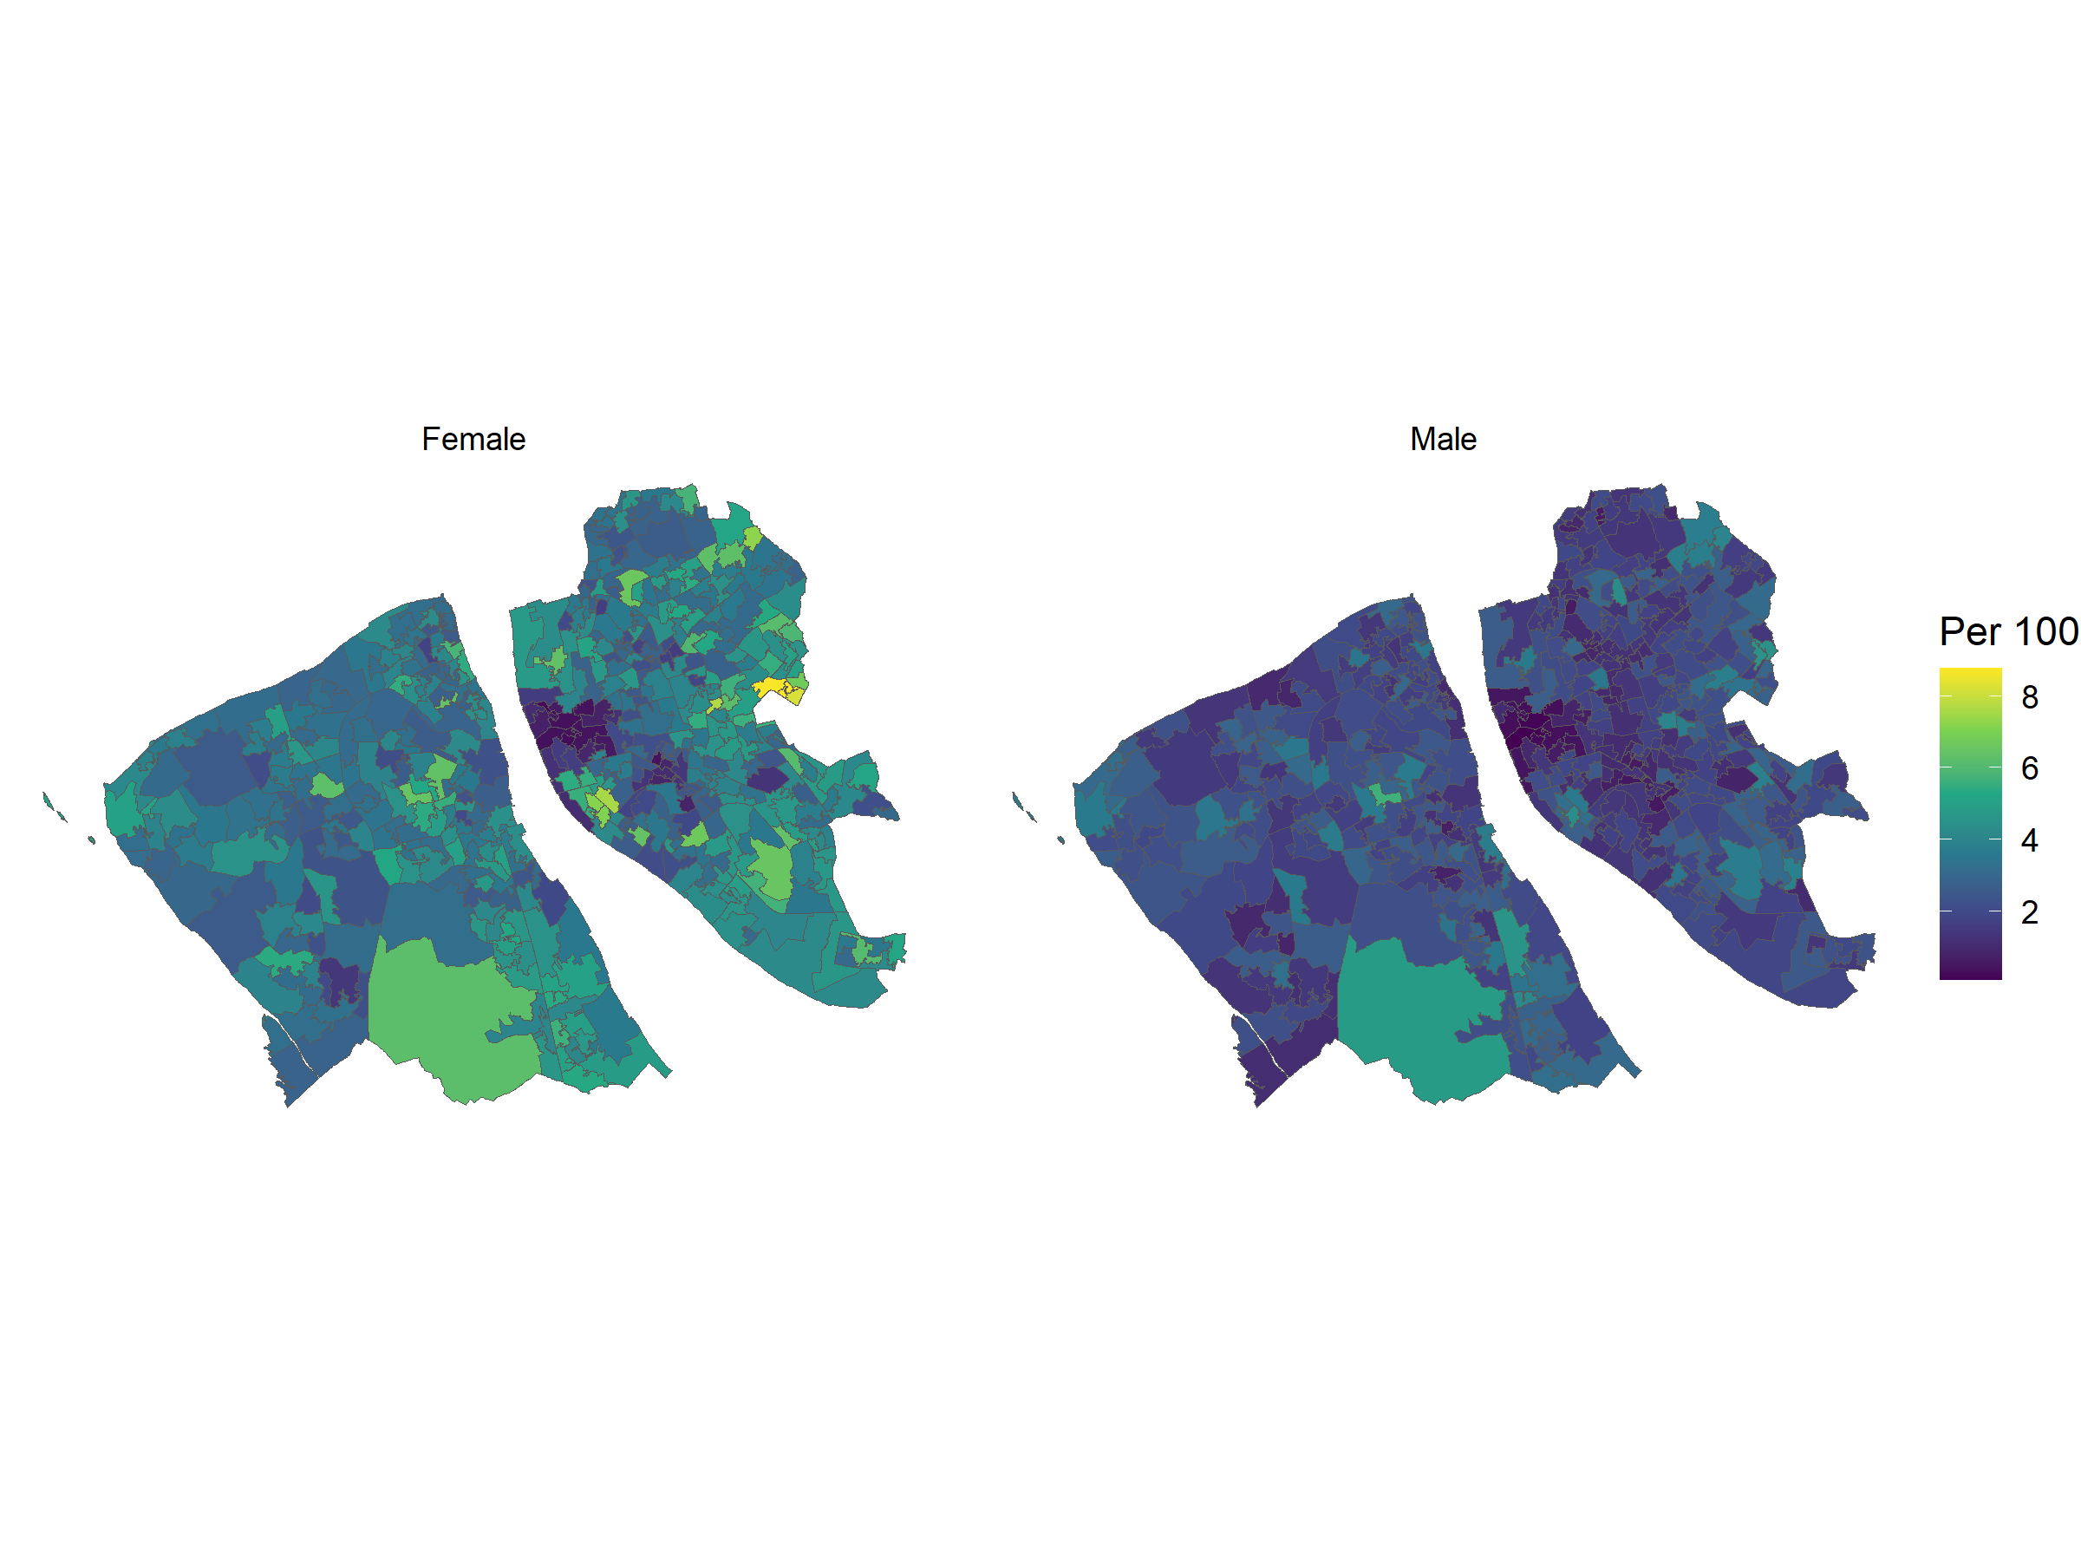

Figure 9 Geographic distribution of carers by LSOA

**Analysis 4**

In this section we report on an attempt to measure the difference in days between a client placing a request for support and a service or plan being put in place. Only those clients who received a service or plan were included in the cohort. The specific categories were ‘Request or contact’ and ‘Service or plan’. This is because the ASC codes were changed within he study period, hence the index date might be based on a client placing a request or making any sort of initial contact with services. The service action following this might include either a service made directly to the client, or else a formalised plan for a programme of services.

One matter we dealt with the possibility a client made multiple attempts to contact ASC, without a direct service response. Hence, the differences in days were found by compiling all Request/Contacts dates, and all Service/Plan dates for each ASC-flagged carer. These were then arranged in date order. The latest Request/Contact date and the then earliest Assessment or Service date were then extracted and the interval in days was calculated.

Figure 10 presents this table arranged by IMD decile and gender. The days are limited to 100. There appears to be no linear relationship between days waited between Request/Contact and Service/Plan relating to levels of deprivation. One outstanding feature is that there is a fair wider range of days waited among males (up to 4325) compared with females (up to 1304). This is perhaps reflective of a low tendency for male carers to follow up their initial request for support (reported in the participatory sessions, described above).

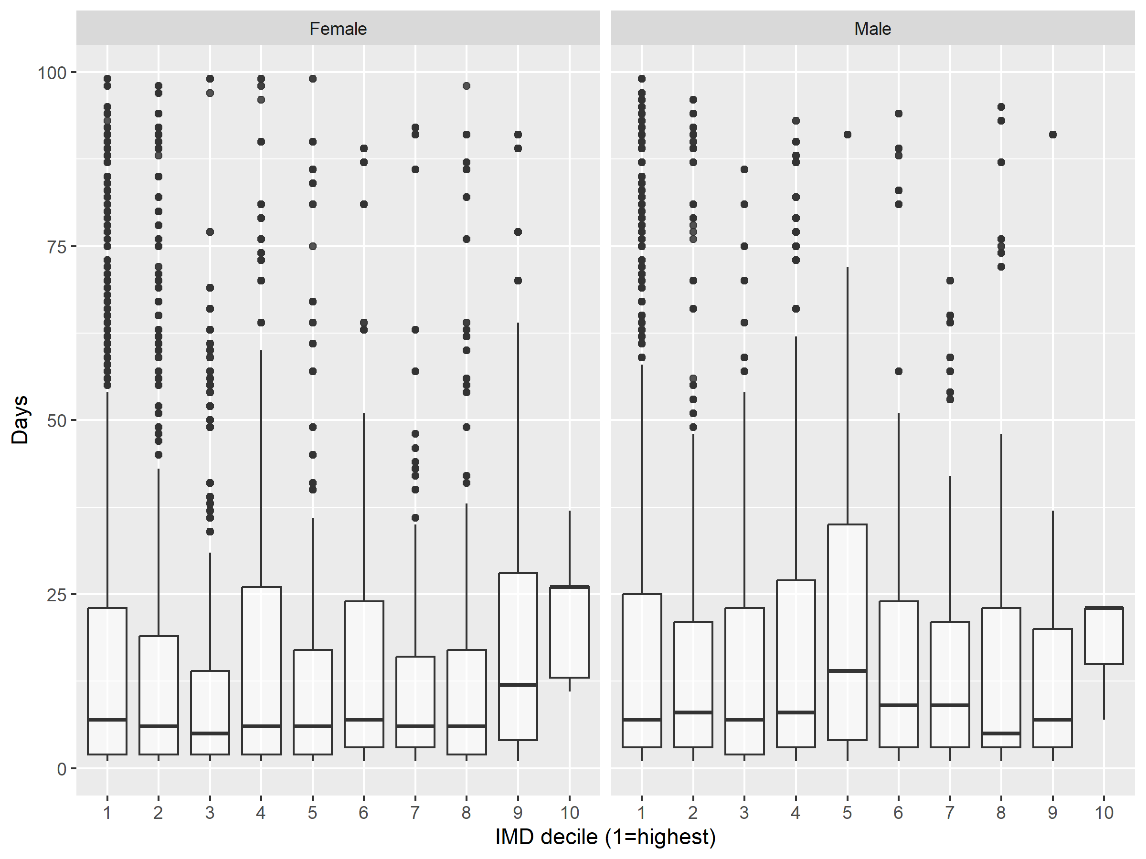

*Figure 10. Days difference IMD and gender*

**Local Analysis**

In this section our research is focused on the characteristics of households in which one or more household members have been designated as carers (although not necessarily to provide care for anyone in that household). We have been able to compare these characteristics of these ‘carer’ households with ‘non-carer’ households, in which no member has been designated a carer. Our aim is to develop a predictive model to distinguish those households that are most likely to include a carer.

Households in the data featured a unique identifier (RALF, a pseudonymised UPRN). Overall, 6.4% of households in the data have a designated carer. However the proportionate distribution of households with carers varies over IMD deciles. The highest proportions are in the lowest-deprivation areas, which have fewer households and a greater proportion of older inhabitants.

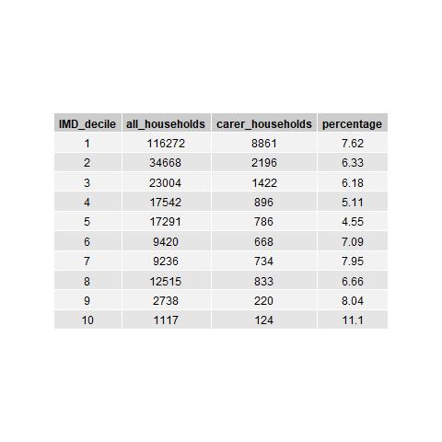

*Table 3. The proportion (%) of households that include   
at least adult carer by IMD decile (1=highest deprivation)*

For each household we flagged members with particular characteristics, such as ‘adult upper middle age’ (i.e. aged 50-64), ‘adult old’ (i.e. aged 60 and over). We were then able to look up combinations of these characteristics by which to define households, for example where a household features one or more upper middle-age adults and one or more old adults, we can designate a ‘multi-generational household’.

**Household composition**

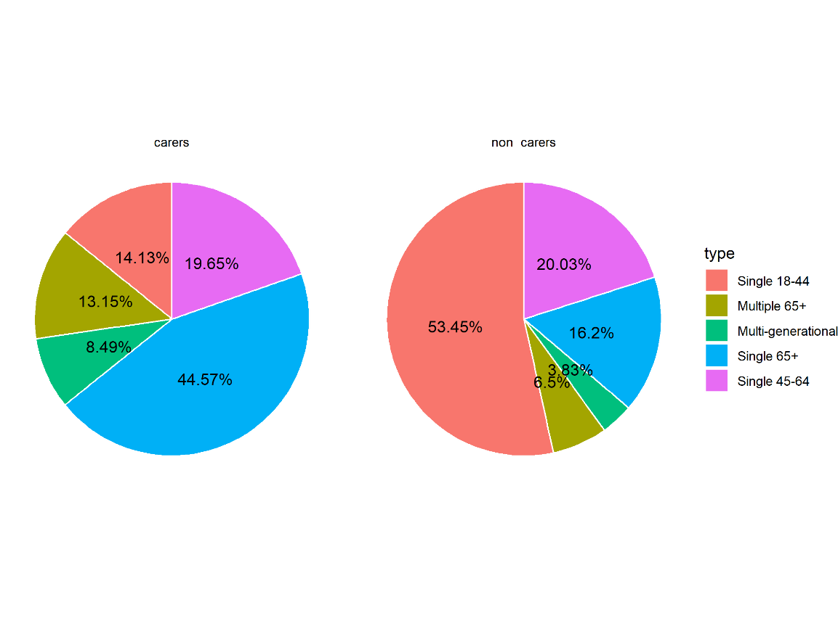

*Figure 11. Carer and non-carer households (%) by composition based on age group*

Figure 11 shows how a greater proportion of ‘carer households’ from the GP+ASC cohort (44% compared to 16%) are singly occupied by an adult aged 65 and over. More households with multiple adults aged 65 and over include at least one carer (13% compared to 6.5%). A major proportion of ‘non-carer households’ (53% compared to 14%) are singly occupied by adults aged 18-44. Among multi-generational households, more have carers than do not (13% compared to 4%).

Numerator: counts of households (with/without designated carers)

Denominator: total households in GP cohort

Table: HF_households_counts_rates.csv

Figure 12 shows carers’ households per 100 total households by any cases of physical health conditions flagged for that household. Rates have been aggregated to IMD deciles. Physical disability is recorded in around 40 per 100 households in each decile. COPD is also evenly distributed at around 12 per 100 households. A higher rate of CVD is recorded in households in low-deprivation areas, which possibly reflects greater longevity among those populations.

A linear trend is found for frailty or dementia, with the rate increasing for each decile, from around 23 per 100 households in decile 1 (highest deprivation) to around 33 per 100 households in decile 10 (lowest deprivation). This trend also possibly reflects greater longevity among populations in low-deprivation areas, and perhaps also a tendency for those with these conditions to be cared for at home.

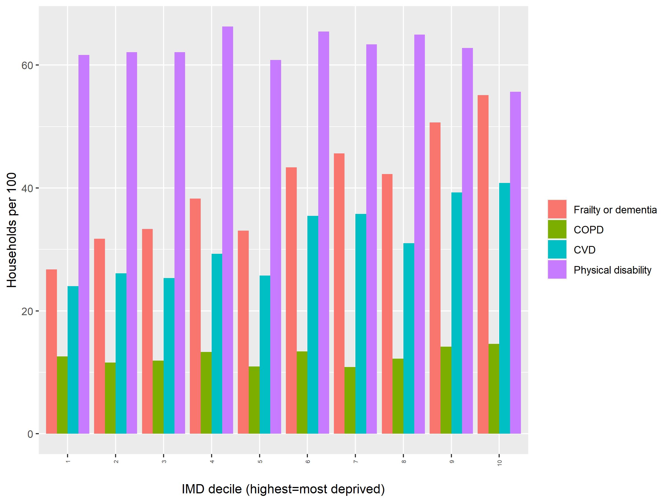

*Figure 12. Rate of carers’ households by physical health conditions per IMD decile*

Table: households_PH_conditions_IMD.csv

Numerator: Households in which a carer is designated (GP+ASC) and there are physical health conditions flagged

Denominator: Total carers’ households per IMD decile

*Predictive model*

In order to estimate those household characteristics that best predict the outcome of an adult becoming a carer, we fitted a set of effects to a General Linear Mixed Model (GLMM; Figure 13). The model results in a log odds output, to show which effects are likely to impact on becoming a carer (see Figure 14).

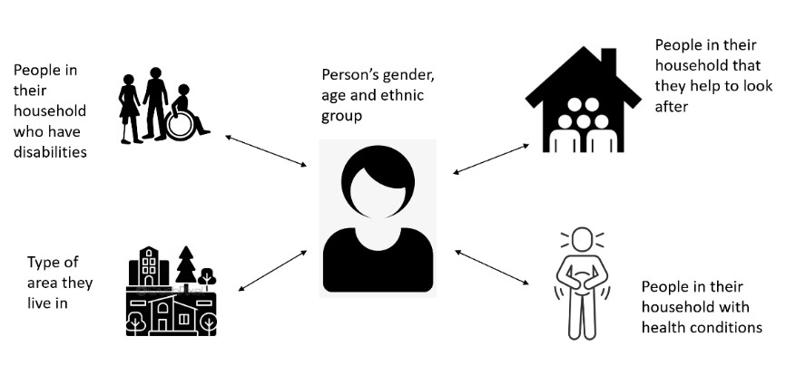

*Figure 13. The contextual interactions that might be associated with a person becoming a carer*

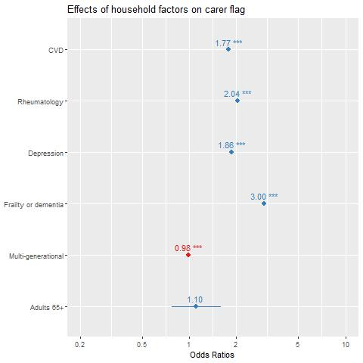

*Figure 14. GLMM of factors associated with being a carer*

Figure 14 represents predictive outputs of the GLMM. This predicts those effects (as physical or mental health conditions) present in households with at least 2 members that are most associated with an adult in that household becoming a carer. In this test output, the presence of at least one adults with frailty or dementia, depression, or a rheumatological conditions appear to be most associated with an adult household member becoming a carer. Household composition (i.e. multi-generational households or multiple inhabitants aged 65 and over), are weakly associated with becoming a carer.

Table: households_model_coeffs.csv

**SUMMARY**

ONS Census 2021 revealed that around 9% of people (aged 5 and over) in England and Wales are carers. Liverpool and Wirral GP and ASC cohorts counts are broadly in line with the ONS gross figure, albeit these are distributed unevenly across age groups.

The likelihood of becoming a carer is influenced by gender, age group and deprivation. BAME carers appear to be under represented in the cohorts, given the overall worse health outcomes among these groups when compared to their White peers. Females are more likely to be cares than their male peers, although this trend is not strong. Age group is, among both males and females of all ethnic groups, strongly associated with being a carer. For example around 3-5% of those aged 70-79, and 10-15% of those aged 80 and over are carers.

The study revealed a year-on-year increase in the incidence of new cares, and in the prevalence of carers with any kind of event during the period 2016-2021. These increases were typically around <1% for most age groups, but up to 3% among those aged 80 and over.

Some areas of Liverpool and Wirral have greater concentrations of carers per capita. These include inner suburbs close the Liverpool’s city centre, and outer suburbs to the city’s affluent south. In Wirral, there appears to be a concentration of carers in the borough’s south, with affluent, older populations.

Carers typically experience delays or 70-150 days from their initial request for support to social services providing a service or plan. Carers aged 59 and below typically wait longer than those aged 60 and above, especially males in their thirties and forties who can wait 30-50% longer than males aged 80 an over.

Carers deal with a range of physical and mental health conditions in their households. These include age-related long-term conditions including CVD and COPD, as well as physical and learning disabilities. Typically 50-60% of all carers’ household have a member with a physical disability (which might also affect the carer personally). This high proportion might be a result of selectivity in the cohort. For example, individuals might attend a GP appointment due to strain or injury resulting from their caring role. Individuals who have caring roles are likely to attend a GP appointment only after that role has affected their health.

**STRENGTHS AND WEAKNESS**

Strengths of the data included the linkage of individuals to GP and ASC records by a unique identifier, and to their households, supporting fine-grain, bottom-up aggregation. Linking individuals to their households also had the potential to analyse those factors most associated with a caring role in that context. A problem here is that we do not know how directly those contextual factors impact on the individual. We also have to assume that the carer is providing care for someone within the household. The data would be improved if GP or ASC were to record systematically who was receiving the care, and the point at which care was ceased.

Another strength was including participatory activities in our research design. However, the input of people with caring experience did serve to highlight difficulties in identifying individuals with caring role, as it is clear that many will not self-refer on this basis alone.

Weaknesses of the data including a lack of linkage between carers and those they care for. An apparently partial list of carers and cared-for was made available for analysis. However, this list was incomplete and not representative of the general carer population. A major limitation in analysing carer data is the fact that carers are not de-registered by the GP from their role. This means we do not know whether the caring role continued after a certain point. Another limitation is that carers might be self-selecting for other heath matters. For example, the attend a GP appointment due to, for example, an injury resulting from lifting someone. There is no reliable mechanism by which those with caring roles become known to services.

A major limitation was the lack of integration between Wirral and Liverpool datasets. A key weakness is in the lack of event data for Wirral, meaning that time analysis was not possible for this cohort.

**DISCUSSION**

Our engagement with carers and with local authority officers has helped to design analysis so that it can feed into local carer support strategies. We were also able to consider some factors that mean people with caring responsibilities in certain groups are less likely to gain or seek support for their role. Some aspects of ethnicity might play a part in this difference, for example where support is provided in the mother language, or else where care is provided through family or community networks.

Hence, while rates for carers are broadly similar among ethnic groups, this implies a short-fall in designated (therefore supported) unpaid carers in contexts where we would expect worse health outcomes, such as BAME households.

A key outcome from our public engagement is in the understanding that not all people with caring responsibilities seek out or secure formal designation as a ‘carer’. The ‘normality’ of caring roles means unpaid carers are supported through family or community networks, rather than through health or social services.

Each stage of the analysis presented in this report has contributed to a profile of carers in Liverpool and Wirral by gender, age group, ethnic group and socio-economic status. Females are more likely than males to be designated as a carer, with higher rates among those aged 70 and over. We also found a linear relationship among carers in younger age groups and IMD decile; for example, with higher rates among 18-29 year-olds in high-deprivation areas.

The linkage between individuals and households has been critical in developing a fine-grain model of contextual factors that might be associated with becoming a carer. These naturally include long-term conditions being present in the household, not least frailty or dementia. However, other more complex relationships may impact on becoming a carer, which we aim to explore through General Linear Mixed Model (GLMM) methods.

The GLMMs we fitted in the study revealed how prevalent conditions of CVD, depressions and frailty or dementia, where present in a household, were highly associated with becoming a carer.

**REFERENCES**

Carers Week (2022) Making Care Visible, Valued and Supported. Available via: [carers-week-2022-make-caring-visible-valued-and-supported-report_final.pdf (carersweek.org)](https://www.carersweek.org/media/qf0p5u4t/carers-week-2022-make-caring-visible-valued-and-supported-report_final.pdf) [Accessed 7th March 2023]

Carers UK (2019) Juggling work and unpaid care: A growing issue. Available via: Juggling_work_and_unpaid_care_report_final_0119_WEB_1 (1).pdf [Accessed 7th March 2023]

Horne J, Kentzer N, Smith L, Trott M, Vseteckova J. (2021( A Systematic Review on the Prevalence of Physical Activity, and Barriers and Facilitators to Physical Activity, in Informal Carers in the United Kingdom. *Journal of Physical Activity and Health*. 2021 Feb 1; 18(2): 212-218.

Raleigh V. and Holmes J. (2021) ‘The health of people from ethnic minority groups in England’. The King’s Fund, 2021.

Liverpool City Council (2022) Liverpool’s Integrated All-Age Carers Strategy: Creating a Carer Friendly City 2019-2024. Available via: <https://liverpool.gov.uk/media/1357617/final-carers-strategy-plan-on-a-page.pdf> [Accessed 7th March 2023]

Petrillo, M., Bennett, M.R., and Pryce, G. (2022) Cycles of caring: transitions in and out of unpaid care. London: Carers UK. Available via: [CUK-Carers-Rights-Day-Research-Report-2022-Web.pdf (centreforcare.ac.uk)](https://centreforcare.ac.uk/wp-content/uploads/2022/11/CUK-Carers-Rights-Day-Research-Report-2022-Web.pdf) [Accessed 7th March 2023]

Public Health England (2021) Caring as a social determinant of health Findings from a rapid review of reviews and analysis of the GP Patient Survey: Report and key findings. Available via: [Caring as a social determinant of health (publishing.service.gov.uk)](https://assets.publishing.service.gov.uk/government/uploads/system/uploads/attachment_data/file/971115/Caring_as_a_social_determinant_report.pdf) [Accessed 7th March 2023]

Wirral Borough Council (2013) Caring for our Carers Wirral’s Strategy For Carers 2014-17 . Available via: [Carers Strategy Final 2013 (wirral.gov.uk)](https://www.wirral.gov.uk/media/11748/download?inline) [Accessed 7th March 2023]

Wirral Borough Council (2022) An update on carers services and development of the adults carers strategy. Available via: <https://democracy.wirral.gov.uk/documents/s50091974/Carers%20Services%20and%20Strategy%20Review.pdf> [Accessed 7th March 2023]

Wirral Intelligence Service (2018) Wirral Joint Strategic Needs Assessment (JSNA): Carers. Available via: [Wirral JSNA: Carers (wirralintelligenceservice.org)](https://www.wirralintelligenceservice.org/media/2455/jsna-carers-final-june-2018.pdf) [Accessed 7th March 2023]

**APPENDIX 1**

**DATA SOURCES**

**NHS**

* Primary care data
* Secondary care data (SUS)
* MHDS
* CSDS

**LA Adult Social Care**

* Adults using social care services
* People assessed for carers support
* Contact with carer services
* Linked carers and those they care for

**Open data – linked to LSOAs**

* Index of Multiple Deprivations  
  Available via: <https://www.gov.uk/government/statistics/english-indices-of-deprivation-2019>

**APPENDIX 1**

SNOMED codes used in the study

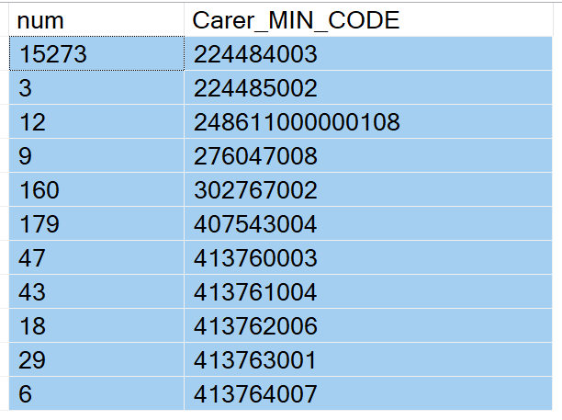

**APPENDIX 2**

Column headers

Cohorts counts/rates

age_group = age group in which individual first registered as a carer

carer_count = cohort totals

carer_rate = carer_count*100/total GP population

total = ONS population estimate (by category) for the year being counted

Household analysis

sum_old_single = n households with individual age 65+ living alone

sum_single_with_deceased = n households with individual age 65+ living alone, and had been living with individual who died during study period

sum_mult_old = n households with two or more individuals aged 65+ living in same household

sum_LowMid_single = n households with indivuduals aged 18-45 living alone

sum_UppMid_single = n households with indivuduals aged 46-64 living alone

sum_multi_gen = n households with at least one person from each age group (lowMidd, uppMid, adult_old) sharing a household

sum_all_White = n households with all indivisuals are White

sum_WhiteMixed = n households with all indivisuals are White or Mixed

sum_all_Asian - = n households with all indivisuals are Asian or Asian British

sum_all_Black = n households with all indivisuals are Black or Black British

sum_all_Mixed = n households with all indivisuals are Mixed

pc_ = counts (as above)*100/total households

Time analysis

diff = means days by gender, age group (individual became a carer) and IMD decile between Request or Contact being made, and Service or Plan being introduced

1. [Local NHS Trusts launch Carers Passport | Healthwatch Liverpool](https://healthwatchliverpool.co.uk/news/2021-11-25/local-nhs-trusts-launch-carers-passport)
2.
3. The ‘Peace of Mind’ project: [Helping carers plan for the future - The Brain Charity](https://www.thebraincharity.org.uk/service/peaceofmind/)