October 11, 2016

To Whom It May Concern:

I am writing this letter as a formal acknowledgment that I give my permission, as owner of the house at 2415 E. Camino La Zorrela, for Keegan Gallagher and her family to have a dog over 25 lbs live in the house.

Please let me know if you need more information from me.

Sincerely,
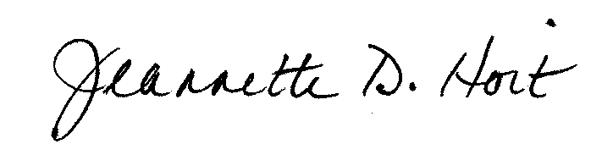

Jeannette D. Hoit

