1. Overview
This report presents the results of a benchmarking exercise conducted on the LLM Inference Server built for Milestone 5. The server implements dynamic request batching and an in-process LRU response cache, both designed to improve throughput and reduce per-request cost. All tests were run on a MacBook Air using the CPU-only tiny-GPT2 model (0.1 M parameters). The goal of this report is to quantify the performance impact of each optimization and identify trade-offs.

Summary metrics
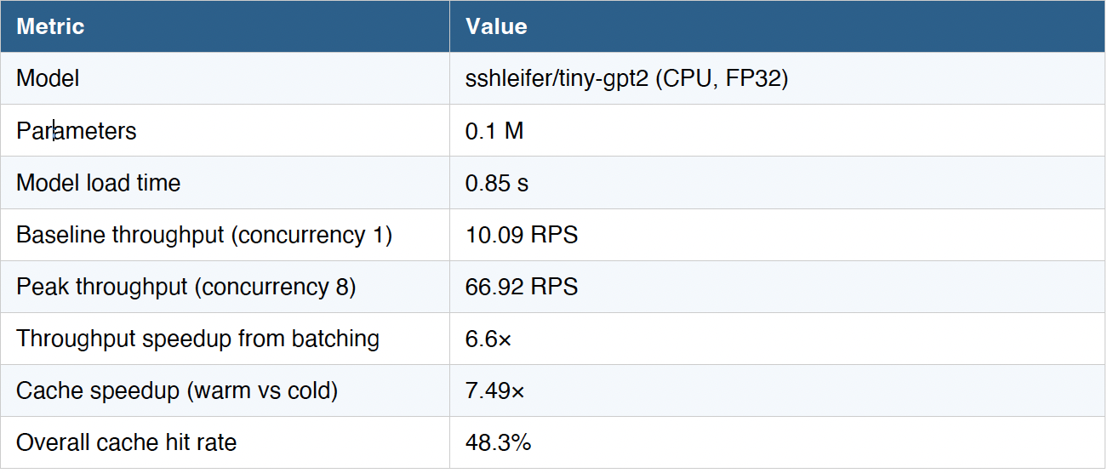

2. Dynamic Request Batching
The batcher groups concurrent requests before dispatching them to the model, so the cost of loading model weights is shared across multiple outputs. Two triggers control batch dispatch: a size threshold (max 8 requests) and a timeout (50 ms). At concurrency 1, every request forms its own batch of 1, yielding 10.1 RPS. At concurrency 8, the batcher consistently fills batches of 7–8, pushing throughput to 66.92 RPS, a 6.6× improvement over the sequential baseline.

Batch Breakdown
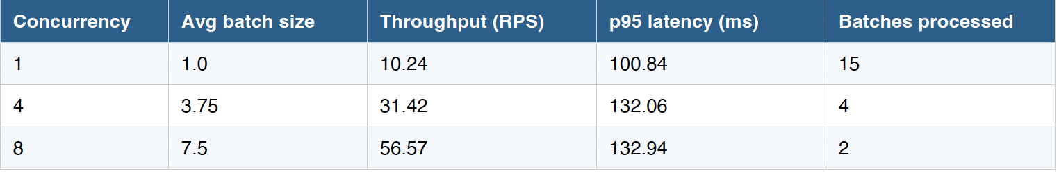

3.Response Catching
The server maintains an in-process LRU cache keyed on a SHA-256 hash of the prompt, model name, temperature, and token limit. Only deterministic (temperature = 0) requests are cached. Entries expire after one hour (TTL = 3 600 s), and the cache holds up to 10 000 entries before LRU eviction kicks in. A fully warm cache delivers a mean latency of 7.69 ms compared to 57.6 ms for a cold miss, a 7.49× speedup. This is because a cache hit requires only a dictionary lookup and SHA-256 hash, bypassing the model entirely. Across the full benchmark run the server recorded 58 hits out of 120 requests, a hit rate of 48.3%.

4. Trade-off Analysis
Batching and caching address different bottlenecks and their benefits compound when combined. The table below summarizes the key trade-offs observed in this benchmark.
One notable observation is that per-request latency increases modestly with batching (from ~98 ms to ~125 ms at p95) because requests must wait up to 50 ms for the batch to fill. For latency-critical workloads the timeout could be reduced to 20 ms, accepting a slightly lower average batch size in exchange for faster first-response time. For throughput-focused workloads, increasing max_batch_size to 16 and the timeout to 100 ms would push RPS higher still, though GPU memory constraints apply at scale.

