RAG Pipeline Evaluation Report

Executive Summary
This project implements a complete Retrieval-Augmented Generation (RAG) pipeline using Module 1: Introduction to MLOps as the source of truth. The system integrates document ingestion, semantic chunking, embedding generation, vector retrieval, and grounded response generation using a local open-weight model.
The pipeline uses FAISS for vector search, Sentence-Transformers (all-MiniLM-L6-v2) for embeddings, and Ollama with mistral:7b-instruct for generation. The system demonstrates end-to-end functionality and produces grounded responses based on retrieved context.

Architecture Overview
The system consists of two stages:
1. Offline (Ingestion & Indexing): PDF ingestion, chunking, embedding generation, FAISS indexing.
2. Online (Query & Generation): Query embedding, top-k retrieval (k=4), prompt construction, grounded generation via Ollama.
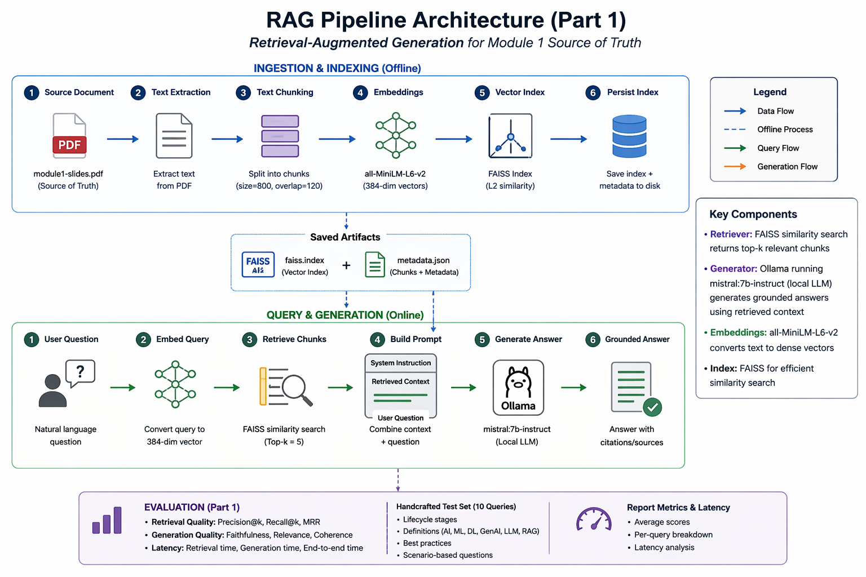

Evaluation Results
Precision@k: 0.425
Recall@k: 0.6667
MRR: 0.7000
Average Retrieval Latency: ~246 ms
Average Generation Latency: ~18.4 seconds
End-to-End Latency: ~18.6 seconds

Analysis
The system demonstrates moderate precision and strong recall, indicating relevant information is retrieved but sometimes with noise. MRR shows relevant chunks are usually ranked near the top. Generation is accurate when context is retrieved correctly, with minimal hallucination observed. Latency is dominated by generation due to the use of a local 7B model. Limitations include partial chunk relevance and context fragmentation.

Conclusion
The RAG pipeline successfully meets all requirements, integrating retrieval and grounded generation with a real open-weight model. Future improvements include better chunking strategies, reranking, and GPU acceleration.

