WEB TECHNOLOGIES LAB
(Course Code: 23UPCSC1L07)
A Programming Laboratory Record submitted to Periyar University, Salem
In partial fulfilment of the requirements for the degree of
MASTER OF COMPUTER APPLICATIONS
By
G. GOWTHAM
[Reg. No: ____________________]
DEPARTMENT OF COMPUTER SCIENCE
PERIYAR UNIVERSITY
STATE UNIVERSITY - NAAC 'A++' GRADE
SALEM - 636 011.
(OCTOBER - 2026)

CERTIFICATE
This is to certify that the Programming Laboratory entitled “WEB TECHNOLOGIES LAB (23UPCSC1L07)” is a bonafide record work done by Mr. G. Gowtham (Register No: ____________________) as partial fulfilment of the requirements for the degree of Master of Computer Applications, in the Department of Computer Science, Periyar University, Salem, during the Academic Year 2026-2027.

Staff In-charge | Head of the Department

Submitted for the practical examination held on: ____________________

Internal Examiner | External Examiner

CONTENTS
S.NO | DATE | TITLE OF THE PROGRAM | PAGE NO | SIGNATURE
1. |  | Educational Details in a Tabular Format
2. |  | Display CV on a Web Page
3. |  | Design a Home Page having three links: About Us, Our Services, and Contact Us
4. |  | Usage of Inline, Internal and External CSS
5. |  | XML Document and Style Sheet in CSS
6. |  | Create Image Maps
7. |  | Input Validation Using AngularJS
8. |  | PHP to Fetch Details from the Database
9. |  | Hide Paragraph using jQuery
10. |  | JavaScript to Handle Mouse Events and Form Events

SOURCE CODE:
index.html
<!DOCTYPE html>
<html lang="en">
<head>
<meta charset="UTF-8">
<meta name="viewport" content="width=device-width, initial-scale=1.0">
<title>Gowtham - Educational Details</title>
<style>
body {
font-family: Arial, sans-serif;
margin: 0;
background: #f5f7fb;
color: #222;
}
header {
background: #4f46e5;
color: #fff;
text-align: center;
padding: 24px;
}
.wrap {
width: min(1100px, 92%);
margin: 35px auto;
}
table {
width: 100%;
border-collapse: collapse;
background: #fff;
box-shadow: 0 8px 25px rgba(0, 0, 0, .08);
}
th,
td {
padding: 14px;
border: 1px solid #ddd;
text-align: center;
}
th {
background: #16a085;
color: #fff;
}
tr:nth-child(even) {
background: #f8fafc;
}
footer {
text-align: center;
background: #111827;
color: #fff;
padding: 15px;
margin-top: 40px;
}
</style>
</head>
<body>
<header>
<h1>My Educational Details</h1>
<p>G. Gowtham</p>
</header>
<div class="wrap">
<table>
<tr>
<th>Qualification</th>
<th>Institution</th>
<th>Board / University</th>
<th>Percentage / Status</th>
<th>Start Year</th>
<th>End Year</th>
</tr>
<tr>
<td>SSLC</td>
<td>Government Higher Secondary School, Chinnapillaiyur</td>
<td>State Board</td>
<td>78%</td>
<td>2019</td>
<td>2020</td>
</tr>
<tr>
<td>HSC</td>
<td>Government Higher Secondary School, Chinnapillaiyur</td>
<td>State Board</td>
<td>73%</td>
<td>2020</td>
<td>2022</td>
</tr>
<tr>
<td>BCA</td>
<td>AVS Arts &amp; Science College, Omalur</td>
<td>Periyar University</td>
<td>75%</td>
<td>2022</td>
<td>2025</td>
</tr>
<tr>
<td>MCA</td>
<td>Periyar University, Salem</td>
<td>Periyar University</td>
<td>Pursuing</td>
<td>2025</td>
<td>2027</td>
</tr>
</table>
</div>
<footer>
© 2026 G. Gowtham | Web Technologies Lab
</footer>
</body>
</html>

OUTPUT:

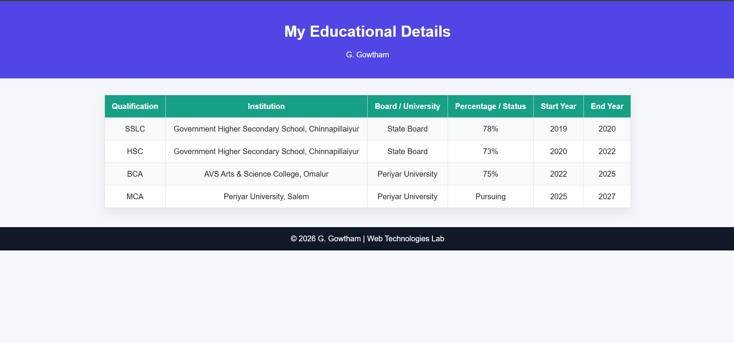

SOURCE CODE:
index.html
<!DOCTYPE html>
<html lang="en">
<head>
<meta charset="UTF-8">
<meta name="viewport" content="width=device-width, initial-scale=1.0">
<title>Gowtham CV</title>
<style>
* {
box-sizing: border-box;
}
body {
margin: 0;
font-family: Arial, sans-serif;
background: #eef2ff;
color: #1f2937;
}
.cv {
max-width: 1100px;
margin: 30px auto;
background: #fff;
display: grid;
grid-template-columns: 1fr 1.4fr;
box-shadow: 0 12px 35px rgba(0, 0, 0, .12);
}
.left {
padding: 34px;
background: #111827;
color: #fff;
}
.right {
padding: 34px;
}
img {
width: 110px;
height: 110px;
border-radius: 50%;
background: #4f46e5;
display: grid;
place-items: center;
font-size: 34px;
font-weight: bold;
margin-bottom: 18px;
}
h1,
h2,
h3 {
margin-top: 0;
}
.tag {
color: #c7d2fe;
}
.section {
margin-top: 28px;
}
.skill {
display: inline-block;
background: #eef2ff;
color: #3730a3;
padding: 7px 11px;
border-radius: 20px;
margin: 4px;
}
a {
color: #a5b4fc;
}
.right h2 {
border-bottom: 3px solid #4f46e5;
padding-bottom: 6px;
color: #312e81;
}
.item {
margin-bottom: 18px;
}
</style>
</head>
<body>
<div class="cv">
<aside class="left">
<img src="my-photo.png">
<p>Hello, I am</p>
<h1>G. Gowtham</h1>
<h3 class="tag">Full-Stack Web Developer</h3>
<div class="section">
<h2>About Me</h2>
<p>
MCA candidate with practical experience in building responsive,
database-driven and production-oriented web applications using
modern full-stack technologies.
</p>
</div>
<div class="section">
<h2>Contact</h2>
<p>📍 Salem, Tamil Nadu</p>
<p>📞 +91 9344232465</p>
<p>✉ itsgowtham.dev@gmail.com</p>
<p>
GitHub:
<a href="https://github.com/HG12265">
github.com/HG12265
</a>
</p>

<p>
Portfolio:
<a href="https://itsgowtham.vercel.app">
itsgowtham.vercel.app
</a>
</p>
</div>
</aside>
<main class="right">
<h2>Education</h2>
<div class="item">
<strong>2025–2027 | Periyar University, Salem</strong>
<br>
Master of Computer Applications (MCA) — Pursuing
</div>
<div class="item">
<strong>2022–2025 | AVS Arts &amp; Science College, Omalur</strong>
<br>
Bachelor of Computer Applications (BCA) — 75%
</div>
<h2>Experience</h2>
<div class="item">
<strong>Full Stack Development Intern — Tech S Cube | June 2026</strong>
<br>
Worked on an online compiler project covering frontend, backend,
workflow and compiler-functionality integration.
</div>
<div class="item">
<strong>Web Development Intern — Optimus Technocrats (India) | Dec 2023</strong>
<br>
Completed a 15-day internship involving practical web-development
project work.
</div>
<h2>Projects</h2>
<div class="item">
<strong>Periyar University Academic Portal</strong>
— Next.js, Node.js, Express.js, MySQL
</div>
<div class="item">
<strong>PG Entrance Examination Portal</strong>
— React.js, FastAPI, MySQL
</div>
<div class="item">
<strong>Ph.D. Entrance Examination Portal</strong>
— React.js, FastAPI, MySQL
</div>
<div class="item">
<strong>Mentor-Mentee Management System</strong>
— React.js, Node.js, Express.js, MySQL
</div>
<h2>Skills</h2>
<span class="skill">Python</span>
<span class="skill">React.js</span>
<span class="skill">HTML</span>
<span class="skill">CSS</span>
<span class="skill">Node.js</span>
<span class="skill">Express.js</span>
<span class="skill">REST APIs</span>
<span class="skill">MySQL</span>
<span class="skill">MongoDB</span>
<span class="skill">Git</span>
<span class="skill">GitHub</span>
<span class="skill">Docker</span>
<span class="skill">cPanel</span>
</main>
</div>
</body>
</html>

OUTPUT:

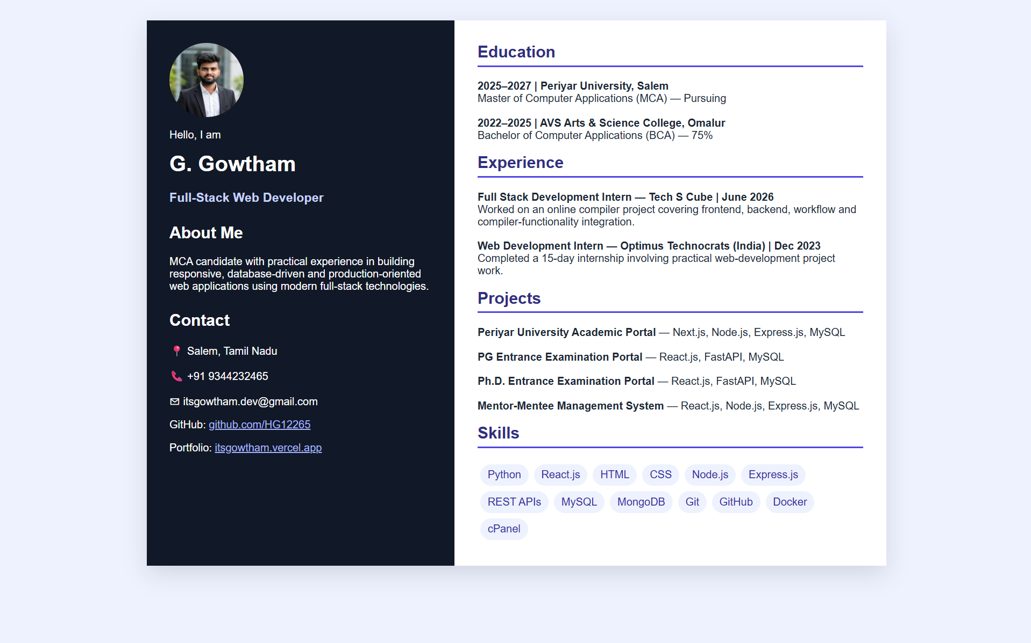

SOURCE CODE:
index.html
<!DOCTYPE html>
<html lang="en">
<head>
<meta charset="UTF-8">
<meta name="viewport" content="width=device-width, initial-scale=1.0">
<title>Gowtham Portfolio</title>
<link rel="stylesheet" href="styles.css">
</head>
<body>
<header>
<h1>Gowtham.dev</h1>
<nav>
<a href="index.html">Home</a>
<a href="about.html">About Us</a>
<a href="services.html">Our Services</a>
<a href="contact.html">Contact Us</a>
</nav>
</header>
<section class="hero">
<h2>Welcome to My Website</h2>
<p>
I am G. Gowtham, an MCA student and full-stack web developer interested in
software engineering, backend development, and database-driven web applications.
</p>
</section>
<div class="container">
<h2>Web Development</h2>
<div class="cards">
<div class="card">
<h3>Frontend Development</h3>
<p>HTML, CSS and React.js for responsive interfaces.</p>
</div>
<div class="card">
<h3>Backend Development</h3>
<p>Node.js, Express.js and Python FastAPI for APIs and application logic.</p>
</div>
<div class="card">
<h3>Database</h3>
<p>MySQL and MongoDB for reliable application data storage.</p>
</div>
</div>
</div>
<footer>
© 2026 G. Gowtham
</footer>
</body>
</html>
about.html
<!DOCTYPE html>
<html lang="en">
<head>
<meta charset="UTF-8">
<meta name="viewport" content="width=device-width, initial-scale=1.0">
<title>About Gowtham</title>
<link rel="stylesheet" href="styles.css">
</head>
<body>
<header>
<h1>Gowtham.dev</h1>
<nav>
<a href="index.html">Home</a>
<a href="about.html">About Us</a>
<a href="services.html">Our Services</a>
<a href="contact.html">Contact Us</a>
</nav>
</header>
<div class="container">
<h1>About Me</h1>
<div class="card">
<h2>Hello, I am G. Gowtham</h2>
<p>
I am pursuing MCA at Periyar University, Salem. I have practical experience
in full-stack development and have built academic portals, online examination
systems and mentoring applications.
</p>
<p>
My interests include full-stack web development, software engineering,
backend development and database-driven applications.
</p>
</div>
</div>
<footer>
© 2026 G. Gowtham
</footer>
</body>
</html>
services.html
<!DOCTYPE html>
<html lang="en">
<head>
<meta charset="UTF-8">
<meta name="viewport" content="width=device-width, initial-scale=1.0">
<title>Services</title>
<link rel="stylesheet" href="styles.css">
</head>
<body>
<header>
<h1>Gowtham.dev</h1>
<nav>
<a href="index.html">Home</a>
<a href="about.html">About Us</a>
<a href="services.html">Our Services</a>
<a href="contact.html">Contact Us</a>
</nav>
</header>
<div class="container">
<h1>Our Services</h1>
<div class="cards">
<div class="card">
<h3>Responsive Web Design</h3>
<p>Clean and responsive interfaces using HTML, CSS and React.js.</p>
</div>
<div class="card">
<h3>Backend API Development</h3>
<p>RESTful APIs using Node.js, Express.js and FastAPI.</p>
</div>
<div class="card">
<h3>Database Integration</h3>
<p>MySQL and MongoDB integration for data-driven applications.</p>
</div>
<div class="card">
<h3>Deployment Support</h3>
<p>Git, GitHub, Docker and cPanel based deployment workflows.</p>
</div>
</div>
</div>
<footer>
© 2026 G. Gowtham
</footer>
</body>
</html>
contact.html
<!DOCTYPE html>
<html lang="en">
<head>
<meta charset="UTF-8">
<meta name="viewport" content="width=device-width, initial-scale=1.0">
<title>Contact</title>
<link rel="stylesheet" href="styles.css">
</head>
<body>
<header>
<h1>Gowtham.dev</h1>
<nav>
<a href="index.html">Home</a>
<a href="about.html">About Us</a>
<a href="services.html">Our Services</a>
<a href="contact.html">Contact Us</a>
</nav>
</header>
<div class="container">
<h1>Contact Us</h1>
<div class="cards">
<div class="card">
<form>
<input type="text" placeholder="Your Name" required>
<input type="email" placeholder="Your Email" required>
<textarea rows="5" placeholder="Your Message"></textarea>
<button type="submit">Send Message</button>
</form>
</div>
<div class="card">
<h3>Get in Touch</h3>
<p>G. Gowtham</p>
<p>Salem, Tamil Nadu</p>
<p>+91 9344232465</p>
<p>itsgowtham.dev@gmail.com</p>
<p>github.com/HG12265</p>
</div>
</div>
</div>
<footer>
© 2026 G. Gowtham
</footer>
</body>
</html>
styles.css
* {
box-sizing: border-box;
}
body {
margin: 0;
font-family: Arial, sans-serif;
color: #172033;
background: #f8fafc;
}
header {
background: #0f172a;
color: #fff;
padding: 22px 6%;
display: flex;
justify-content: space-between;
align-items: center;
}
header h1 {
margin: 0;
font-size: 24px;
}
nav a {
color: #fff;
text-decoration: none;
margin-left: 22px;
font-weight: bold;
}
.hero {
padding: 70px 8%;
background: linear-gradient(135deg, #eef2ff, #ecfeff);
}
.hero h2 {
font-size: 42px;
margin: 0 0 10px;
}
.hero p {
max-width: 760px;
line-height: 1.7;
}
.container {
width: min(1050px, 88%);
margin: 40px auto;
}
.cards {
display: grid;
grid-template-columns: repeat(auto-fit, minmax(220px, 1fr));
gap: 20px;
}
.card {
background: #fff;
padding: 22px;
border-radius: 14px;
box-shadow: 0 8px 25px rgba(0, 0, 0, .08);
}
form {
display: grid;
gap: 12px;
max-width: 560px;
}
input,
textarea,
button {
padding: 12px;
font: inherit;
}
button {
background: #4f46e5;
color: #fff;
border: 0;
border-radius: 8px;
cursor: pointer;
}
footer {
text-align: center;
background: #0f172a;
color: #fff;
padding: 18px;
margin-top: 50px;
}

OUTPUT:
Home Page
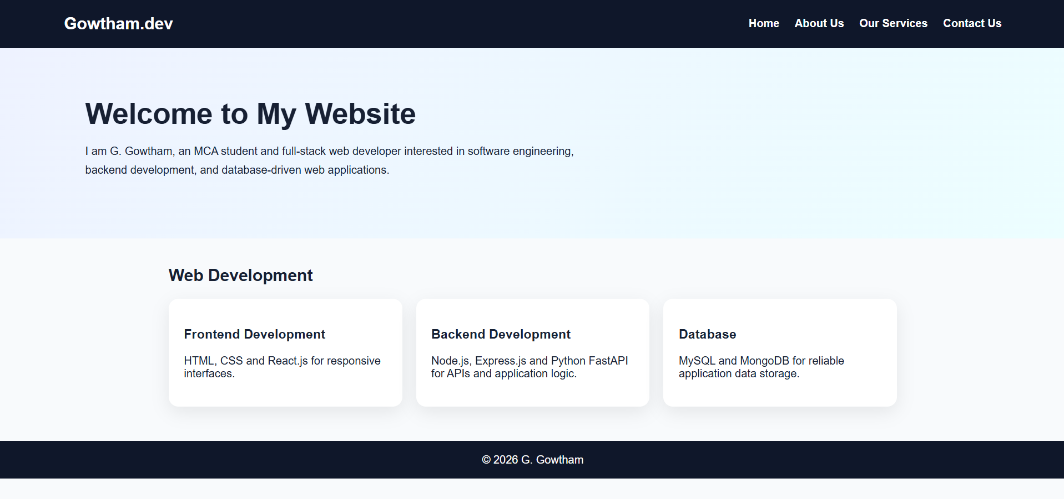
About Us
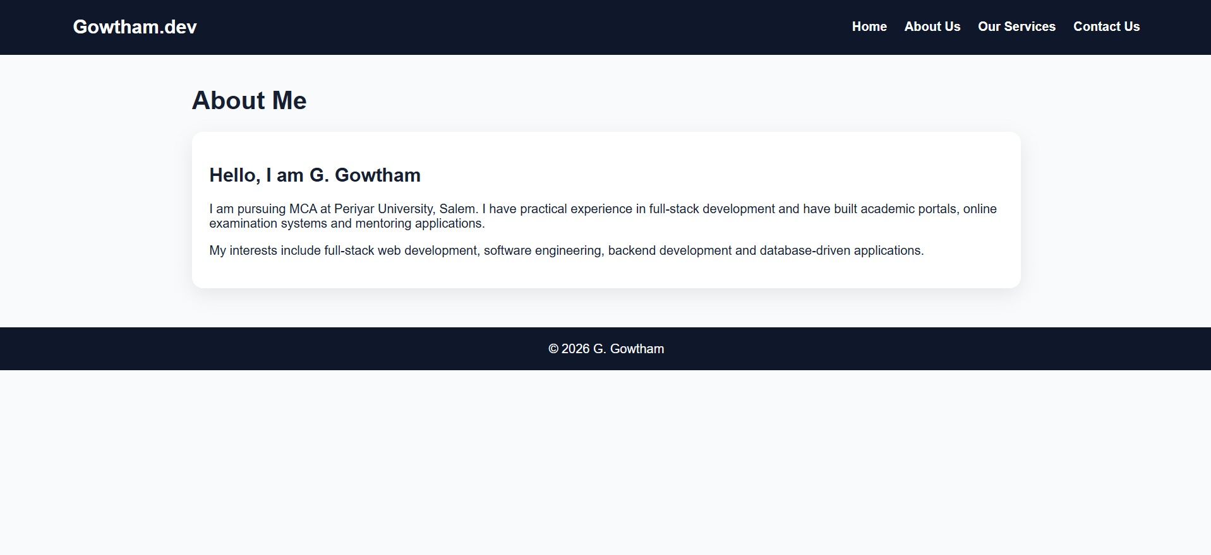

OUTPUT:
Our Services
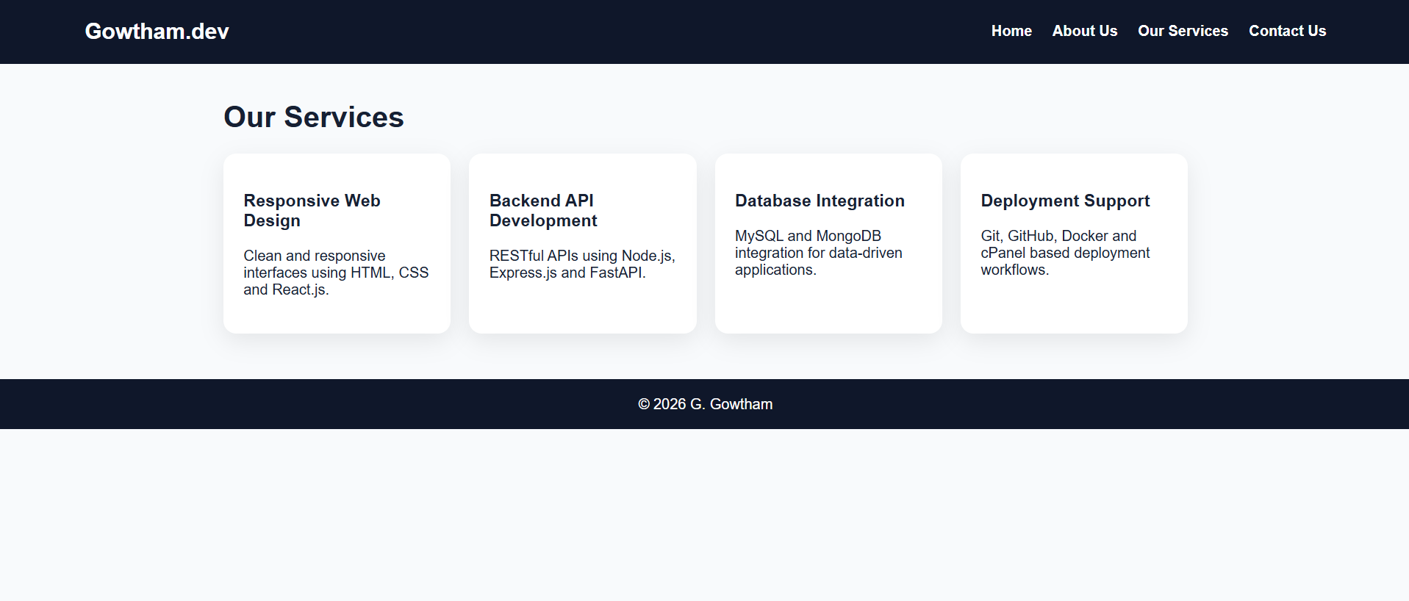

Contact Us
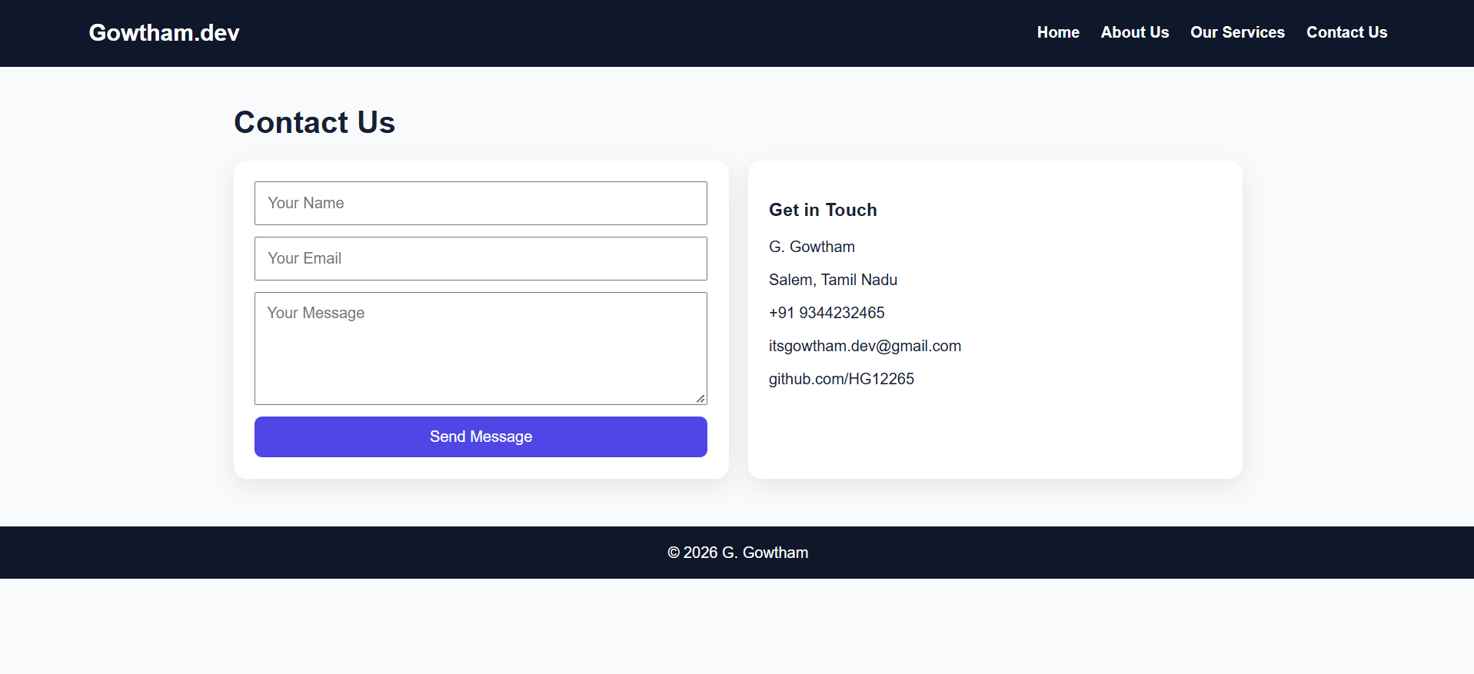

SOURCE CODE:
index.html
<!DOCTYPE html>
<html lang="en">
<head>
<meta charset="UTF-8">
<meta name="viewport" content="width=device-width, initial-scale=1.0">
<title>CSS Types - Gowtham</title>
<link rel="stylesheet" href="external.css">
<style>
h1 {
text-align: center;
color: #312e81;
margin-top: 30px;
} /* Internal CSS */

.intro {
text-align: center;
max-width: 800px;
margin: auto;
color: #475569;
}
</style>
</head>
<body>
<h1>My Full-Stack Project Showcase</h1>
<p class="intro">
This page demonstrates Inline, Internal and External CSS using projects from my resume.
</p>
<div class="projects">
<div class="card">
<div class="content">
<span class="tag">Next.js • Node.js • MySQL</span>
<h3 style="color:#0f172a">Periyar University Academic Portal</h3>
<p>
Responsive, database-driven portal for schools and department information.
</p>
</div>
</div>
<div class="card">
<div class="content">
<span class="tag">React.js • FastAPI • MySQL</span>
<h3 style="color:#0f172a">PG Entrance Examination Portal</h3>
<p>
Online examination workflow with authentication, answer submission and results.
</p>
</div>
</div>
<div class="card">
<div class="content">
<span class="tag">React.js • Node.js • MySQL</span>
<h3 style="color:#0f172a">Mentor-Mentee Management System</h3>
<p>
Academic mentoring platform with student records, dashboards and reports.
</p>
</div>
</div>
</div>
</body>
</html>
external.css
body {
font-family: Arial, sans-serif;
background: #f6f7fb;
margin: 0;
}
.projects {
display: flex;
gap: 20px;
justify-content: center;
flex-wrap: wrap;
padding: 30px;
}
.card {
width: 300px;
background: #fff;
border-radius: 14px;
overflow: hidden;
box-shadow: 0 8px 24px rgba(0, 0, 0, .08);
transition: .25s;
}
.card:hover {
transform: translateY(-6px);
border: 2px solid #4f46e5;
}
.card .content {
padding: 18px;
}
.tag {
font-size: 13px;
color: #6366f1;
font-weight: bold;
}

OUTPUT:

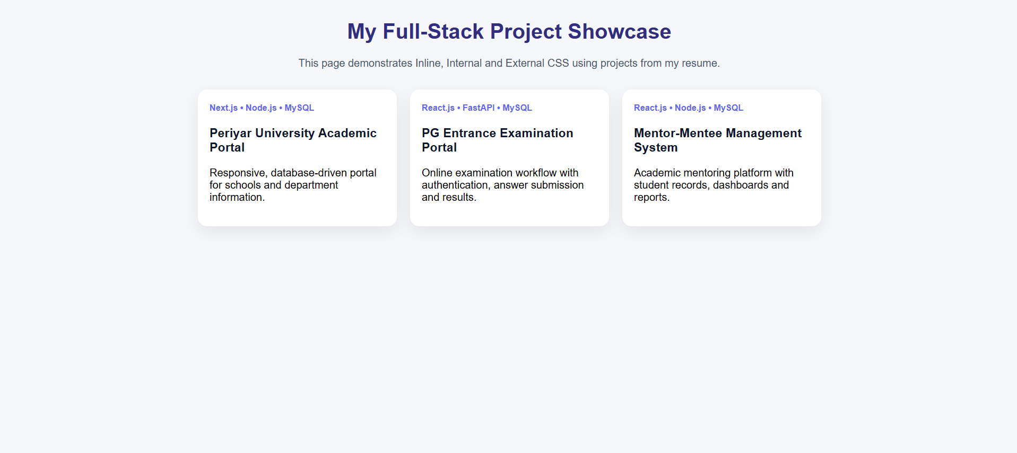

SOURCE CODE:
courses.xml
<?xml version="1.0" encoding="UTF-8"?>
<?xml-stylesheet type="text/css" href="lang.css"?>
<learning_hub>
<main_title>
<title>Gowtham's Technology Learning Hub</title>
<sub_title>Technologies from my full-stack profile</sub_title>
</main_title>
<main_section>
<technology>
<name>Frontend Development</name>
<description>Build responsive and interactive user interfaces.</description>
<topics>
<topic>HTML</topic>
<topic>CSS</topic>
<topic>React.js</topic>
</topics>
</technology>
<technology>
<name>Backend Development</name>
<description>Create RESTful APIs and application logic.</description>
<topics>
<topic>Node.js</topic>
<topic>Express.js</topic>
<topic>FastAPI</topic>
</topics>
</technology>
<technology>
<name>Database</name>
<description>Store and manage application data.</description>
<topics>
<topic>MySQL</topic>
<topic>MongoDB</topic>
<topic>Database Design</topic>
</topics>
</technology>
<technology>
<name>DevOps &amp; Deployment</name>
<description>Manage versions and application deployment.</description>
<topics>
<topic>Git</topic>
<topic>GitHub</topic>
<topic>Docker</topic>
</topics>
</technology>
</main_section>
</learning_hub>
lang.css
learning_hub {
display: block;
font-family: Arial;
background: #f8fafc;
padding: 25px;
}
main_title {
display: block;
text-align: center;
background: #0891b2;
color: white;
padding: 22px;
}
title {
display: block;
font-size: 32px;
font-weight: bold;
}
sub_title {
display: block;
margin-top: 8px;
}
main_section {
display: flex;
flex-wrap: wrap;
justify-content: center;
gap: 18px;
margin-top: 25px;
}
technology {
display: block;
width: 300px;
background: white;
border: 1px solid #ddd;
border-radius: 12px;
padding: 18px;
box-shadow: 0 6px 18px rgba(0, 0, 0, .08);
name {
display: block;
font-size: 22px;
font-weight: bold;
color: #0f172a;
margin-bottom: 10px;
}
description {
display: block;
color: #475569;
margin-bottom: 12px;
}
topics {
display: block;
}
topic {
display: inline-block;
background: #e0e7ff;
color: #3730a3;
padding: 7px 10px;
border-radius: 18px;
margin: 4px;
}
OUTPUT:

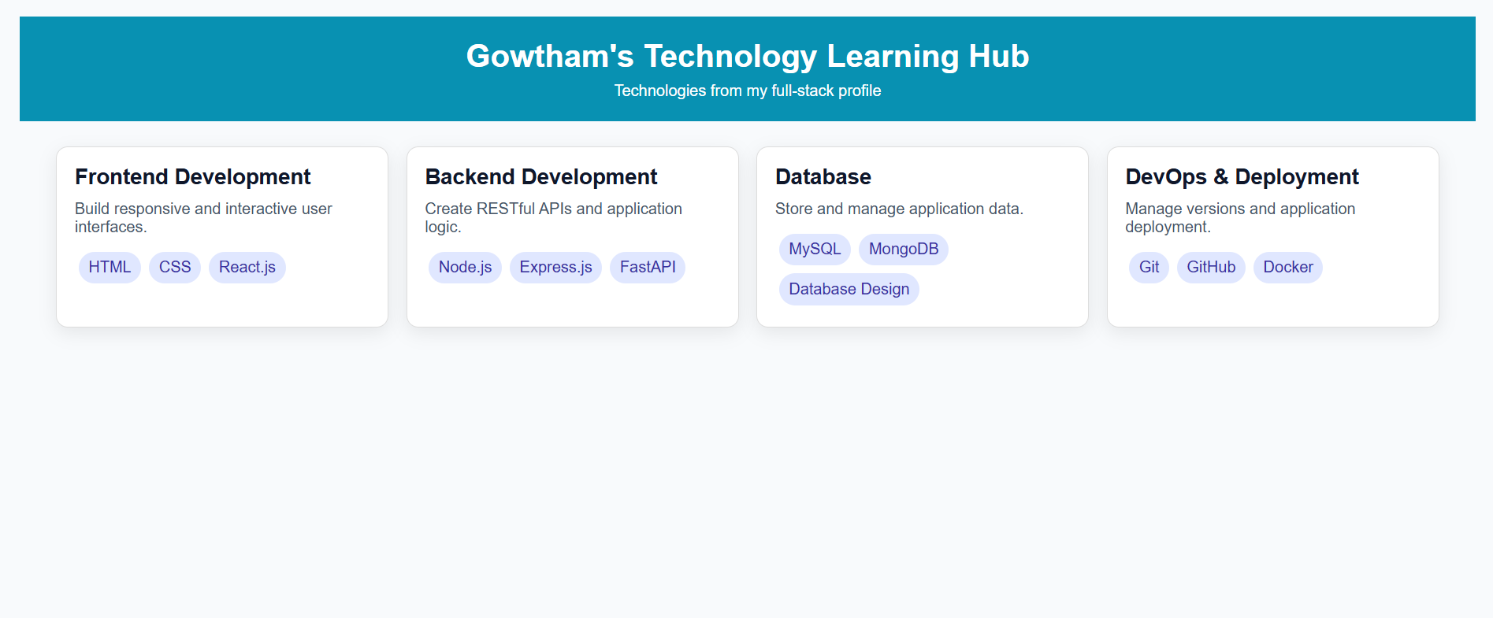

SOURCE CODE:
index.html
<!DOCTYPE html>
<html lang="en">
<head>
<meta charset="UTF-8">
<meta name="viewport" content="width=device-width, initial-scale=1.0">
<title>Technology Image Map</title>
<style>
body {
background: #0b1020;
color: white;
text-align: center;
font-family: Arial;
}

img {
max-width: 95%;
height: auto;
margin-top: 20px;
border-radius: 16px;
}
</style>
</head>
<body>
<h1>Gowtham's Full-Stack Technology Map</h1>
<p>Click a technology to open its official website.</p>
<img
src="techstack.svg"
usemap="#techmap"
width="1000"
height="600"
alt="Technology Stack"
>
<map name="techmap">
<area
shape="rect"
coords="70,110,280,250"
href="https://react.dev"
alt="React"
title="React.js"
>
<area
shape="rect"
coords="395,110,605,250"
href="https://nodejs.org"
alt="Node.js"
title="Node.js"
>
<area
shape="rect"
coords="720,110,930,250"
href="https://fastapi.tiangolo.com"
alt="FastAPI"
title="FastAPI"
>
<area
shape="rect"
coords="70,350,280,490"
href="https://www.mysql.com"
alt="MySQL"
title="MySQL"
>
<area
shape="rect"
coords="395,350,605,490"
href="https://www.mongodb.com"
alt="MongoDB"
title="MongoDB"
>

<area
shape="rect"
coords="720,350,930,490"
href="https://www.python.org"
alt="Python"
title="Python"
>
</map>
</body>
</html>

OUTPUT:

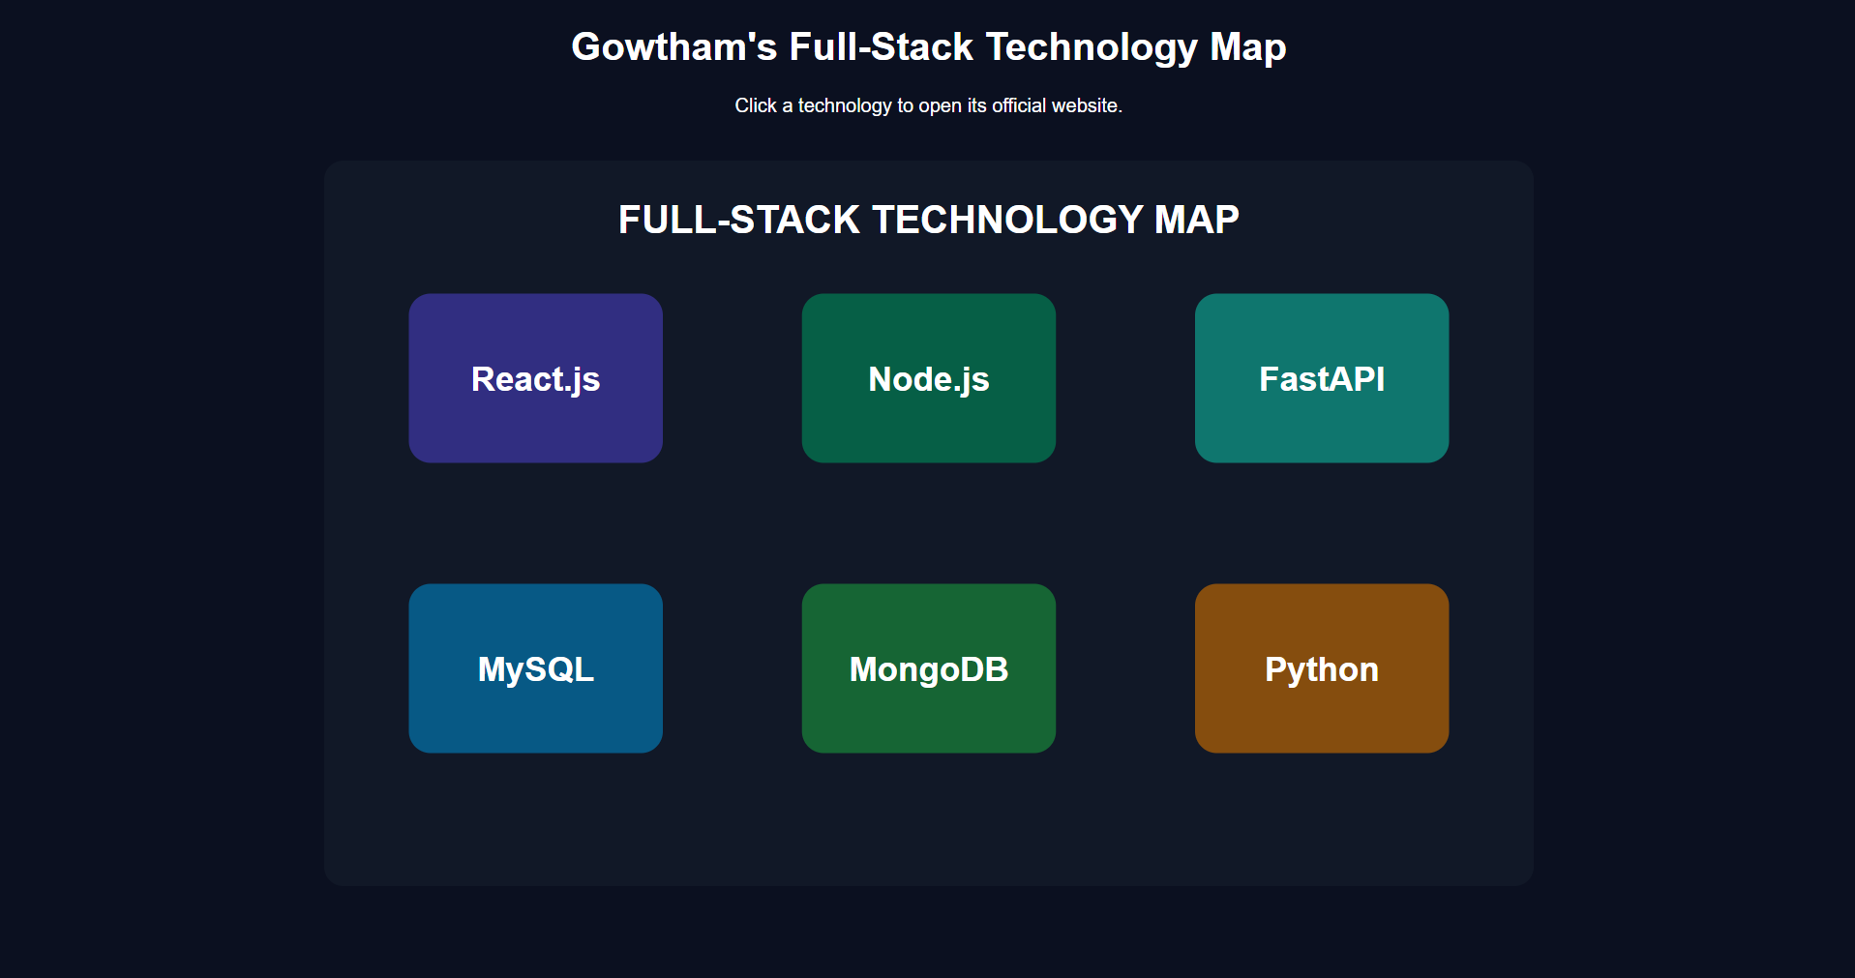

SOURCE CODE:
login.html
<!DOCTYPE html>
<html lang="en" ng-app>
<head>
<meta charset="UTF-8">
<meta name="viewport" content="width=device-width, initial-scale=1.0">
<title>AngularJS Validation</title>
<script src="https://ajax.googleapis.com/ajax/libs/angularjs/1.8.2/angular.min.js"></script>
<style>
body {
font-family: Arial;
background: #eef2ff;
}
.box {
width: 380px;
margin: 70px auto;
background: #fff;
padding: 25px;
border-radius: 14px;
box-shadow: 0 10px 28px rgba(0, 0, 0, .1);
}
input {
width: 100%;
padding: 11px;
margin: 7px 0 4px;
box-sizing: border-box;
}
.error {
color: #dc2626;
font-size: 13px;
}
.success {
color: #059669;
}
button {
width: 100%;
padding: 11px;
background: #4f46e5;
color: white;
border: 0;
border-radius: 8px;
margin-top: 12px;
}
button:disabled {
opacity: .5;
}
</style>
</head>
<body>
<div class="box">
<h2>Gowtham Portfolio Login</h2>
<form name="loginForm" novalidate>
<label>Email</label>
<input
type="email"
name="email"
ng-model="email"
required
>
<div
class="error"
ng-show="loginForm.email.$touched && loginForm.email.$error.required"
>
Email is required
</div>
<div
class="error"
ng-show="loginForm.email.$error.email"
>
Invalid email format
</div>
<br>
<label>Password</label>
<input
type="password"
name="password"
ng-model="password"
required
ng-minlength="6"
>
<div
class="error"
ng-show="loginForm.password.$touched && loginForm.password.$error.required"
>
Password is required
</div>
<div
class="error"
ng-show="loginForm.password.$error.minlength"
>
Minimum 6 characters required
</div>
<p
class="success"
ng-show="loginForm.$valid"
>
All fields look good!
</p>
<button
type="submit"
ng-disabled="loginForm.$invalid"
>
Login
</button>
</form>
</div>
</body>
</html>

OUTPUT:

Validation - Minimum Length Error
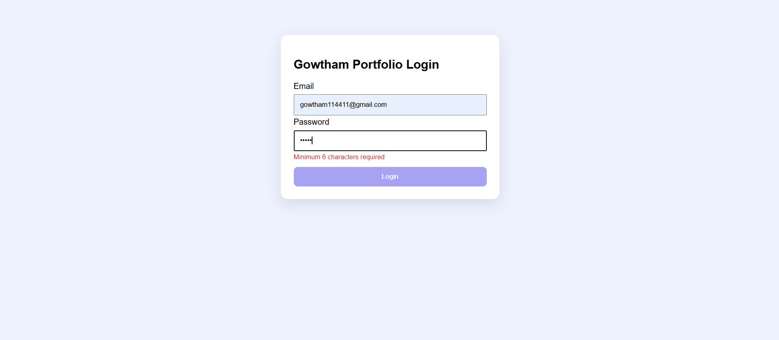

Validation - Valid Form
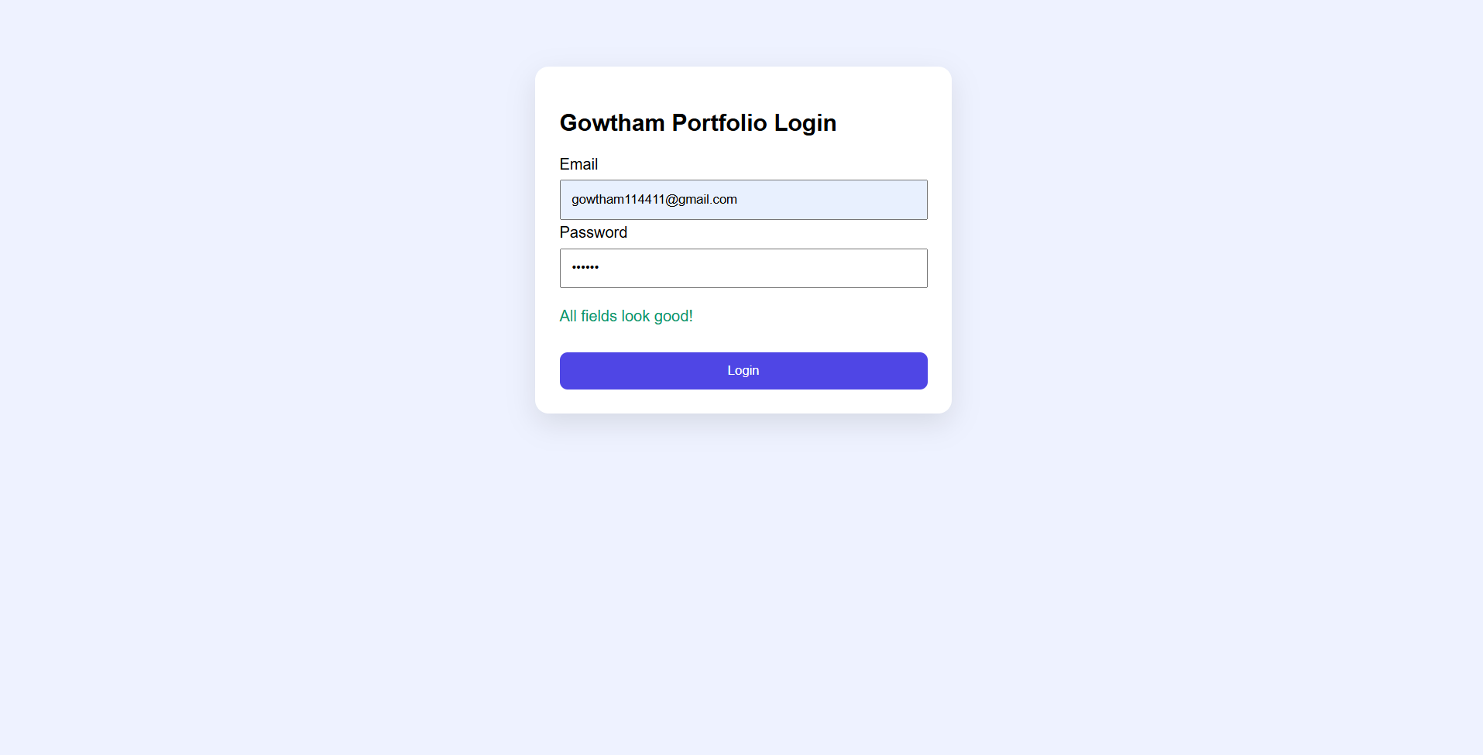

SOURCE CODE:
database.sql
CREATE DATABASE gowtham_lab;
USE gowtham_lab;
CREATE TABLE profile (
id INT AUTO_INCREMENT PRIMARY KEY,
name VARCHAR(100) NOT NULL,
qualification VARCHAR(100) NOT NULL,
institution VARCHAR(150) NOT NULL,
email VARCHAR(150) NOT NULL,
city VARCHAR(100) NOT NULL
);
INSERT INTO profile (
name,
qualification,
institution,
email,
city
)
VALUES (
'G. Gowtham',
'MCA - Pursuing',
'Periyar University, Salem',
'itsgowtham.dev@gmail.com',
'Salem, Tamil Nadu'
);
db.php
<?php
$host = "localhost";
$user = "root";
$password = "";
$database = "gowtham_lab";
$conn = new mysqli($host, $user, $password, $database);
if ($conn->connect_error) {
die("Connection failed: " . $conn->connect_error);
}
?>
index.php
<?php
include 'db.php';
$result = $conn->query("SELECT * FROM profile");
?>
<!DOCTYPE html>
<html lang="en">
<head>
<meta charset="UTF-8">
<meta name="viewport" content="width=device-width, initial-scale=1.0">
<title>PHP Database Fetch</title>
<style>
body {
font-family: Arial;
background: #f8fafc;
}
.wrap {
width: 90%;
max-width: 950px;
margin: 50px auto;
}
table {
width: 100%;
border-collapse: collapse;
background: white;
}
th,
td {
padding: 13px;
border: 1px solid #ddd;
text-align: left;
}
th {
background: #4f46e5;
color: white;
}
</style>
</head>
<body>
<div class="wrap">
<h2>Student Details Fetched from MySQL</h2>
<table>
<tr>
<th>ID</th>
<th>Name</th>
<th>Qualification</th>
<th>Institution</th>
<th>Email</th>
<th>City</th>
</tr>
<?php while ($row = $result->fetch_assoc()) { ?>
<tr>
<td>
<?= $row['id'] ?>
</td>
<td>
<?= htmlspecialchars($row['name']) ?>
</td>
<td>
<?= htmlspecialchars($row['qualification']) ?>
</td>
<td>
<?= htmlspecialchars($row['institution']) ?>
</td>
<td>
<?= htmlspecialchars($row['email']) ?>
</td>
<td>
<?= htmlspecialchars($row['city']) ?>
</td>
</tr>
<?php } ?>
</table>
</div>
</body>
</html>
<?php
$conn->close();
?>

OUTPUT:

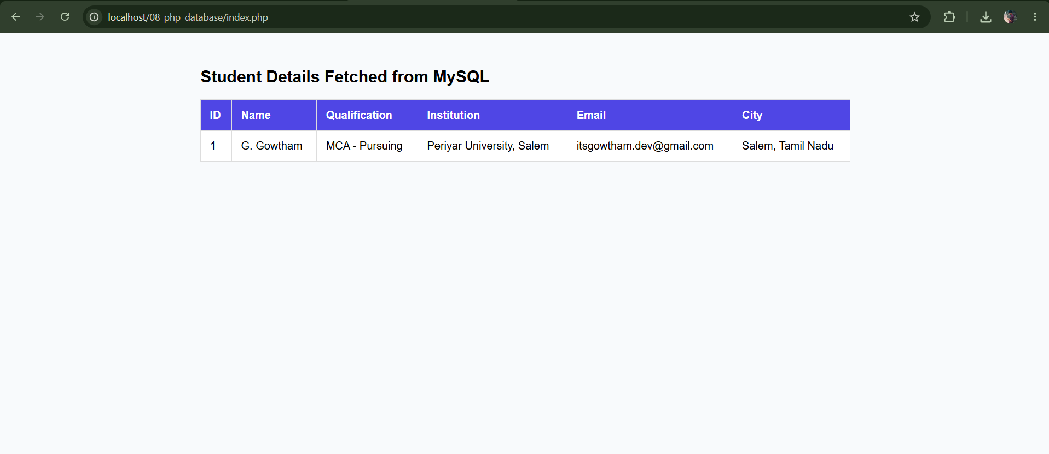

SOURCE CODE:
index.html
<!DOCTYPE html>
<html lang="en">
<head>
<meta charset="UTF-8">
<meta name="viewport" content="width=device-width, initial-scale=1.0">
<title>Hide Paragraph using jQuery</title>
<script src="https://code.jquery.com/jquery-3.6.0.min.js"></script>
<script>
$(document).ready(function () {
$("#hideBtn").click(function () {
$("#about").hide();
});
$("#showBtn").click(function () {
$("#about").show();
});
});
</script>
<style>
body {
font-family: Arial;
padding: 40px;
background: #f8fafc;
}
.box {
max-width: 750px;
background: #fff;
padding: 25px;
border-radius: 12px;
box-shadow: 0 7px 22px rgba(0, 0, 0, .08);
}
button {
padding: 10px 16px;
margin-right: 8px;
border: 0;
border-radius: 7px;
cursor: pointer;
}
</style>
</head>
<body>
<div class="box">
<h2>Hide Paragraph Example using jQuery</h2>
<p id="about">
G. Gowtham is an MCA candidate at Periyar University with interests in
full-stack web development, software engineering, backend development
and database-driven applications.
</p>
<button id="hideBtn">Hide Paragraph</button>
<button id="showBtn">Show Paragraph</button>
</div>
</body>
</html>

OUTPUT:
Paragraph Visible
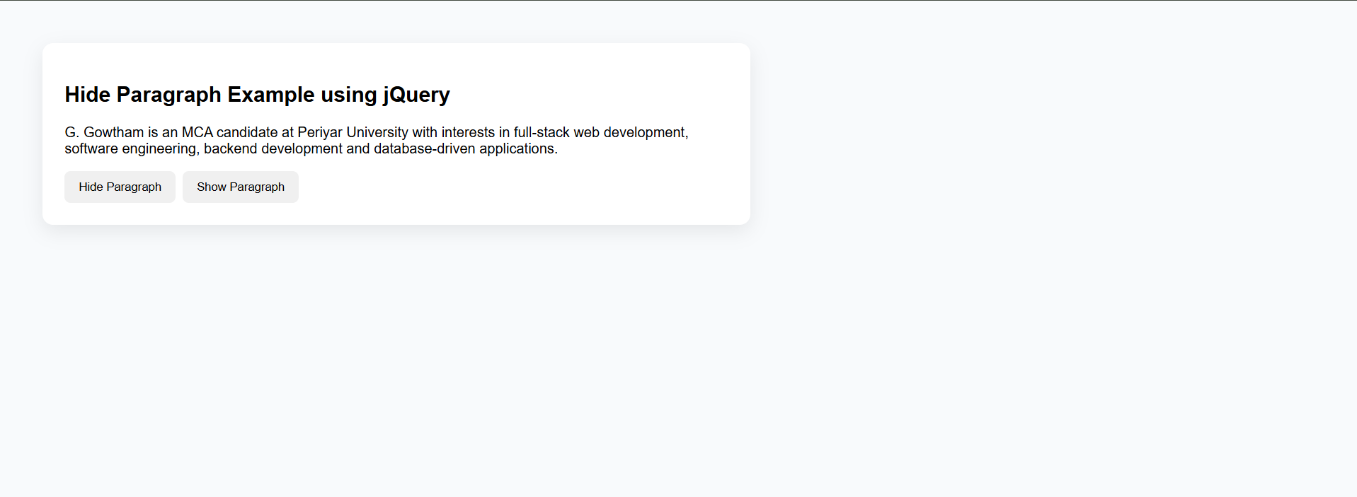
Paragraph Hidden
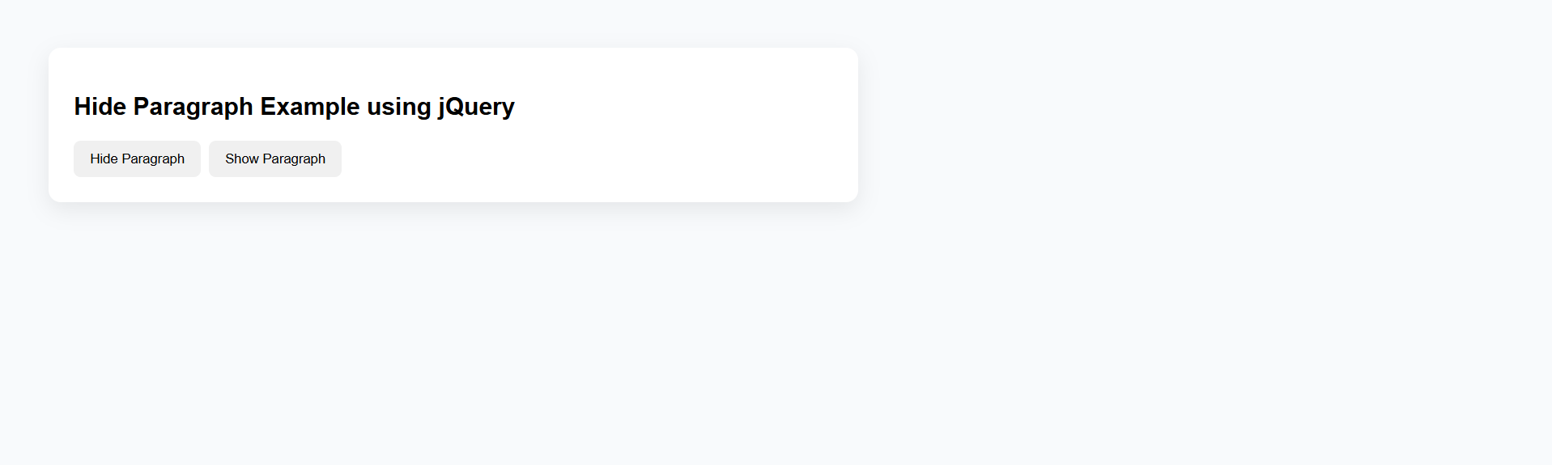

SOURCE CODE:
index.html
<!DOCTYPE html>
<html lang="en">
<head>
<meta charset="UTF-8">
<meta name="viewport" content="width=device-width, initial-scale=1.0">
<title>Mouse & Form Events</title>
<style>
body {
font-family: Arial;
padding: 30px;
background: #f8fafc;
}
#box {
width: 250px;
height: 120px;
background: lightblue;
display: grid;
place-items: center;
margin-bottom: 20px;
cursor: pointer;
border-radius: 12px;
}
input,
button {
padding: 10px;
margin-right: 8px;
}
</style>
</head>
<body>
<h2>Mouse & Form Events</h2>
<div id="box">
Hover / Click Me
</div>
<form id="form">
<input
id="name"
placeholder="Enter your name"
required
>
<button>Submit</button>
</form>
<p id="msg"></p>
<script>
const box = document.getElementById('box');
box.onmouseover = () => {
box.style.background = 'lightgreen';
};
box.onmouseout = () => {
box.style.background = 'lightblue';
};
box.onclick = () => {
box.style.background = 'orange';
};
document.getElementById('form').onsubmit = (e) => {
e.preventDefault();

document.getElementById('msg').textContent =
`Hello, ${document.getElementById('name').value}! Welcome to G. Gowtham's Web Technologies Lab.`;
e.target.reset();
};
</script>
</body>
</html>

OUTPUT:
Initial State
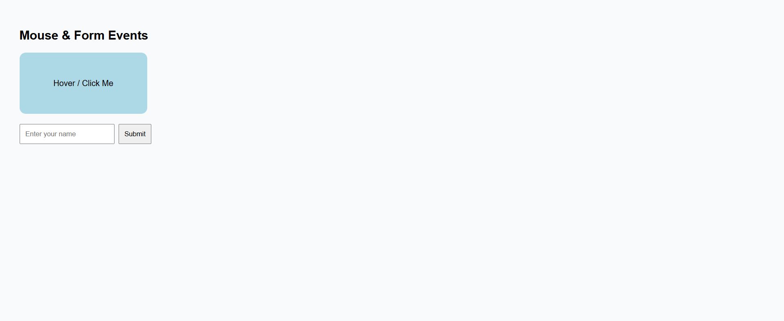
Mouse Hover Event
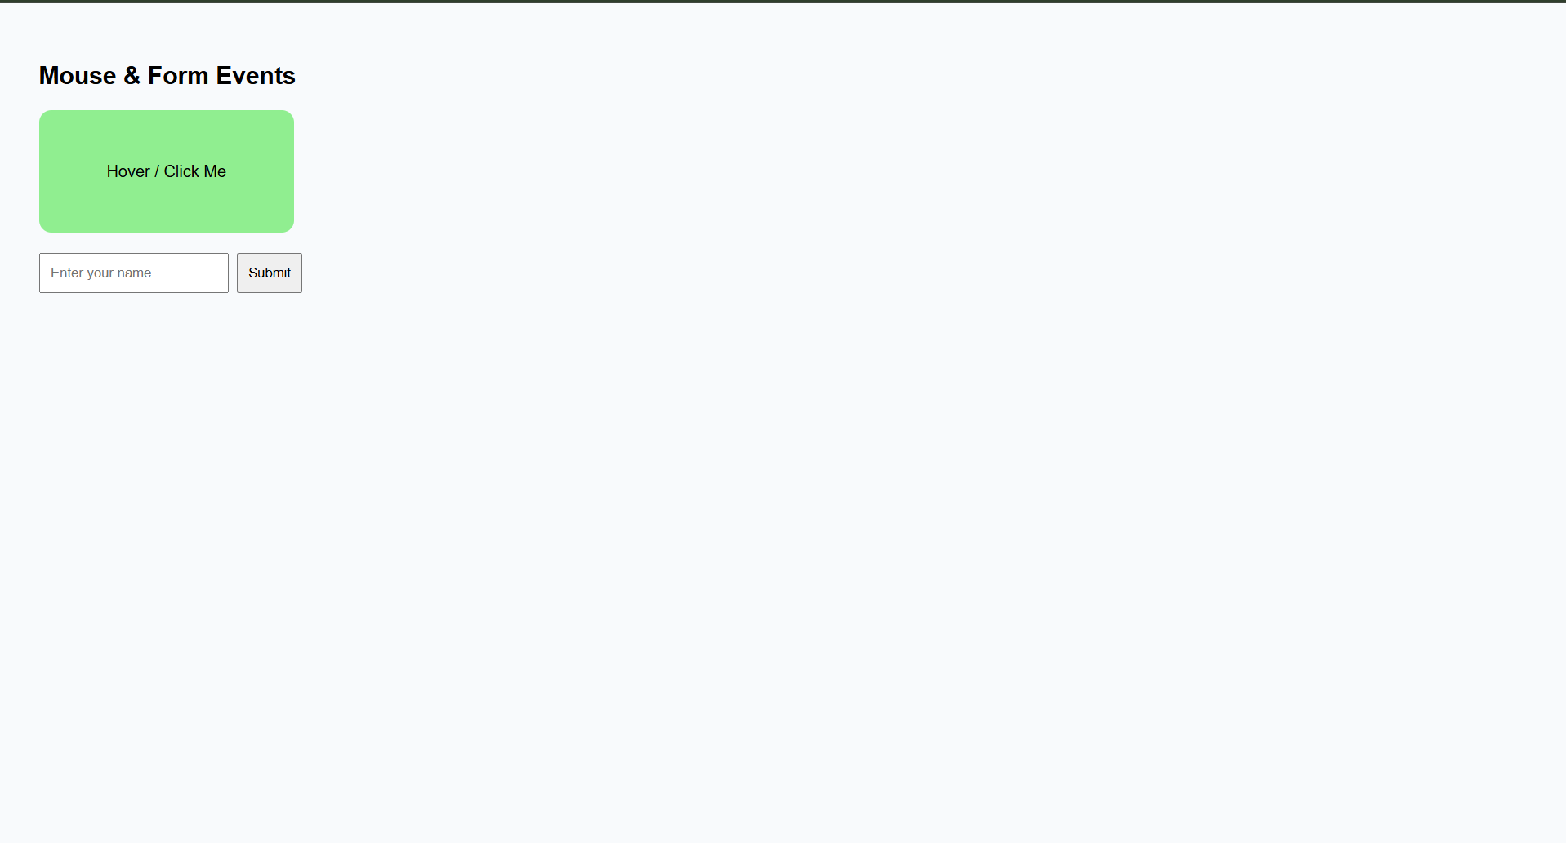
Form Submit Event
