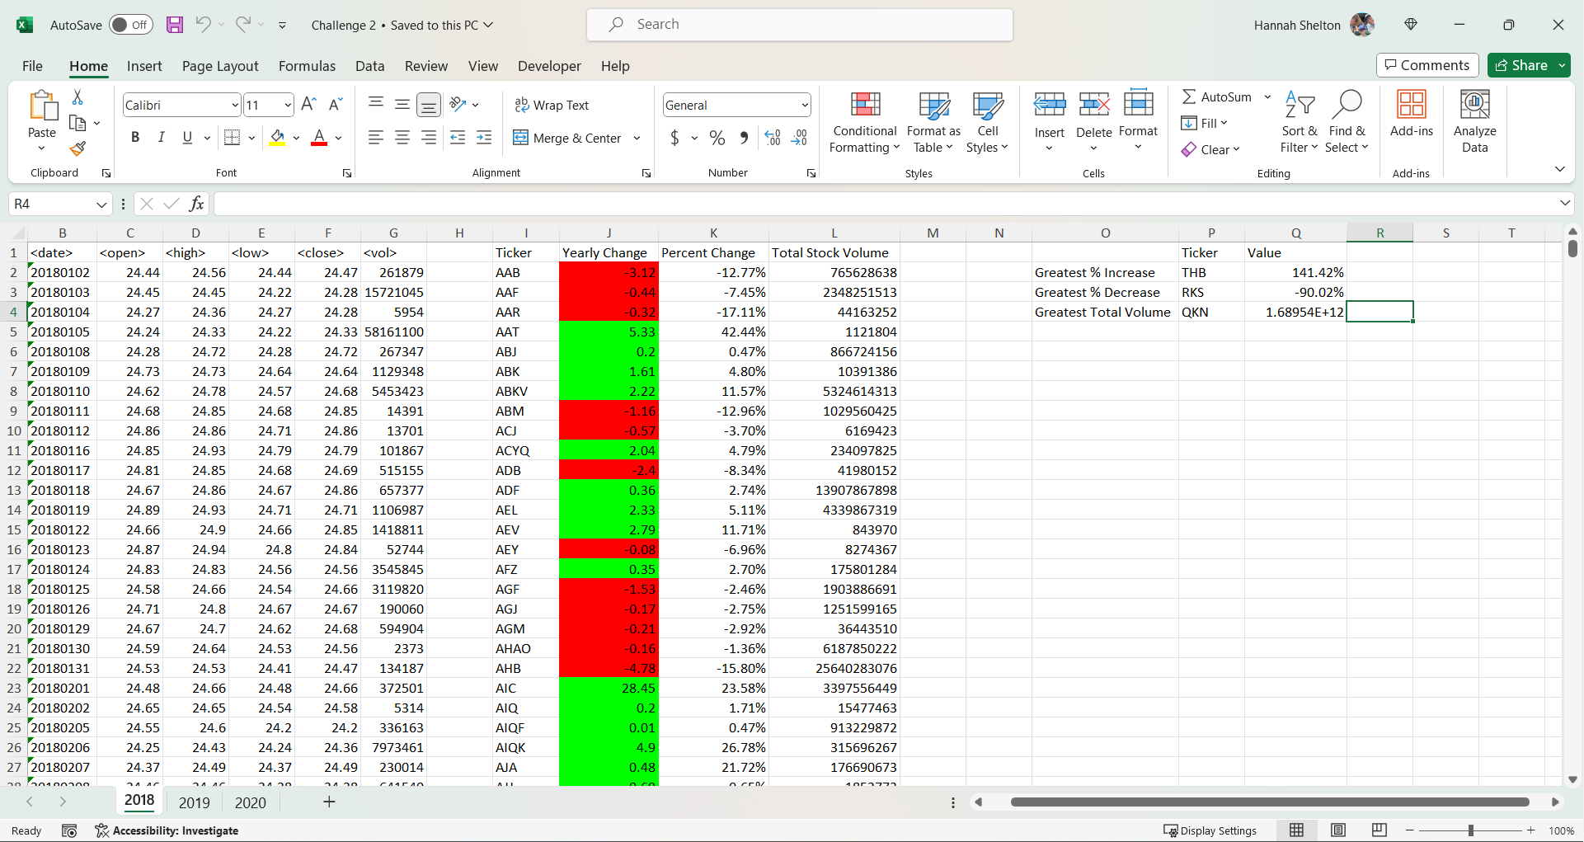2018

2019

2020