Rate Shopper H5 SDK Requirements

Contents

Summary 2

Release Notes 2

Prerequisites 2

How To 3

Launch Dialog Script 5

ION API Configuration 6

CMS100 (CMS010) Information Categories 10

CMS100MI (CMS015) Transactions 11

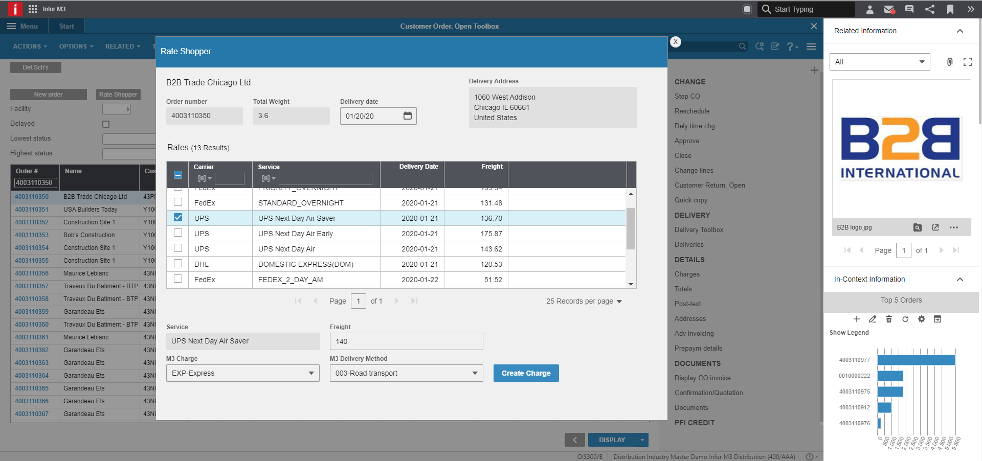

Summary

A web application built using the H5 SDK that allow the user to shop for freight rates using an external web service provided by ProcessWeaver.

Once a freight rate has been selected the user can update an M3 order charge (selected from a drop down) with the value from the selected freight rate.

Release Notes

Version 1.0.0.0

* Initial version

Prerequisites

* The application calls an external web service provided by ProcessWeaver. This webservice must be configured in ION API.
* The application uses information categories and custom MI transactions. These need to be configured in CMS010 and CMS015.
* The LaunchApplicationDialog_H5_V1 script is used to launch the rate shopper dialog. It must be installed and available in the applicable environment.
* The customer order and the warehouse on the order header must have valid addresses.

How To

In program OIS300 the user selects an order for which to do rate shopping. Pressing the button will launch the application dialog.

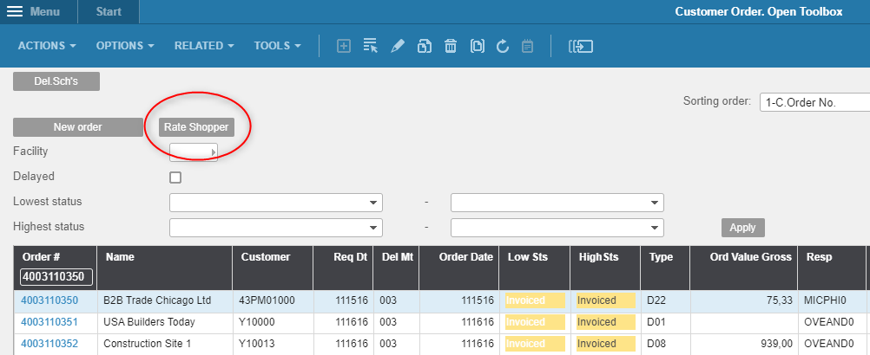

When doing so, information about the selected customer order is retrieved and the ProcessWeaver webservice is called via ION API, using data from the customer order as input (from- and to-address, delivery date).

The web service returns an array of available freight rates, which are then displayed in a list.

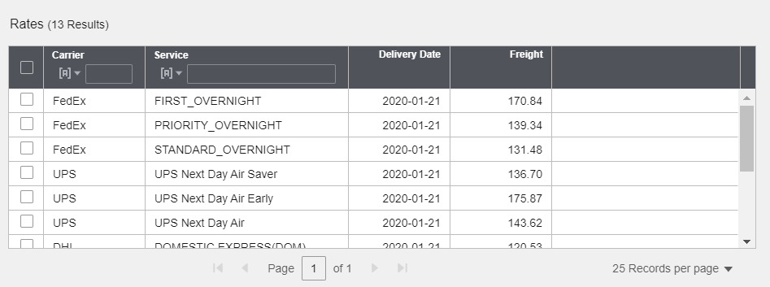

The user can now select a freight rate. Doing so will populate the bottom of the part with the application dialog. Here the user can select an M3 charge that should be used to “transfer” the freight rate to the customer order. Future version of the application will also allow the delivery method to be updated. **Note**, this is currently not supported.

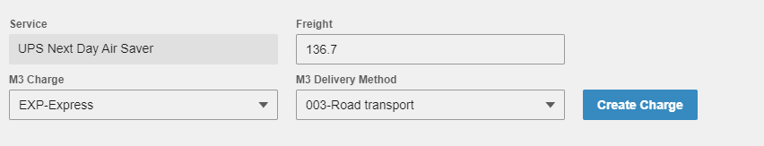

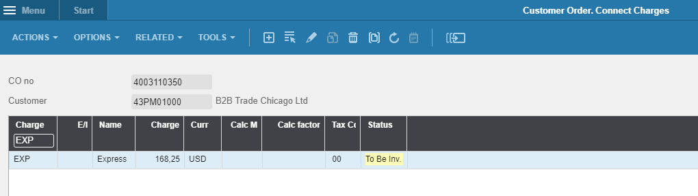

Launch Dialog Script

The LaunchApplicationDialog_H5_V1 script is used launch the rate shopper application. It contains functionality to

* Retrieve the data from the selected order in the OIS300 listpanel and pass it to the rate shopper application.
* Display the rate shopper in a dialog with the dimensions provided in the script arguments

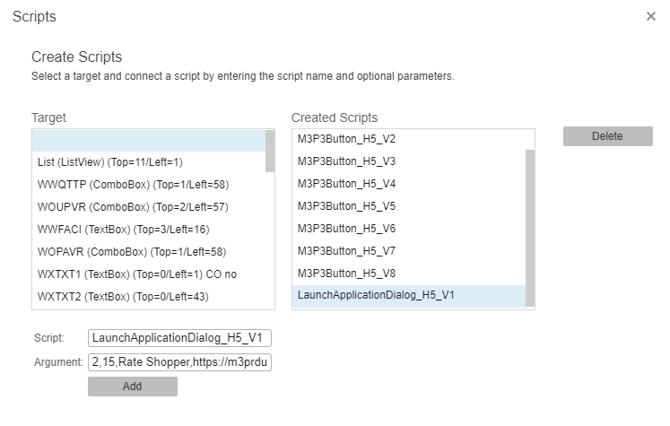

Script name

LaunchApplicationDialog_H5_V1

Script arguments:

ButtonRow, ButtonColumn, ButtonText, ApplicationUrl, DialogWidth, DialogHeight

Example

(2,15,Rate Shopper,https://<serverUrl>/mne/apps/rate-shopper-h5-sdk/,1000,750)

ION API Configuration

The rate shopper application calls the external ProcessWeaver web service. It must be configured as an ION API.

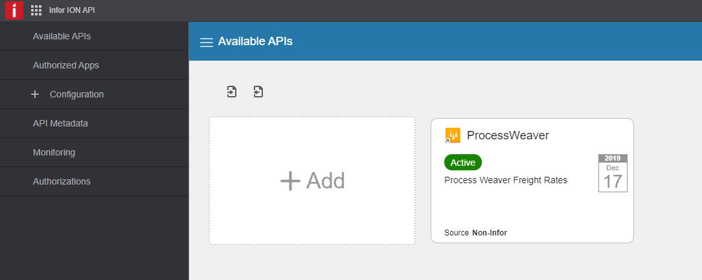

Configuration Details

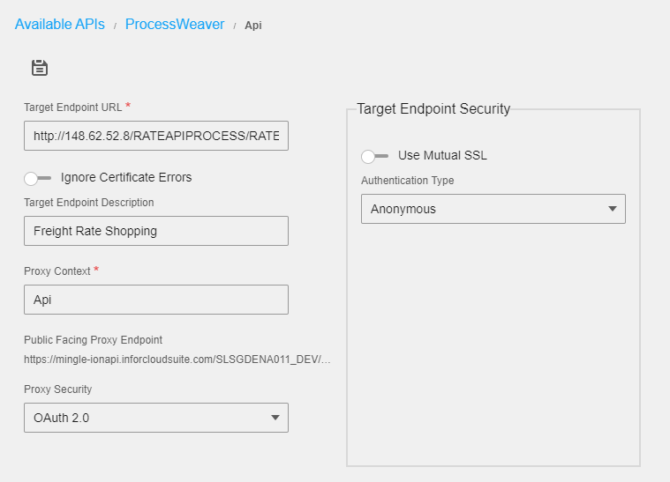

Target endpoint Url: <http://148.62.52.8/RATEAPIPROCESS/RATESHOPPING.ASHX>

Swagger Documentation

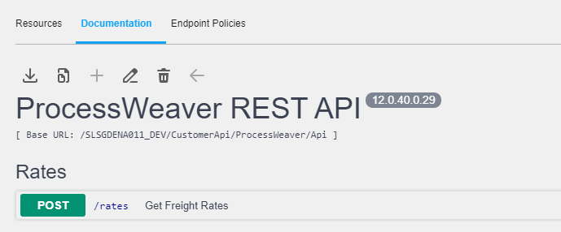

The swagger documentation is listed below. It can be copied to a .json file, which in turn can be imported into the environment.

{

"swagger": "2.0",

"info": {

"version": "12.0.40.0.29",

"title": "ProcessWeaver REST API"

},

"basePath": "/<TenantID>/CustomerApi/ProcessWeaver/Api",

"schemes": [

"https"

],

"tags": [

{

"name": "Rates"

}

],

"paths": {

"/rates": {

"post": {

"tags": [

"Rates"

],

"summary": "Get Freight Rates",

"description": "Get Freight Rates",

"operationId": "getRates",

"consumes": [

"application/json;charset=utf-8",

"application/xml;charset=utf-8"

],

"produces": [

"application/json;charset=utf-8",

"application/xml;charset=utf-8"

],

"parameters": [

{

"in": "body",

"name": "body",

"description": "Model of request body with necessary data for get freight rates",

"required": true,

"schema": {

"$ref": "#/definitions/FreightRates"

}

}

],

"responses": {

"200": {

"description": "OK",

"schema": {

"type": "string"

}

},

"400": {

"description": "Bad Request",

"schema": {

"type": "string"

}

},

"401": {

"description": "Unauthorized",

"schema": {

"type": "string"

}

},

"403": {

"description": "Forbidden",

"schema": {

"type": "string"

}

},

"500": {

"description": "Internal Server Error",

"schema": {

"type": "string"

}

}

}

}

}

},

"definitions": {

"FreightRates": {

"type": "object",

"properties": {

"RateAPI": {

"$ref": "#/definitions/FreightRatesInner"

}

}

},

"FreightRatesInner": {

"type": "object",

"properties": {

"ShipToCity": {

"type": "string"

},

"ShipToState": {

"type": "string"

},

"ShipToCountry": {

"type": "string"

},

"ShipToZipcode": {

"type": "string"

},

"ShipFromCity": {

"type": "string"

},

"ShipFromState": {

"type": "string"

},

"ShipFromCountry": {

"type": "string"

},

"ShipFromZipcode": {

"type": "string"

},

"TotalWeight": {

"type": "string"

},

"WeightUnits": {

"type": "string"

},

"DeliveryDate": {

"type": "string",

"format": "date-time"

},

"Departuredate": {

"type": "string",

"format": "date-time"

}

}

}

}

}

When calling the webservice the following input data is mandatory

* Ship from zip code
* Ship from state
* Ship from country
* Ship to zip code
* Ship to state
* Ship to country
* Weight
* Delivery date
* Departure date

This data must be available for the selected customer order. In particular, the customer order must have a valid delivery address and the warehouse must have a valid address setup in CRS235.

CMS100 (CMS010) Information Categories

|  |  |  |
| --- | --- | --- |
| **Information category** | **File** | **Related tables** |
| PRW_OOHEAD | OOHEAD | OCUSMA, OCUSAD, CIADDR |

Related tables

PRW_OOHEAD - Related tables

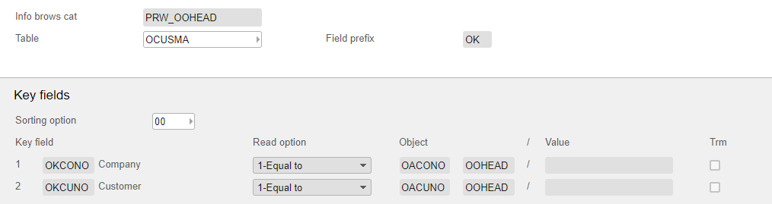

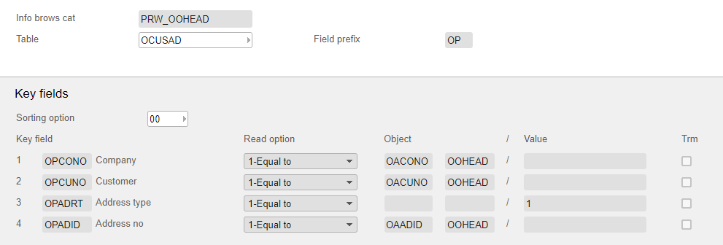

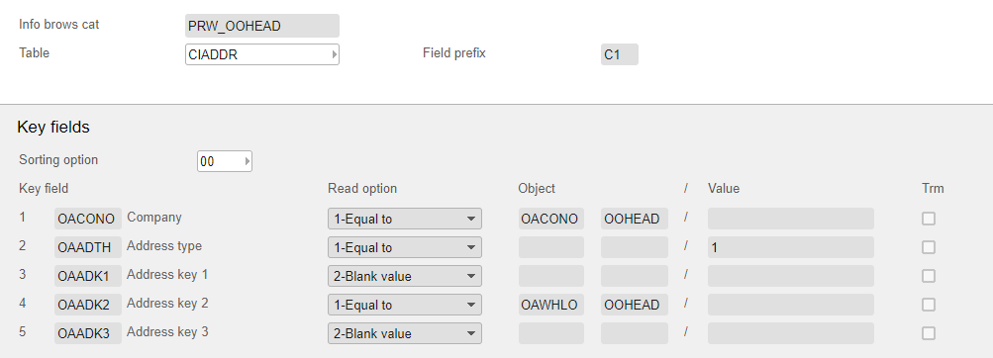

Views

|  |  |  |  |  |
| --- | --- | --- | --- | --- |
| **Information category** | **Sorting order** | **Sorting option** | **View** | **Fields** |
| PRW_OOHEAD | 1 | 00 | PRW_1 | OAORNO, OACUNO, OKCUNM, OAGRWE, OANEWE, OAVOL3, OARLDT, OAWHLO, OAMODL, OKPONO, OKTOWN, OKECAR, OKCSCD, OAADID, OPPONO, OPTOWN, OPECAR, OPCSCD, C1PONO,  C1TOWN,  C1ECAR, C1CSCD |

CMS100MI (CMS015) Transactions

|  |  |  |  |  |  |  |  |
| --- | --- | --- | --- | --- | --- | --- | --- |
| **Transaction** | **Information category** | **Sort order** | **View** | **No. filters** | **Selection fields** | **Search** | **Aggr** |
| LstPrwCO | PRW_OOHEAD | 1 | PRW_1 | 1 |  |  |  |