

**PROGRESS | GROWTH | FUTURE**

**Domestic  
Solar Proposal**

Client: {name}

Dated: 15-12-2021

**ATTOCK ENERGY (PRIVATE) LIMITED**

**{name}**

{address}

{city}

{phno}

**Proposal for Solar Power System**

Dear Client,

Thank you for your interest in the installation of our Solar Power System Solution.

Renewable Energy not only provides lower electricity bills, but also improves our environment and reduces greenhouse gas emissions. We think it is our responsibility to save our environment, our country and our future generations.

We are pleased to submit herewith our proposal for Solar Power System.

We look forward to working with you after the acceptance of subject proposal. For any kind of details or further information / clarification, please feel free to contact us.

Sincerely,

Sales Team

Attock Energy (Private) Limited

+92-51-5406004-5

Sales@attockenergy.com.pk

# Quotation (On Grid System)

|  |  |  |
| --- | --- | --- |
| **Item** | **Detail** | **Price (PKR)** |
| **AEPL Charges** | | |
| Solar Panels | Panels {pnlsize} W x {panels} = {sys_size} kW  Tier – 1  Mono PERC Type  {pnl_brand} Solar | {aepl_charges} |
| Attock Energy deals in top rated brands that come with OEM Warranty |
| Smart Energy Inverter | {inv_size}kW  {inv_brand} |
| Our ‘Smart’ Inverters provide remote monitoring via mobile application |
| Other Accessories | Wires, Ducts, Cables, Circuit Breakers, Distribution Panels & other necessary accessories |
| **Sub-Contractor Charges** | | |
| Installation of System | Approximate charges that will be payable directly to Installation Contractor | {sub_charges} |
| Net Metering | Approximate charges that will be payable to third party contractor (without load extension) |
| Customized Structure | {cust_struct} |
| Civil Works | Approximate charges that will be payable directly to Construction Contractor for PCC solid blocks |
| Special Discount from AEPL Charges | | {discount} |
| **Total Amount (AEPL + Sub-Contractor)** | | **{total}** |

This quotation is subject to the Terms & Conditions attached in the proposal.

# Terms and Conditions

## Quotation Validity

This quotation (Ref # {refno}) is valid till {valid}.

## Payment & Project Schedule

### Payment

|  |  |
| --- | --- |
| **Payment Schedule** | |
| **On Proposal Acceptance (Advance)** | **Against delivery of Material** |
| AEPL Charges | |
| 90 % | 10 % |
| Sub-Contractor Charges | |
| 100 % | - |

### Project Schedule

|  |
| --- |
| **Project Timeline** |
| Project Installation will be completed within 02 Weeks after Availability of Equipment |
| Net Metering may take 8 – 12 Weeks after Completion of Installation |

## Pricing

* AEPL charges are inclusive of GST only on items other than solar panels.
* Sub-Contractor charges are exclusive of services sales tax and withholding tax.
* Structure, installation, net metering and civil work costs will be paid separately (included in quoted price).
* Cost for net metering have been approximated based on currently enforced regulations. This may vary based on actual site requirements.
* Any statutory variation in taxes and duties e.g., GST on Solar Panels and Inverters from the date of submission of this proposal would be to the client’s account and shall be payable by the client at actual.
* GST is charged on parts / components / equipment under the preview of Sales Tax Act, 1990.
* Standard civil works costs are included; however, any customized civil structure may change the price accordingly.

## Additional Works

* Additional work may be carried out upon mutual agreement between client and Attock Energy. All such will be charged / invoiced separately and carried out after receipt of its payments in advance.
* Other accessories in excess of quoted lengths will be charged as per actual.

## Liability

* Quotation provided is for Attock Energy customized solar solution. Additional costs may incur to client post detailed civil and structural analysis, where required.
* If engaged for Net Metering, Attock Energy will facilitate in documentation and processing of Net Metering. Since Net Metering is dependent upon prevalent laws and regulatory approvals, Attock Energy will not be liable if such approval is not granted by the relevant authority (ies).
* No refunds / order reversals will be accepted 15 calendar days after receipt of payment.
* Safety of Material supplied would be client’s scope after delivery at the site.
* Evaluation of rooftop structural loading is in client’s scope, AEPL will not be held responsible for any damage caused by solar installation.

## Our Scope of Work

Our solar system solution is designed for complete customer satisfaction. Our team will ensure provision of the following:

1. Designing of complete Solar System.
2. Supply of materials as mentioned in the quotation.
3. Installation of Solar Panels on mounting structure.
4. Installation of Solar Inverters, Solar Distribution Boxes and Protective Equipment.
5. Testing and Commissioning of the Solar System.
6. Remote Monitoring Solution via a mobile application.

## Scope of Work Not Included

1. Provision of clear access to the rooftop.
2. Any modification (such as cutting / trimming of trees, etc.) near installation site.
3. Any civil works, if opted by engaging a third-party contractor.
4. Electrical mains with proper earthing.
5. Wi-Fi connection in the inverter room for remote monitoring system.
6. Additional electrical work apart from Solar System Installation i.e. ATS modification etc.
7. Change of name and sanction load for DISCO connection for Net Metering processing, if required. However, Attock Energy will facilitate in documentation and processing.

# Our Warranty

|  |  |
| --- | --- |
| **Item** | **Warranty**[1] |
| Solar Panels | 10 Years (Product) |
|
|
| Inverter | {warranty} |
|
| Workmanship | 1 Year |

* Standard warranty from the manufacturers of solar panels and inverter will be passed on to the client.
* The warranty does not cover Damage/ Malfunctioning of Solar System due to:
  + Physical damage
  + Normal wear and tear
  + Cosmetic variations
  + Any modification by client or third-party post installation
  + Electrical surges, fluctuation, instability, grounding or lightning
  + Natural Calamities
  + Unauthorized / Wrong Handling
  + Theft
  + Uncontrollable Acts (Fire, Stray Bullets, etc)

(Client Copy)

# Acceptance of Proposal

|  |  |  |  |
| --- | --- | --- | --- |
| I CONFIRM THAT I HAVE READ THE ATTACHED PROPOSAL (REF # {refno}) AND I FULLY UNDERSTAND ALL THE ENCLOSED COMMITMENTS, TRANSACTIONS, AND TERMS & CONDITIONS. I WILLINGLY ACCEPT THE PROPOSAL FOR THE INSTALLATION OF THE MENTIONED SOLAR SYSTEM AND AGREE TO ADHERE TO ALL OBLIGATIONS (FINANCIAL OR OTHERWISE) AS A RESULT OF ACCEPTANCE OF THIS PROPOSAL. I AM NOT RELYING ON ANY OTHER DOCUMENT OR REPRESENTATION MADE BY THE COMPANY TO ME EXCEPT THIS PROPOSAL. | | | |
| Client | | Company Representative | |
| Name:  Date:  CNIC / NTN: | _________________________  _________________________  _________________________ | Name:  Date:  Designation: | __________________________  __________________________  __________________________ |

Ref: {refno}

**(For Client Acknowledgement)**

Acknowledged that the proposal has been accepted on _____________ and the required payment of Rs. ______________________ via Cheque # _______________ has been received on behalf of the Company. The timeline for project execution is accepted to start from _____________________.

|  |  |
| --- | --- |
| Company Representative | |
| Name:  Date:  Designation: | __________________________  __________________________  __________________________ |

(Company Copy)

# Acceptance of Proposal

|  |  |  |  |
| --- | --- | --- | --- |
| I CONFIRM THAT I HAVE READ THE ATTACHED PROPOSAL (REF # {refno}) AND I FULLY UNDERSTAND ALL THE ENCLOSED COMMITMENTS, TRANSACTIONS, AND TERMS & CONDITIONS. I WILLINGLY ACCEPT THE PROPOSAL FOR THE INSTALLATION OF THE MENTIONED SOLAR SYSTEM AND AGREE TO ADHERE TO ALL OBLIGATIONS (FINANCIAL OR OTHERWISE) AS A RESULT OF ACCEPTANCE OF THIS PROPOSAL. I AM NOT RELYING ON ANY OTHER DOCUMENT OR REPRESENTATION MADE BY THE COMPANY TO ME EXCEPT THIS PROPOSAL. | | | |
| Client | | Company Representative | |
| Name:  Date:  CNIC / NTN: | _________________________  _________________________  _________________________ | Name:  Date:  Designation: | __________________________  __________________________  __________________________ |

**ANNEXURE -I**

# PVSYST Solar System Simulation Report:

|  |  |
| --- | --- |
| **Parameter** | **Value** |
| System Capacity | {sys_size} KW |
| PV Tilt Angle | {tilt}o |
| Specific Production | 1387 kWh / kWp / Year |

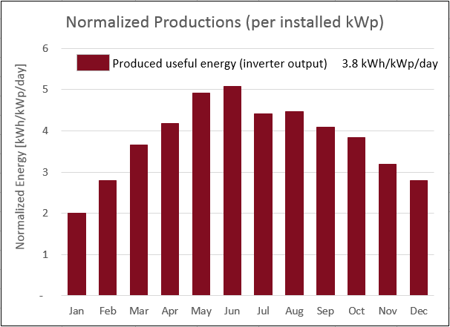

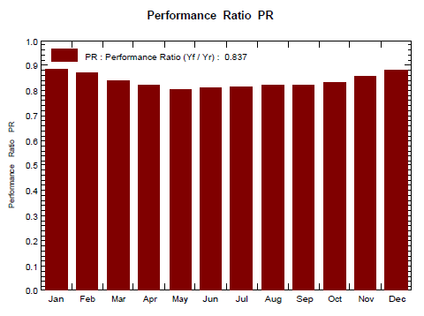

* Simulation Report is for first year of use.
* Actual results may vary due to specific site conditions.

**ANNEXURE -I**

# Payback Analysis

Tentative Payback Period is less than 03 years.

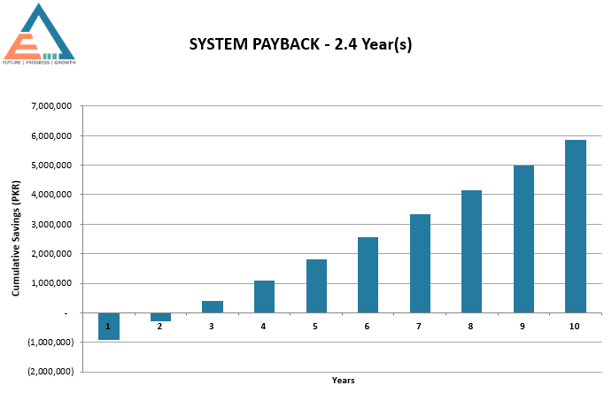

This analysis assumes the following:

* + Rs. 45 As average solar unit saving rate.
  + 10 % increase in unit cost per annum.
  + 1 % average degradation of solar panel performance.
  + No load shedding has been taken into account.
  + This analysis takes into account the export of excess energy back to grid through net metering (If Applicable).

1. According to Supplier / Manufacturer Terms and Conditions