|  |  |  |  |
| --- | --- | --- | --- |
| LSSTlogo | Document # | Date Effective | Status |
| Document-17402 | 05-MAR-2015 | DRAFT 1 |
| Author(s) |  |
| Walt Innes |  |
|  |  |  |
| Subsystem/Office | | |
| Systems Integration | | |
| Document Title | | | |
| Thermal Analysis of an RTM using SPICE | | | |

1. Change History Log

|  |  |  |
| --- | --- | --- |
| Revision | Effective Date | Description of Changes |
| 1 | 05-MAR-2015 | First draft |

1. Contents

1. Change History Log 1

2. Contents 1

3. Acronyms 2

4. Applicable Documents 2

5. Purpose and Scope 2

6. The Issue 2

7. The Method 2

8. The Cryo Circuit 3

9. The Cold Circuit 11

10. Thermal loads 15

11. Effect of thermal impedance differences **Error! Bookmark not defined.**

12. Effect of cadence differences 18

13. Heater failures 18

14. Temperature control loops, cool down, warm up 18

15. The Cold Circuit 23

16. Summary 24

17. Appendix 25

1. Acronyms

ADC Analog to Digital Converter

CCD Charge Coupled Device, aka sensor

REB Raft Electronics Board

ASPIC Dual slope integrating ASIC

CABAC Clock And BiAs Control ASIC

PREG Power Regulator

RTM Raft Tower Module

REC Raft Electronics Crate

FEA Finite Element Analysis

1. Applicable Documents
2. Thermal Model for SPICE (Steve Bellavia)
3. Raft Power Summary (Rick Van Berg).
4. IR Radiation from L3 (updated) (Document 7926, Gordon Bowden)
5. Gain Stability Budget (LCA-10065).
6. CCD Heat Flow (Innes, March 2012 Camera Workshop)
7. Thermal Effects Due to Cadence in the REB (LCA-16549, Bellavia, Innes Van Berg)
8. Consequences of Heater Failures (LCA-16628, Innes)
9. Purpose and Scope

This note describes an analysis of the thermal control the Raft Tower Modules (RTMs) using the electronics simulation tool Spice. This note is primarily focused on describing how the tool is used and its input assumptions. The most critical analysis results will also be presented.

1. The Issue

Maintaining the sensor array at the desired temperature and keeping that temperature constant between calibrations is critical to meeting the LSST’s science requirements. Our ability to do this is among the most serious of our outstanding risks. The Science Raft specification calls for a sensor temperature stability of 0.25 K over a twelve hour observing period and a stability of 1 K for the cold plate over that same period. The cryostat specification calls for a stability of 1 K for the cryo plate. The Science Raft specification for the sensor temperature is –100+-5 C. The cryostat specification calls for a cryo plate temperature of -130 C.

1. The Method

PSpice (a proprietary version of Spice) is an electronics simulation tool. A thermal system is a perfect analog of an electrical one so PSpice may be used to simulate it. The analog quantities are:

* Potential in Volts is the analog of absolute temperature in Kelvin.
* Current in Amperes is the analog of heat flow in Watts.
* Capacitance in Farads is the analog of heat capacity in J/K.
* Resistance in Ohms is the analog of thermal impedance in K/W.
* Heat sinks are represented by voltage sources.
* Heat sources are represented by current sources.

Large chunks of material are represented as distributed RC networks (very lossy transmission lines) specified by their total heat capacity and their effective end to end thermal impedance. We choose to break these large chunks into 8 equal pieces. The heat capacities are taken from a table derived from a 3D ANSYS simulation. The thermal impedances are inferred from the static thermal solution from that same model as are the resistances that represent the thermal-contact impedances. See the Excel spread sheet, REB_1-D_Model_10-08-2014_revA, from Steve with help from Jessica Li. We entered the description of the system using the schematic capture tool ORCAD Capture.

More complicated objects and connections are represented by Analog Behavioral Models, i.e., boxes executing algebraic functions. These are used to describe non-conductive (radiative and convective) heat transfer, implement lookup tables representing refrigerators, and perform integration.

The resulting model is a multiply connected 1 D network. Effects included in the model are:

* All known components in one RTM (3 REBs treated as a single larger one).
* All radiative heat paths
* All conductive heat paths
* Cryo and cold refrigerator behavior
* Proportional Integral (PI) control loops ( sensors, cryo-plate, cold plate)
* Assumes high quality heat shields over the REBs (e.g., gold flashed Cu foil).

Some limitations are:

* Emissivities are not temperature dependent
* Heat capacities and resistivities are not temperature dependent
* Some emissivities are not well known
* Cryo refrigeration performance may be different
* Refrigerator performance is not dependent on the ambient temperature.
* Cannot evaluate differences across the raft as the sensors are treated as one lump.
* Assumes effects such as radiation from the cryostat are uniform over all RTMs. Differences are estimated to be small.
* Also assumes that the full system is 22.3 science rafts, i.e., that the corner rafts are one third of a science raft. This is an underestimate, and a value between 23 and 24 would have been better. This difference has small, partially offsetting, effects on several parameters.

There are two main heat flow paths defined by their respective primary heat sinks, the cryo plate and the cold plate. We will now describe each circuit in detail.

1. The Cryo Circuit

The cryo circuit starts with the sensors and the heat sources connected to the sensors and runs through the raft base plates, the thermal straps, the REC box sides to the cryo plate, where the heat is removed by the cryo refrigerator evaporator loops. The schematic for this circuit is shown in Fig. 1. Material is represented by the transmission lines, TLURC8. TLURC stands for lumped RC transmission. The 8 indicates that the overall capacitance and resistance has been divided into 8 pieces. Most of the resistors represent thermal-contact impedances. R7 represents the flex cables (all of them in one RTM) connecting the sensors to the REBs (all three of them in an RTM). PID and PID2 are the proportional-integral controllers, which regulate the temperatures of the sensors and the cryo plate respectively by controlling heaters G1 and G2.

Let’s start with the heat sources. The radiative heat load from L3 is connected at IR-PWR. Figure 2 shows the model for this source. This one dimensional L3 has the average thickness of the actual 3D lens. R9 represents the heat transferred from the gas in the camera body to the lens and is dependent on



Figure 1. Cryo circuit schematic.

the velocity of that gas as described by Gordon Bowden in his Camera Engineering Note CE1-06. The velocity used is 1 m/s (Vair). The voltage source on the left is the ambient temperature in the body, which is supposed to be within 1 K of the dome temperature. The limit boxes are there to ensure that solutions are physical. The two ABM boxes implement the Stefan-Boltzman equation as applied to parallel surfaces whose separation is much smaller than their dimensions:

where  is the Stefan-Boltzman constant, *A* is the area, *T1* and *T2* are the temperatures of the two surfaces, and *1* and *2* are their emissivities. The left hand box in the figure represents radiation from the environment to L3. The environment emissivity is assumed to be 0.95 and the emissivity of L3, 0.91. While L3 has an anti-reflection coating, this will not work in the mid-infrared and the glass will have its standard value. The box on the right describes the radiation from L3 to the sensors. The emissivity of L3 is again 0.91 and the emissivity of the sensors is 0.80. This latter is a very conservative, i.e., high value, since the front surface reflectivity alone is nearly 30% for normal incidence and larger for other incident angles. (The refractive index is a bit larger than 3.4, and the anti-reflective coatings will be ineffective.)

The 2 integral of the reflectance of unpolarized light is 0.37. Of the infrared radiation that makes it through, 10% or so will be diffusely reflected back by the ceramic substrate, but much of this will be internally reflected, yada, yada, yada.

The lumped element, T7, represents L3 itself. There is no conductive path between L3 and the sensors; R11 is there just for computational stability and is too large to have a significant effect.

The other heat sources at the sensors are the flex cables previously mentioned and the process power in the sensors themselves. This latter is represented by the current source I12, which has a value of 3.84 W. R18 represents the cables from the REB to raft heaters. This is a significant heat flow path to the raft base plate.

Returning to Fig.1, we next examine the material and the thermal contacts. The material lumps are labeled. The resistors connecting them are the thermal contacts. The values for these come from the Finite Element Analysis, FEA, done using the ANSYS model generated by Steve Bellavia. His model is a very detailed 3D description of the an RTM. Given the dimensions, material and typical temperature, the software can generate the heat capacity and resistivity of the elements. This software can generate time dependent solutions, but this is very computer intensive. Dynamic behavior and various what ifs that are needed for thermal design are more easily explored with the Spice model. On the other hand, the ANSYS model can yield detailed descriptions of temperature within components such the temperature distribution across the sensor array. The flow of heat through the bulk material is complicated and difficult to calculate from first principles. Static solutions to the ANSYS model can be used to infer the effective thermal impedance of the bulk components and the impedances of the contacts. The latter have some uncertainty and the sensitivity to their values has been studied. The ANSYS methodology has been tested by applying the method to a partial RTM in Test Stand 9. The results were report by Steve on Confluence, Camera Science Raft -> Raft Sensor Assembly -> Mechanical Test Reports -> Attachments. There was very good agreement between the FEA and the measurements, as is shown in Fig. 3. The values inferred from the FEA model for the production science rafts are given in Table 1.

There are other heat sources which connect primarily to the REC Box Sides and the cryo plate itself. They are radiation and conduction from the REBs to the Box Sides, from the cryostat to the grid (which is strapped to the cryo plate), and from the cold plate to cryo plate. The schematics for these heat flows are shown in figures 4, 5, and 6. The construction parallels that of the L3 radiation model. The critical values are the values of the emissivities that are used. For the cryostat to the floating shroud and floating shroud to grid shroud, a value of 0.03 is used for the combined emissivity factor. Since gold flashed polished copper on both surfaces would give 0.015, this is conservative, assuming due diligence.



Figure 2. Model of L3.

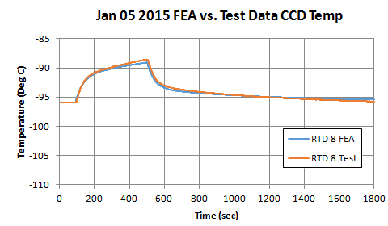

Figure 3. Test stand 9 ANSYS FEA vs. measurement (from Steve Bellavia).

|  |  |  |  |  |  |
| --- | --- | --- | --- | --- | --- |
|  | **Ri** | **Mass** | **Cp** | **M*Cp** | **Q** |
|  | K/W | Kg | J/Kg-K | J/K | Watts |
| **1. CCD (Sensor)** | **0.556** | **0.391245** | **237.3** | **92.824** | **10.35** |
| **2. Thermal Contact: CCD-to-Raft Baseplate** | **0.102** |  |  |  |  |
| **3. SIC baseplate** | **0.008** | **0.444335** | **173.2** | **76.9587** | **0 to 2** |
| **4. Thermal Contact Sic to Thermal Strap** | **0.162** |  |  |  |  |
| **5. Thermal Strap** | **1.152** | **0.089611** | **342.0** | **30.6469** |  |
| **6. Thermal Contact: Thermal Strap - REC Walls** | **0.192** |  |  |  |  |
| **7. REC Walls** | 0.372 | 1.931776 | 342.0 |  |  |
| **Hold-down mechanisms** |  | **0.417801** | **316.2** | **132.109** |  |
| **8. Thermal Contact: REC walls - Cryo plate** | **0.127** |  |  |  |  |
| **Total Contact** | **0.581** |  |  |  |  |
| **Total Other** | **2.063** |  |  |  |  |
| **Total** | **2.64** |  |  | **1028.72** |  |

Table 1. Cryo circuit component values. The actual values in the model may be read from the schematics and/or the appendix.



Figure 4. Model for heat flow from the cryostat walls to the grid shroud.



Figure 5. Model for the heat flow from the REBs to the REC box sides.

For the Box Side to REB radiation, one surface is assumed to be black and the other to have an emissivity of 0.05. This should be easy to achieve and could be improved by at least a factor of two. However, the heat flow between these components is dominated by the conduction via the support pins. The model uses a value of 46 K/W for the ensemble of support pins in an RTM. This is based on the an ANSYS analysis of the current design, which uses stainless steel bolts and a G10 spacer arranged so that the heat has to flow through the spacer. This gives a heat leak of 1.9 W/RTM.

Figure 6 describes the conduction and radiation from the cold plate to the cryo plate plus various conduction paths due to support structures for the plates and the grid. The combined emissivity assumed for the cold-cryo plate connection is 0.05. Resistors R14, R15, and R19 are the supports.



Figure 6. Model for the heat flow from the cold plate to the cryo plate. Also includes details on grid to cryo plate heat flow.

The remaining parts of the cryo circuit are the heaters, the heater controllers, and the cryo refrigerator. The components G1 and G2 are the heaters. The heat setting, in Watts, is given by the gain times the control voltage. The control voltage for G1 ranges from 0 to 2 Volts, so G1, the sensor base plate heater, has a maximum of 8 Watts. G2, the cryo plate heater, has a control voltage range -8 to 0 Volts and the gain is -2, so the maximum heater value is also 16 Watts. This scales to 357 Watts for entire cryo plate. The current design has a maximum capacity of 300 W.

Figures 7 and 8 show the schematics for the Proportional Integral controllers. The difference between the measured temperature and the set point is multiplied by the proportional gain. A Laplace transform box is used to integrate this signal. The integral is added to the proportional term. The sum is limited to a value that has meaning for the heaters. A value proportional to the difference between the limited and unlimited output is added to the input of the integrator to prevent the integral from growing without limit while the output is limited (“anti-windup”). In this example the proportional gain for the sensor heater controller is 15 and the integration time is 500s. For the cryoplate, the gain is 0.2 and integration time is 1000s.

The final element is the lookup table, GTABLE, G3, which models the cryo refrigerator behavior. The cooling performance vs. temperature curve is drawn from measurements, done at SLAC using a prototype system and Mix 21-18, which are plotted in Figure 9.



Figure 7. PID2 Proportional Integral Controller. The controller for the cryo plate heater.



Figure 8. PID Proportional Integral Controller. The controller for the sensor base plate heater.

Figure 9. Cooling capacity vs. temperature for one cryo refrigeration circuit. To get the values used in the model, multiply by 5 circuits and divide by 22.3 RTMs. The nominal design calls for 6 circuits. These data are from tests done at SLAC using a prototype refrigeration system.

1. The Cold Circuit

Figure 10 shows the very busy cold plate circuit. Most of this circuit is the REB and its components. Thermal zones containing particular components are generally divided into two lumps and the heat generated by the components is injected between them. In addition to the active components and the portions of the REB in their thermal zones, there are additional parts such as the cold bars and the cold straps. The schematic is multiply connected because of the bridging done by the cold bars. The values for the components are given in Table 2 for one REB. These all need to be multiplied by three for the complete RTM in the Spice model. Also shown on this schematic are the cold straps, which connect to the cold plate, and the heat dissipation due to the sensor trim heater control, which is assumed to be done by a linear regulator.



Figure 10. The cold plate circuit.

|  |  |  |  |  |  |
| --- | --- | --- | --- | --- | --- |
| G's | G |  | **q's** |  |  |
|  | (W/K) |  |  | ( W) |  |
| G01 | 0.011 | flex |  |  | **3 CCD's** |
| G1a | 0.111 | REB | **q1** | 0 | **connector** |
| Ga2 | 1.184 | REB | **qa** | 0 | **CB-a** |
| G23 | 0.754 | REB | **q2** | 5.76 | **CS** |
| G34 | 0.828 | REB | **q3** | 0 | **CB-3** |
| G45 | 0.182 | REB | **q4** | 1.45 | **ASPIC** |
| G56 | 0.118 | REB | **q5** | 3 | **CABAC** |
| G67 | 0.292 | REB | **q6** | 0 |  |
| G78 | 0.271 | REB | **q7** | 0 | **CB-7** |
| G89 | 0.256 | REB | **q8** | 0.14 | **ADC's** |
| G9-10 | 0.349 | REB | **q9** | 1.21 | **diff amp** |
| G10-11 | 0.851 | REB | **q10** | 4.4 | **Pregs** |
| G11-12 | 0.364 | REB | **q11** | 0.04 | **CB-11** |
| Gcb_a-3 | 2.241 | CB-bridge | **q12** | 3.25 | **FPGA** |
| Gcb_3-7 | 0.359 | CB-long |  |  |  |
| Gcb_7-11 | 0.324 | CB-short |  |  |  |

Table 2. Cold Circuit component values from the 1D analysis by Jessica Li and Steve Bellavia.

Figure 11 shows the cold plate temperature control circuitry. There is a PI controller like the ones described previously. The heater is capable of delivering 13.5 W, the complete loop gain is 60 W/K, and the integration time constant is 100s. The cold refrigeration is done by the lookup table G7, whose values were drawn from the Danfoss specification sheet for the model GS26CLX compressor using R404A refrigerant. We assume 2 refrigeration circuits and 22.3 RTMs. The performance curve is shown in Figure 12. The capacity increases rapidly with temperature. The typical requirement for the cold circuit, exclusive of cold plate heater output is 50.4 W/RTM. This is achieved at -38 C. The temperature drop from the cold bar to the cold plate is 14.2 K. If we lose one of the two circuits, the required cooling would be achieved with a cold plate temperature of -27 C resulting in a rise of the cold bar temperature to -13 C from the nominal -22 C. This 9 K change would have negligible effect on the cryo circuit. The changes in the REB gains, if significant, could be calibrated out.



Figure 11. The cold plate control circuit.

Figure 12. The cold refrigeration performance assuming two circuits and 22.3 RTMs. This for a Danfoss GS26CLX compressor with R404A refrigerant.

This completes the description of the model. Now let’s make a few observations and review a few past results obtained with the model.

1. Thermal loads

First let’s look at the static (bias) solution shown in the schematics. Remember the voltages are temperature in K and the currents are heat flow in Watts. This particular solution is for an ambient temperature 298K, the maximum value in the environmental specification. The sensor temperature is set to 173 K, the cryo plate temperature to 145 K and cold bar temperature to 251 K. The resulting cold plate temperature is 236.7 K. These settings require 1.86 W of sensor base plate heat, 1.16 W of cryo plate heat, and 8.64 W of cold plate heat, all for one RTM. The radiative heat load on the sensors is 2.3 W, the REB to Box Side leak is 3.3 W, the flex cable leak is 3.0 W, and the various other miscellaneous leaks add up to 2.4 W. The total load on the cryo refrigerator is 17.7 W. Excluding the trim heat reduces this to 14.7 W or 328 W for the full camera. More realistically we can adjust the temperature set points so that the required trim heat is 1 W each for the sensors and the cryo plate at this highest of ambient temperatures. This would give refrigerator burden of about 16.7 W/RTM or 372 W for the full camera. Changing the ambient temperature to the minimum reduces the L3 radiation to 1.5 W. The same one Watt per heater exercise as above yields 14.4 W/RTM and 321 W for the camera. Figure 13 shows the raft heat vs. ambient temperature.

These simulation results should be compared to the cryostat subsystem specification of 540 W @ 142 K giving a margin of 45%. Current tests of the cryo refrigerator are consistently delivering more than 85 W @ 148 K for one circuit ( 510 W for 6 circuits), with peak values well over 100 W per circuit @ 148 K. The cold circuit cooling capability that was discussed above has 16% margin with all the specified set points. If we accept an increase in the REB temperature of 10 K, the margin is 100%.

The result for the cryo-plate heat load seem seems surprisingly optimistic, so let’s examine the contributions one by one. The L3 radiation load is smaller than Gordon Bowden’s due to different choices for emissivities as discussed in the text above. The CCD process power is assumed to be 3.84 W/RTM. Table 4 in LCA-16549 gives an estimate of less than 3.6 for the ITL devices and somewhat less than this for e2v devices. This is sensitive to the output drive setting, but the ITL estimate is considered to be at the high end of possible settings. The choice in the Spice model, which is an old best estimate, remains reasonable and conservative . The heat flow down the flex cables is 2.95 W/RTM. This was a design goal in the thermal rezoning and REB design. The raft heater leads are often overlooked, but included here. The various other IR loads are smaller than those estimated by J Langton due assuming more careful control of emissivity of various surfaces. The effect of emissivity is shown in figure 14. This shows a total trim margin of 150 W with 6 circuits and 70 with 5 circuits for my nominal choice of 0.05 for the copper surfaces. For J’s choice of 0.3, we would have to raise the sensor temperature by about 10 K if we lost a refrigeration circuit. On the whole, the miscellaneous conduction paths sum to values similar to J’s. Altogether, these paths add up 5.3 W/RTM. The biggest contributor is conduction through the REB supports (2.62 W/RTM). This latter is an important number since this conduction path dominates the radiation path between the REBs and the REC. The impedance between the two is 46 K/W. Therefore, an increase of 10 K in the REB temperature would increase the heat load on the cryo circuit by 0.22 W/RTM. The flex cable would add 0.33 W/RTM and the heater lead 0.55 W/RTM for a total of 1.10 W/RTM or about 23 W total (2.3 W/K).

To summarize, the source of differences between the result of the Spice simulation and other estimates of cryo plate heat load are understood. They are partly due to more careful consideration of the actual system in its entirety and assumptions of more care in the construction. The latter points out where care in the thermal treatment is essential to maintaining our margin in the refrigeration system.

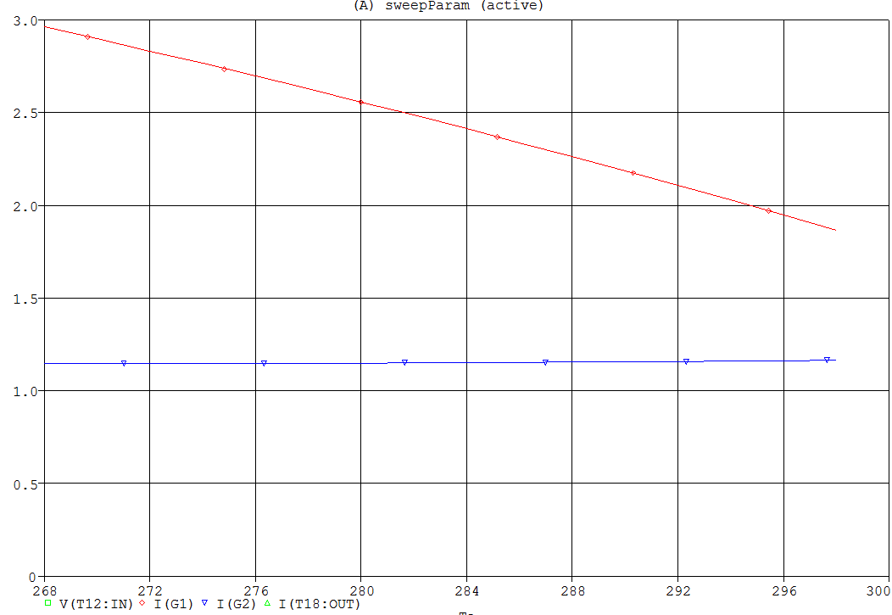

Heat (W)

Ambient temperature (K)

Figure 13. Raft heat (red) and cryo plate heat (blue) vs. the ambient temperature.

Figure 14. Total trim heat vs. surface emissivity.

1. Thermal impedance variations

A major source of load on the cryo refrigeration system is the trim heat. Ambient temperature variations only require a modest range of trim heat, 0 to 2 W/RTM. The 8 W requirement stems from a desire to compensate for raft to raft differences. Since the spec allows for a 10 K range in raft temperatures, we must be expecting large variations. The usual proposed source for such variations is the thermal impedance in the cryo-plate cooling path caused by varying contact impedances.

This study required a few special purpose mods to the PSpice model to accommodate a range of impedance factors. The cryo refrigeration is increased by 25%, i.e., going from four to five circuits of 95 W @ 143 K cooling. The cryo-plate temperature set point is lowered to 139 K. The impedance parameter range F = 0.1 to 10. is evaluated, where F is a factor which multiplies all contact impedances in the CCD to cryo-plate path. The result is in the Figure 14.

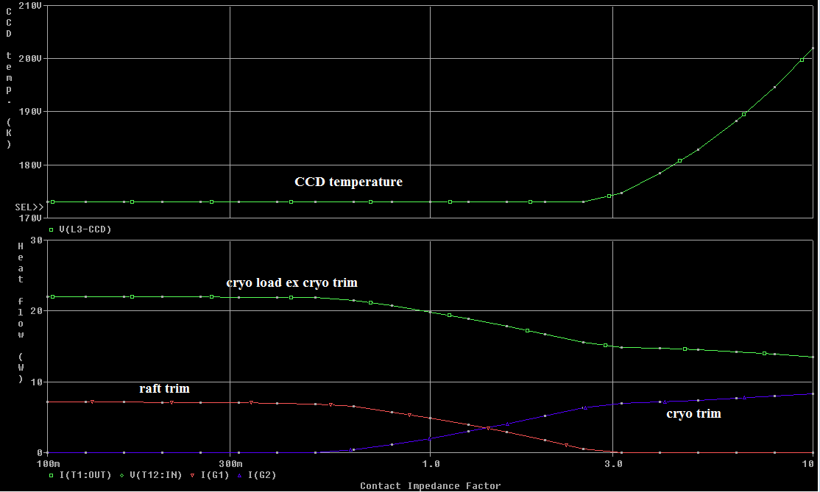

Figure 14. The effect of varying contact impedances.

For very low contact impedances, the raft trim heaters are near maximum (8 W). At 3 times nominal, the raft trim heaters have gone to 0. and can no longer regulate the CCD temperature. The cryo trim goes in the reverse of the raft trim and the total heat flow (cryo trim + cryo load ex trim) remains constant. The slope of the trim heat near the nominal value is about 1 W/ 20% change in the thermal impedance. Approaching from a more basic direction and ignoring some of the subtleties of this multiply connected system, we can look Steve's numbers for thermal impedances. His sum of nominal values is 2.64 K/W, of which, 0.58 or 22% is due to contact impedances. If we didn't have any trim heat, the temperature drop from CCD to cryo-plate would be about 25 K, of which, 5.4 K may be attributed to contact impedances. We are looking for effects which will break our +-5 K budget or roughly a factor of 2 in contact impedances.

This leaves us to evaluate how likely a variation this large will occur. My impression is that for a single contact, quite likely. However, all of our paths have multiple contacts and each contact stage is responsible for less than 40% of the contact impedance. The biggies are the thermal strap contacts and the REC to cryo-plate contacts. Assume there is a complete failure of a single contact. If no compensation is made with the trim heaters, the change in temperature of the CCDs would the normal temperature drop across that contact divided (N-1), where N is the number of contacts in parallel at that point in the thermal circuit. Each sensor had three contacts and a temperature drop of 0.83 K. Loss of one contact would increase the temperature by 0.42 K. For the raft to strap the numbers are 1.89 K and 0.63 K; for the strap to REC, 2.24 K and 0.74 K; and for the REC to plate, 1.9 K and 1.9 K.

If we conclude that we don't have to use the raft trim to compensate for raft to raft variations, I think we can use 1W as the nominal trim heat (for mean ambient temperature). This would save us more than 60W in cryo heat load vs. using 4W as the center point of an 8W range. Furthermore, we could agree to connect no more than one heater per REB, thus reducing peak power requirements on the REB power supplies.

1. Effect of cadence differences

The effects of cadence differences were studied and the results reported in LCA-10549.

1. Heater failures

The effects of heater failures were studied and the results reported in LCA-16628.

1. Temperature control loops, cool down, warm up

In this section some earlier results are presented. Not all details of the models used are as described above, but the differences have no consequences for the conclusions of the studies. Figures 15 through 17 show the closed loop response to changes in the sensor heat load.

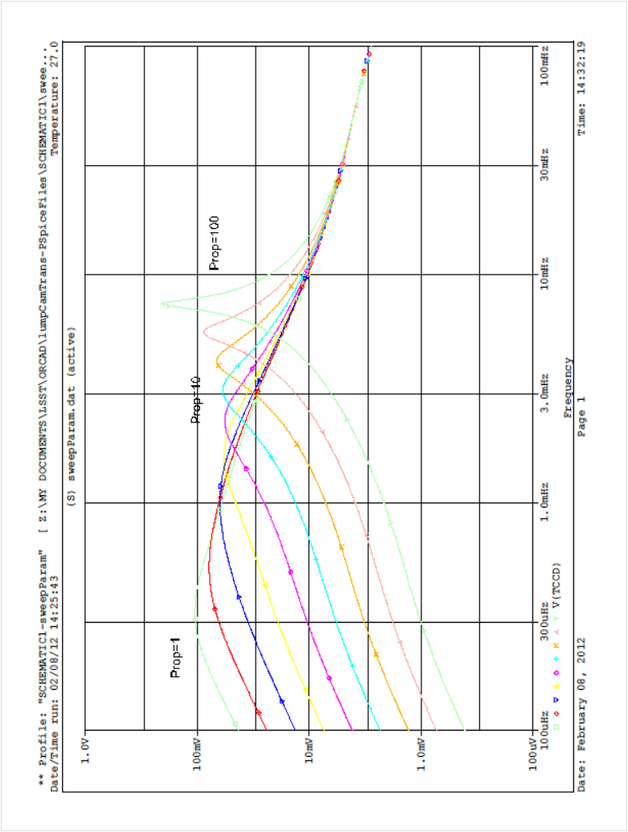

Figure 15. The closed loop CCD temperature response to 0.1 W changes in the CCD heat load. The integration time constant is set to 500 s and the frequency response is determined for a series of values of the overall gain {PROP}=W/DT. The values for {PROP} are distributed logarithmically with for four values per decade staring with 1 at top left and ending with 100 at the bottom left. The plot is log-log; the vertical scale goes from 100 K to 1 K; the horizontal scale goes from 100 Hz to 100 mHz.

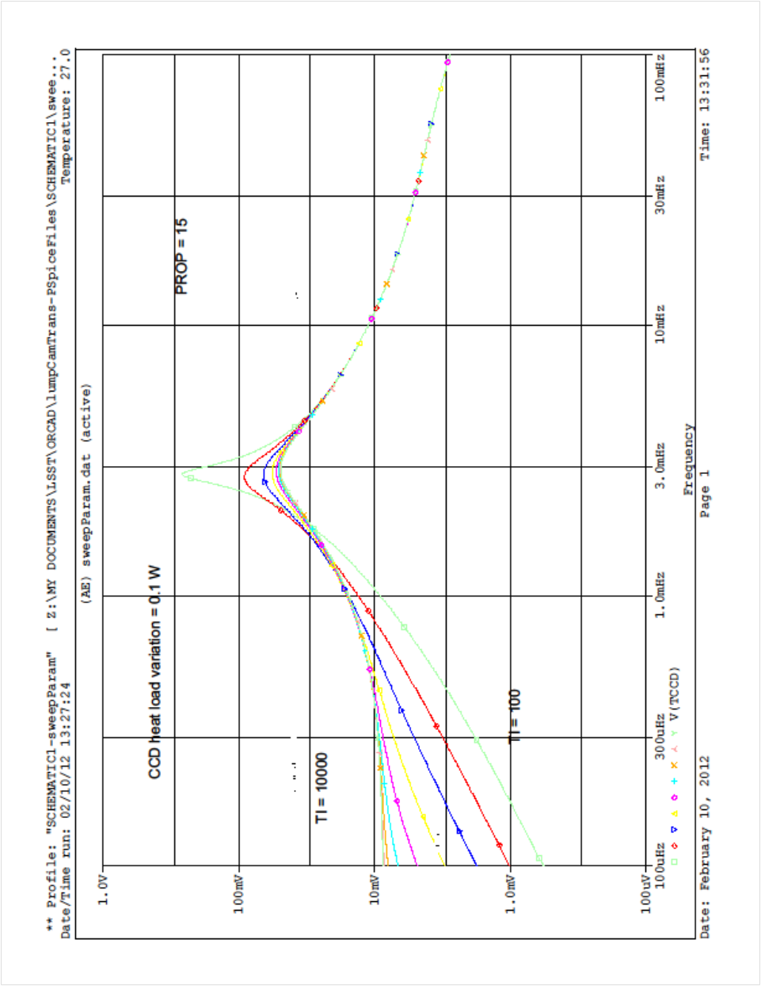

Figure 16. The closed loop response to 0.1 W changes in the CCD heat load for a fixed overall gain of {PROP} = 15. {TI} varies logarithmically from 10000 at the top left to 100 at the bottom left. There are four curves per decade. The plot is log-log; the vertical scale goes from 100 K to 1 K; the horizontal scale goes from 100Hz to 100 mHz.



Figure 17. Response to a 0.1 W step in the CCD heat load. The curves range from a gain {PROP} of 5 for the lowest curve and 50 for the highest. The middle blue curve is closest to the nominal value of 15. Both axes are linear; vertical axis ranges from 172.96 to 173.01 K. the horizontal axis goes from 0 to 2400 s. the step occurs at 100 s. The open loop step response would be 0.18 K.

Figures 18 and 19 show the same for changes in the cryo plate temperature.

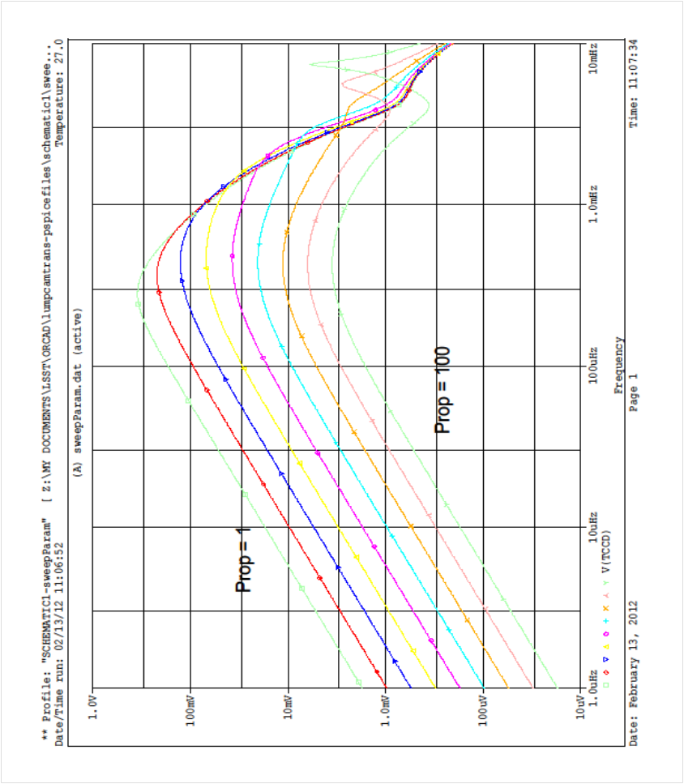

Figure 18. Frequency response to 1 K change in the cryo plate temperature. The curves are for different overall gain values and are logarithmically distributed from 1 to 100. The nominal gain of fifteen is close to magenta curve with the circle points. The vertical axis goes form 10 mK to 1 K. The horizontal axis goes from 1 mHz to 10 mHz.



Figure 19. The response to a 1 K step change in the cryo plate temperature. The top curve is for a gain of 5 and the bottom curve for a gain of 50. The middle curve is close to the nominal gain of 15. The plot is linear in both axes; the vertical axis goes form 173.0 K to 173.08 K; the horizontal axis goes from 0 to 4500 s. The step occurs at 100 s.

Figure 20 shows the response to 0.5 W ramps in the CCD heat load with a linear rises of varying lengths.



Figure 20. The response to 0.5 W ramps in the CCD heat load with a linear rises of varying lengths. The rise times are distributed logarithmically from 1000 s (top left) to 10000 s (bottom right). The vertical axis goes from 173 K to 173.024 K; the horizontal axis goes from 0 s to 16 Ks.

The cool down behavior of the system is shown in Fig. 21. The REB and sensor electronics were turned when the cold plate and cryo plate, respectively, neared their desired temperatures.

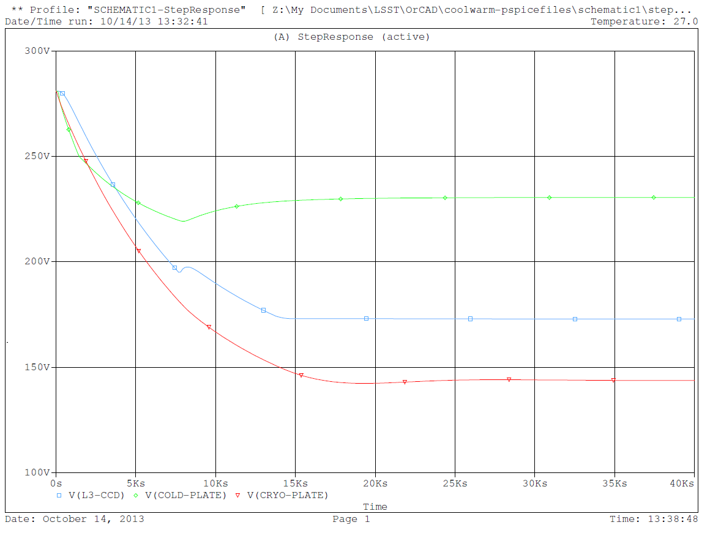

Figure 21. Cool down behavior. Green is the cold plate temperature, blue is the sensor temperature, and red is the cryo plate temperature.

The warmup with no heaters is shown in Fig. 20. The minimum REB temperature is 225 K.

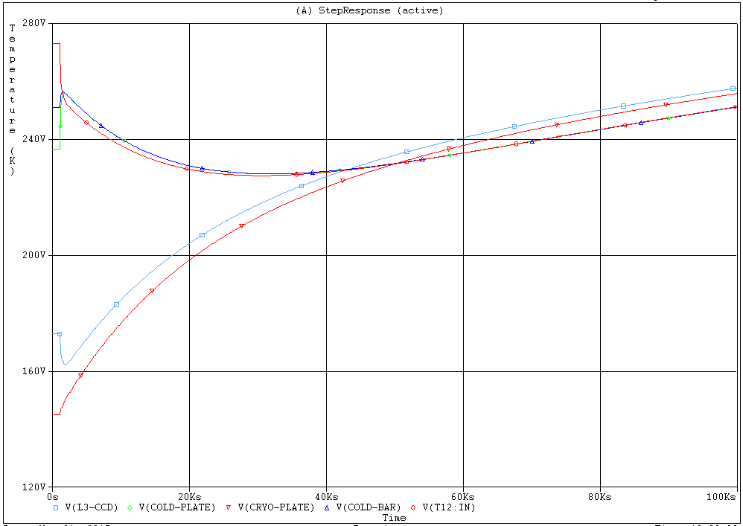

Figure 20. System warm up without the assist of heaters. Lower curves are sensor and cryo plate. Upper curves are the REB and the cold plate.

Warmup with the plate heaters full on is shown in figure 21.

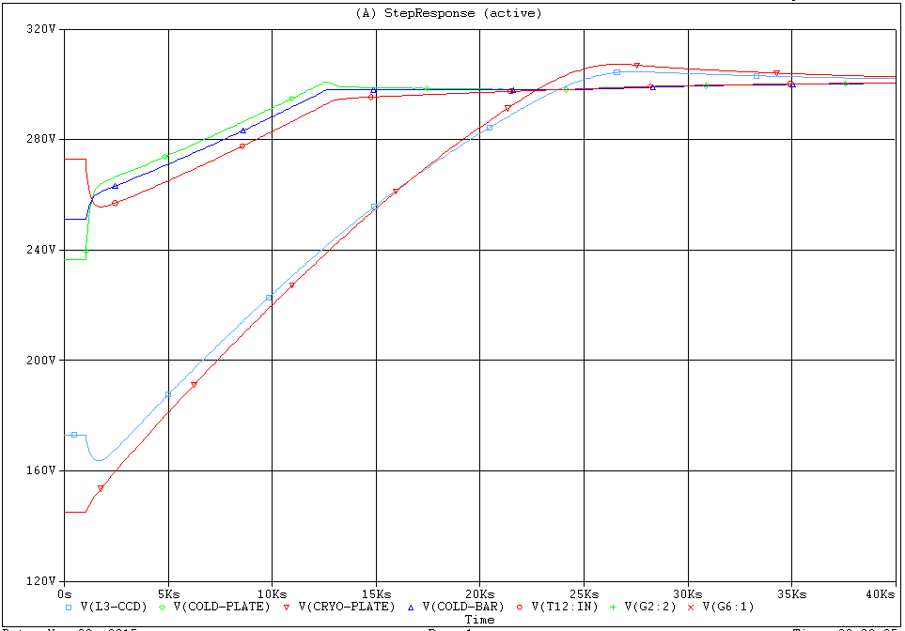

Figure 21. System warm up with the assist of heaters. Lower curves are sensor and cryo plate. Upper curves are the REB and the cold plate.

Figure 22 shows the frequency response to ambient temperature changes.

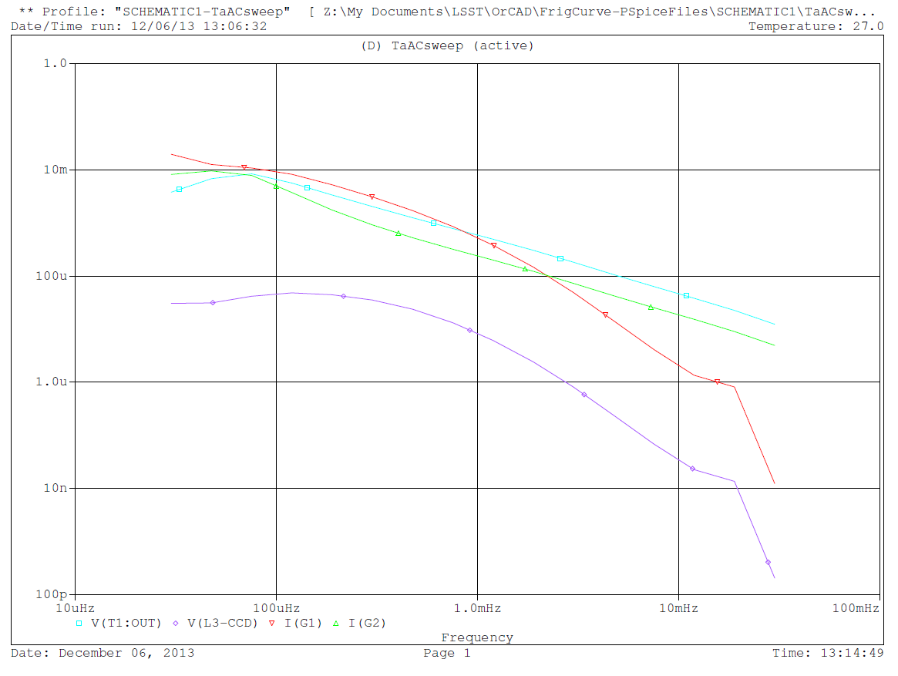

Figure 22. Frequency response to changes in the ambient temperature. Cyan is the cryo plate temperature response (K/K), green is the cryo plate heater response (W/K), violet is the sensor temperature response (K/K), and red is the raft heater response (W/K)

1. The Cold Circuit

Now let’s turn our attention to issues with the cold circuit. These are mainly to do with the REB temperature. Figure 23 shows the frequency response of the ASPIC temperature to changes in the ambient temperature. Figure 24 shows the changes in the APSIC temperature to changes in power dissipated by the power regulators.

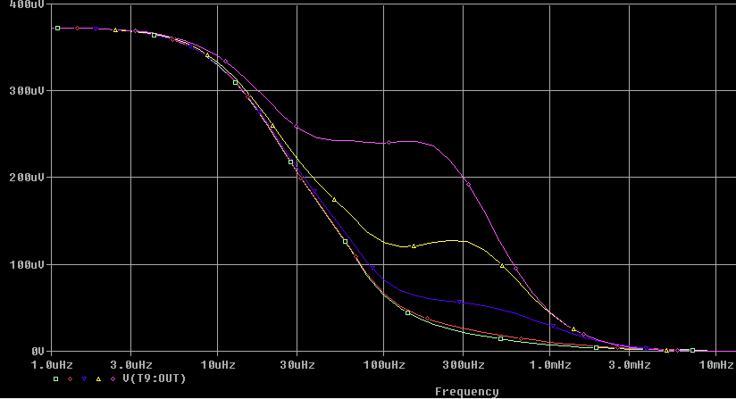

Figure 23. Frequency response of the ASPIC temperature to changes in ambient temperature. The different curves are for cold plate control loop integration times from 20 s to 1000 s. The longer times have higher value.

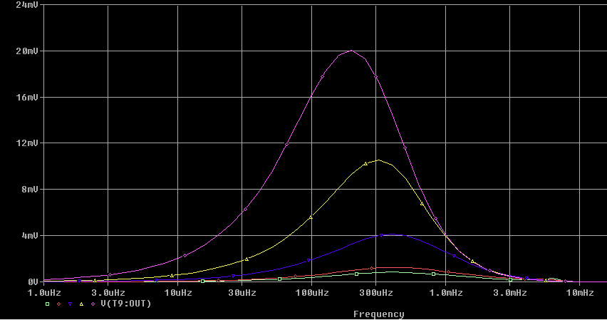

Figure 24. Frequency response of the ASPIC temperature to changes in the heat dissipation at the power regulators (PREGS).Curve colors as above.

Next, we examine the effect of differences in the thermal contact between the REB and the cold strap and the cold strap and the cold plate. Figure 25 shows the sensitivity those thermal contact impedances. Contact impedances increasing by a factor of 10 has ~ the same effect as losing a refrigerator circuit, i.e., it would increase the flex heat flow by 0.3 W/RTM.

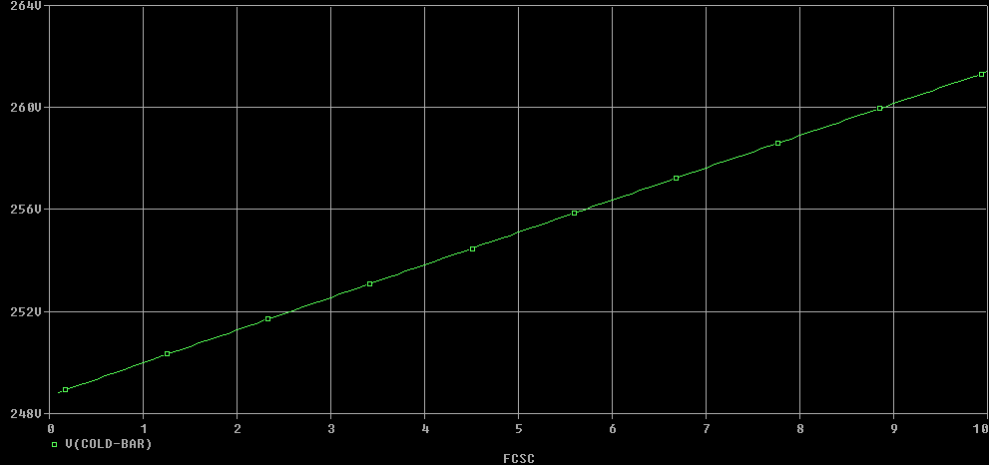

Cold bar temperature (K)

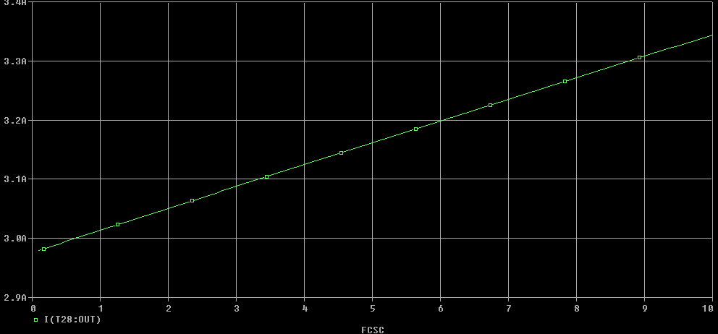

**Flex heat flow (W)**

0 1 5 10

**Factor relative to the nominal thermal contact impedance.**

Figure 25. REB to strap and strap to cold plate thermal contact dependence. Open loop (constant cold plate heater value). Vary both thermal contact impedances by a common factor WRT nominal.

1. Summary

The Spice model approach can provide answers to many of the questions affecting thermal design. Application to the current working design shows adequate margin in most parameters and isolates the largest risks.

1. Appendix

*17.1Material values*

|  |  |  |  |  |
| --- | --- | --- | --- | --- |
| **Reference** | **Value** | **C (F)** | **R ()** | **Object/Thermal Zone** |
| T1 | TLURC8 | 860 | 0.05 | Cryo plate |
| T2 | TLURC8 | 14.1 | 0.282 | ½ current source |
| T3 | TLURC8 | 363.5 | 0.1735 | ½ box side |
| T4 | TLURC8 | 30.7 | 1.152 | Box-raft strap |
| T5 | TLURC8 | 77 | 0.008 | raft |
| T6 | TLURC8 | 92.8 | 0.556 | sensors |
| T7 | TLURC8 | 1109 | 2.671 | L3 |
| T8 | TLURC8 | 22.3 | 0.442 | ½ current source |
| T9 | TLURC8 | 20.2 | 0.403 | ½ ASPIC |
| T10 | TLURC8 | 45.9 | 0.915 | ½ ASPIC |
| T11 | TLURC8 | 45.9 | 0.915 | ½ CABAC |
| T12 | TLURC8 | 141 | 2.82 | ½ CABAC |
| T13 | TLURC8 | 57.2 | 1.14 | Center REB |
| T14 | TLURC8 | 397 | 0.927 | Cold bar section |
| T15 | TLURC8 | 48.2 | 1.229 | Cold bar section |
| T16 | TLURC8 | 775 | 1.028 | Cold bar section |
| T17 | TLURC8 | 51.1 | 1.302 | ADC |
| T18 | TLURC8 | 129.39 | 0.259 | Cold straps |
| T20 | TLURC8 | 37.5 | 0.955 | ½ PREGs |
| T21 | TLURC8 | 15.4 | 0.392 | ½ PREGs |
| T22 | TLURC8 | 18 | 0.458 | ½ FPGA |
| T23 | TLURC8 | 18 | 0.458 | ½ FPGA |
| T24 | TLURC8 | 363.5 | 0.1735 | ½ box side |
| T25 | TLURC8 | 7.7 | 0.01 | Floating shroud |
| T26 | TLURC8 | 430 | 0.1 | Grid shroud |
| T27 | TLURC8 | 395 | 0.1 | Grid |
| T28 | TLURC8 | 19 | 3.003 | REB sensor end |
| T29 | TLURC8 | 201 | 0.149 | Cold bar section |

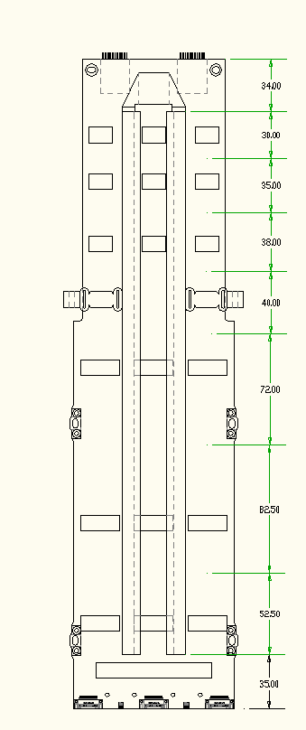

**9) voltage regulators**

**5)**

**2) current sources**

**1) flex circuit**

**6) Cold-plate attachment**

**3) ASPIC**

**4) CABAC**

**7) ADCs**

**8) diff amps**

**10) FPGA**

Figure 26. The definition of the thermal zones of the REB (from LCA 10771).

*17.2 Contact and other non-material impedances, material without conductance*

|  |  |
| --- | --- |
| **Reference** | **R(), C(F)** |
| R1 | {{F}*{R1V}} |
| R3 | {{F}*{R3V}} |
| R4 | {{F}*{R4V}} |
| R5 | {{FC}*{R5V}} |
| R6 | 90 |
| R7 | 30.1 |
| R9 | {21.9/SQRT({Vair})} |
| R10 | 46 |
| R11 | 10000 |
| R12 | 100000 |
| R13 | 100000 |
| R14 | 200 |
| R15 | 199 |
| R16 | {{FCSC}*0.013} |
| R17 | {{FCSC}*0.013} |
| R18 | 181 |
| R19 | 558 |
| C1 | 385 |

*17.3 Parameters*

|  |  |
| --- | --- |
| **AC** | 1 |
| **AG** | 0.022 |
| **AT** | 0.0144 |
| **AWG** | {GAWG} |
| **AWG2** | 4 |
| **AWG3** | 4 |
| **BB** | 0.092 |
| **EA** | 0.95 |
| **EAF** | 0.029 |
| **EAG** | 0.03 |
| **EAL** | {1/(1/{EE}+1/{EL}-1)} |
| **EB** | 0.05 |
| **EE** | 0.91 |
| **EL** | 0.91 |
| **ELL** | {1/(1/{EN}+1/{EL}-1)} |
| **ELS** | {1/(1/{EN}+1/{EL}-1)} |
| **EN** | 0.65 |
| **EP** | 0.05 |
| **ER** | 0.05 |
| **ERB** | {(EB*ER)/(EB+ER-EB*ER)} |
| **ES** | 0.6 |
| **F** | 1 |
| **FC** | {SQRT({F})} |
| **FCSC** | 1 |
| **IG** | 5.67E-08 |
| **Location** | 60 |
| **Location** | 90 |
| **NR** | 5 |
| **POW** | 0 |
| **PP** | 0.03 |
| **Prop3** | 10 |
| **R1V** | 0.127 |
| **R3V** | 0.192 |
| **R4V** | 0.162 |
| **R5V** | 0.102 |
| **RON** | 1 |
| **RR** | 1 |
| **SIG** | 5.67E-08 |
| **Ta** | 268 |
| **Tam** | 173 |
| **Tb** | 300 |
| **Tc** | 173 |
| **Tccd** | 173 |
| **TE** | 300 |
| **TI3** | 100 |
| **TL** | 1 |
| **TRISE** | 1 |
| **TRR** | 3600 |
| **Ts** | 173 |
| **Vair** | 1 |

*17.4 Formulae for the analog behavioral models*

|  |  |  |  |
| --- | --- | --- | --- |
| **Reference** | **Value** | **EXP1** | **EXP2** |
| ABM2I1 | ABM2I | ABS({EAL}*{IG}*{AT}* | (PWR(V(%IN1),4) - PWR( V(%IN2),4))) |
| ABM2I2 | ABM2I | ABS({ELL}*{IG}*{AT}* | (PWR(V(%IN1),4) - PWR( V(%IN2),4))) |
| ABM2I3 | ABM2I | {ERB}*{IG}*{BB}* | (PWR(V(%IN1),4) - PWR( V(%IN2),4)) |
| ABM2I4 | ABM2I | {EAF}*{IG}*{AG}* | (PWR(V(%IN1),4) - PWR( V(%IN2),4)) |
| ABM2I5 | ABM2I | {EAG}*{IG}*{AG}* | (PWR(V(%IN1),4) - PWR( V(%IN2),4)) |
| ABM2I6 | ABM2I | {EP}*{IG}*{PP}* | (PWR(V(%IN1),4) - PWR( V(%IN2),4)) |
| ABMII9 | ABMII | 4*SQRT(V(%IN)*(2.01-V(%IN))) |  |

*17.5 Lookup tables and gains*

|  |  |  |  |
| --- | --- | --- | --- |
| **Reference** | **Value** | **GAIN** | **Table** |
| G1 | G | 4 |  |
| G2 | G | 2 |  |
| G3 | GTBL |  | (0.,0.),(126.7,15.2.),(135.7,17.4),(195.9,19.7),(220.,28.8),(289.,71.7) |
| G6 | G | 6 |  |
| G7 | GTBL |  | (140,0),(228,29),(233.,45),(238,63),(243,85),(248,111),(253,142),(258,177),(300,200 |
| GAIN2 | GAIN | PROP3 |  |
| GAIN4 | GAIN | AWG3 |  |

**2) current sources**

**1) flex circuit**

**3) ASPIC**

**4) CABAC**