Q1.
For this project, I selected Cryptochrome-1 (CRY1) from Homo sapiens as my starting protein.
The RefSeq accession number for this protein is NP_004066.1, or Q16526 for UniProt.
Q2.
Among the top hits, a strong match was identified as Bos taurus cDNA clone LB01721.CR_O20 GC_BGC-17 IMAGE:8095822 5′, mRNA sequence (GenBank accession DV817148.1). The sequence was annotated only as a cDNA clone with no defined functional name, making it a suitable candidate for a potentially novel homolog of human CRY1.
The alignment between the human CRY1 query and the Bos taurus sequence showed an E-value of 0.0, a bit score of 609, and 99.3% sequence identity across a 901-nt region. These results indicate a very high level of homology, suggesting that this Bos taurus clone encodes a protein closely related to human Cryptochrome-1.
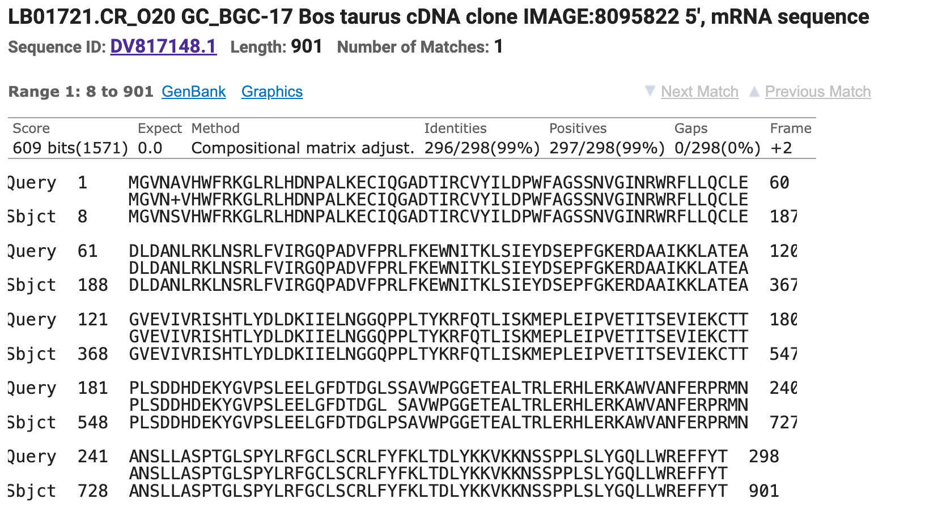
Q3.
Protein sequence:
>putative_CRY1_like|Bos_taurus|DV817148.1|ORF2|frame+2|len=297aa
MGVNSVHWFRKGLRLHDNPALKECIQGADTIRCVYILDPWFAGSSNVGIN
RWRFLLQCLEDLDANLRKLNSRLFVIRGQPADVFPRLFKEWNITKLSIEY
DSEPFGKERDAAIKKLATEAGVEVIVRISHTLYDLDKIIELNGGQPPLTY
KRFQTLISKMEPLEIPVETITSEVIEKCTTPLSDDHDEKYGVPSLEELGF
DTDGLPSAVWPGGETEALTRLERHLERKAWVANFERPRMNANSLLASPTG
LSPYLRFGCLSCRLFYFKLTDLYKKVKKNSSPPLSLYGQLLWREFFYT
Name (provisional): Putative cryptochrome-1–like protein
Species: Bos taurus (from cDNA clone LB01721.CR_O20 GC_BGC-17 IMAGE:8095822; GenBank DV817148.1)
How obtained: The nucleotide sequence DV817148.1 was translated with NCBI ORFfinder (standard code; ATG start; six-frame translation). I selected the longest ORF (ORF2, + strand, frame +2, 894 nt / 297 aa) with no internal stops.
Q4.
As shown by figure below, none of my hits had 100% identity to this protein. The best BLASTP hit is Cryptochrome-1 from Bos mutus (ELR57829.1) with 99.66% identity, 0.0 E-value, and 0 gaps over 298 aa. Because the top match is <100% identical and from a different species than the source clone (Bos taurus), this satisfies the project’s definition of a novel homolog.
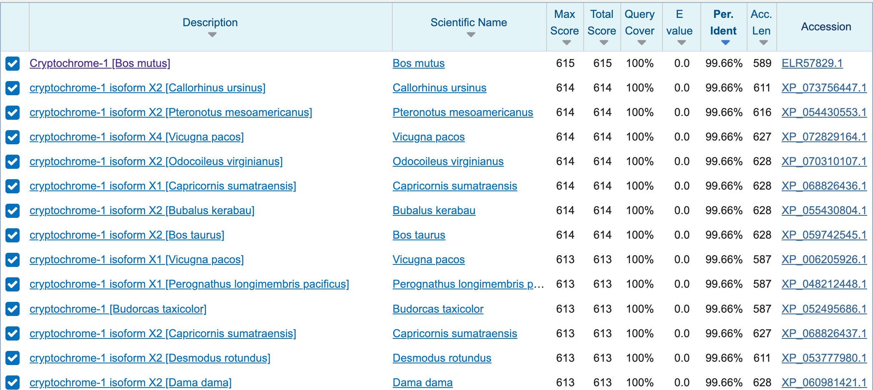
Q5.
The members I chose, aside from Cryptochrome-1 and Putative cryptochrome-1-like protein, are: Mus musculus CRY1, Bos taurus CRY1, Gallus gallus CRY1, Danio rerio CRY1a or CRY1b, and Arabidopsis thaliana CRY1.

Human_CRY1_586aa ---------MGVNAVHWFRKGLRLHDNPALKECIQGADTIRCVYILDPWFAGSSNVGINR
Mouse_CRY1_606aa ---------MGVNAVHWFRKGLRLHDNPALKECIQGADTIRCVYILDPWFAGSSNVGINR
Cow_CRY1_587aa ---------MGVNAVHWFRKGLRLHDNPALKECIQGADTIRCVYILDPWFAGSSNVGINR
Chicken_CRY1_621aa ---------MGVNAVHWFRKGLRLHDNPALRECIRGADTVRCVYILDPWFAGSSNVGINR
Zebra_fish_CRY1_658aa ---------MAPNSIHWFRKGLRLHDNPALQEAVRGADTVRCVYFLDPWFAGSSNLGVNR
Arabidopsis_CRY1_681aa MSGSVSGCGSGGCSIVWFRRDLRVEDNPALAAAVRAGPVI-ALFVWAPEEEGHYHPGRVS
PutativeCow_CRY1_298aa ---------MGVNSVHWFRKGLRLHDNPALKECIQGADTIRCVYILDPWFAGSSNVGINR

Human_CRY1_586aa WRFLLQCLEDLDANLRKLNSRLFVIRGQPAD-VFPRLFKEWNITKLSIEYDSEPFGKERD
Mouse_CRY1_606aa WRFLLQCLEDLDANLRKLNSRLFVIRGQPAD-VFPRLFKEWNITKLSIEYDSEPFGKERD
Cow_CRY1_587aa WRFLLQCLEDLDANLRKLNSRLFVIRGQPAD-VFPRLFKEWNITKLSIEYDSEPFGKERD
Chicken_CRY1_621aa WRFLLQCLEDLDANLRKLNSRLFVIRGQPAD-VFPRLFKEWSIAKLSIEYDSEPFGKERD
Zebra_fish_CRY1_658aa WRFLLQCLDDLDSNLRKLNSRLFVVRGQPAN-VFPRLFKEWKISRLTFEYDSEPFGKERD
Arabidopsis_CRY1_681aa RWWLKNSLAQLDSSLRSLGTCLITKRSTDSVASLLDVVKSTGASQIFFNHLYDPLSLVRD
PutativeCow_CRY1_298aa WRFLLQCLEDLDANLRKLNSRLFVIRGQPAD-VFPRLFKEWNITKLSIEYDSEPFGKERD

Human_CRY1_586aa AAIKKLATEAGVEVIVRISHTLYDLDKIIELNGGQPPLTYKRFQT----LI-SKMEPLEI
Mouse_CRY1_606aa AAIKKLATEAGVEVIVRISHTLYDLDKIIELNGGQPPLTYKRFQT----LV-SKMEPLEM
Cow_CRY1_587aa AAIKKLATEAGVEVIVRISHTLYDLDKIIELNGGQPPLTYKRFQT----LI-SKMEPLEI
Chicken_CRY1_621aa AAIKKLASEAGVEVIVRISHTLYDLDKIIELNGGQPPLTYKRFQT----LI-SRMEPLEM
Zebra_fish_CRY1_658aa AAIKKLAMEAGVEVIVKTSHTLYNLDKIIELNGGQPPLTYKRFQT----LI-SRMDPPEM
Arabidopsis_CRY1_681aa HRAKDVLTAQGIAVRSFNADLLYEPWEVTDEL-GRPFSMFAAFWERCLSMPYDPESPLLP
PutativeCow_CRY1_298aa AAIKKLATEAGVEVIVRISHTLYDLDKIIELNGGQPPLTYKRFQT----LI-SKMEPLEI

Human_CRY1_586aa PVETITSEVIEKCTTPLSDDHDEKYGVPSLEELGFDTDGLSSAVWPGGETEALTRLERHL
Mouse_CRY1_606aa PADTITSDVIGKCMTPLSDDHDEKYGVPSLEELGFDTDGLSSAVWPGGETEALTRLERHL
Cow_CRY1_587aa PVETITSEVIEKCTTPLSDDHDEKYGVPSLEELGFDTDGLPSAVWPGGETEALTRLERHL
Chicken_CRY1_621aa PVETITPEVMQKCTTPVSDDHDEKYGVPSLEELGFDTDGLPSAVWPGGETEALTRLERHL
Zebra_fish_CRY1_658aa PVETLSNSIMGCCVTPVSEDHGDKYGVPSLEELGFDIEGLPSAVWPGGETEALTRIERHL
Arabidopsis_CRY1_681aa PKKIISGDVSKCVADPLVFEDDSEKGSNALLARA------WSPGWSNGDKALTTFINGPL
PutativeCow_CRY1_298aa PVETITSEVIEKCTTPLSDDHDEKYGVPSLEELGFDTDGLPSAVWPGGETEALTRLERHL

Human_CRY1_586aa ERKAWVANFERPRMNANSLLASPTGLSPYLRFGCLSCRLFYFKLTDLY----KKVKKNSS
Mouse_CRY1_606aa ERKAWVANFERPRMNANSLLASPTGLSPYLRFGCLSCRLFYFKLTDLY----KKVKKNSS
Cow_CRY1_587aa ERKAWVANFERPRMNANSLLASPTGLSPYLRFGCLSCRLFYFKLTDLY----KKVKKNSS
Chicken_CRY1_621aa ERKAWVANFERPRMNANSLLASPTGLSPYLRFGCLSCRLFYFKLTDLY----KKVKKNSS
Zebra_fish_CRY1_658aa ERKAWVANFERPRMNANSLLASPTGLSPYLRFGCLSCRLFYFKLTDLY----RKVKKTST
Arabidopsis_CRY1_681aa ------LEYSKNRRKA--DSATTSFLSPHLHFGEVSVRKVFHLVRIKQVAWANEGNEAGE
PutativeCow_CRY1_298aa ERKAWVANFERPRMNANSLLASPTGLSPYLRFGCLSCRLFYFKLTDLY----KKVKKNSS

Human_CRY1_586aa PPLSLYG-QLLWREFFYTAATNNPRFDKMEGNPICVQIPWDKNPEALAKWAEGRTGFPWI
Mouse_CRY1_606aa PPLSLYG-QLLWREFFYTAATNNPRFDKMEGNPICVQIPWDKNPEALAKWAEGRTGFPWI
Cow_CRY1_587aa PPLSLYG-QLLWREFFYTAATNNPRFDKMEGNPICVQIPWDKNPEALAKWAEGRTGFPWI
Chicken_CRY1_621aa PPLSLYG-QLLWREFFYTAATNNPRFDKMEGNPICVQIPWDKNPEALAKWAEGRTGFPWI
Zebra_fish_CRY1_658aa PPLSLYG-QLLWREFFYTAATTNPRFDKMEGNPICVRIPWDKNPEALAKWAEAKTGFPWI
Arabidopsis_CRY1_681aa ESVNLFLKSIGLREYSRYISFNHPYSHERPLLGHLKFFPWAVDENYFKAWRQGRTGYPLV
PutativeCow_CRY1_298aa PPLSLYG-QLLWREFFYT------------------------------------------

Q6.
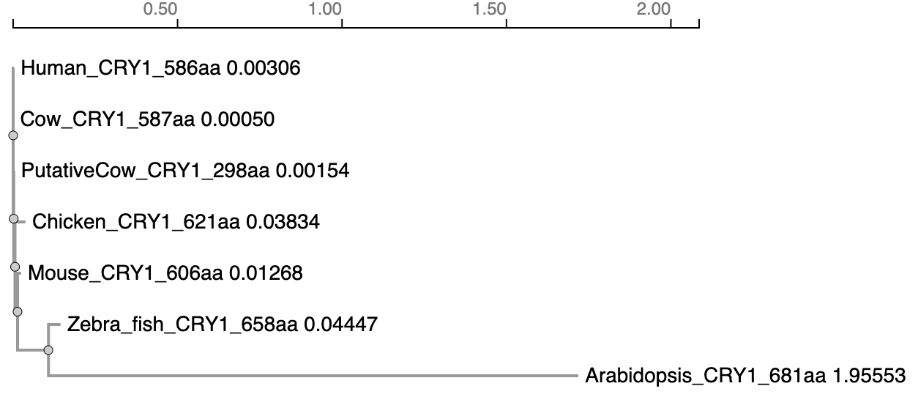
Q7.
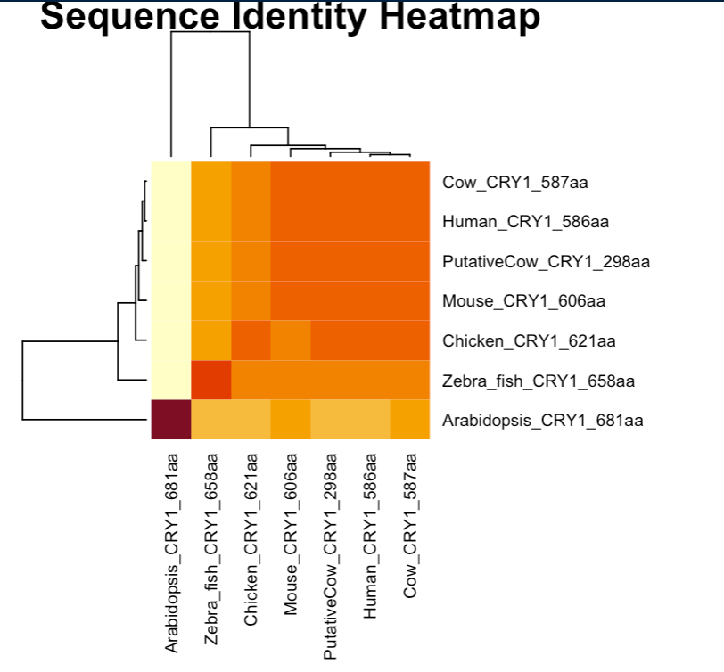
Q8.
I used Human CRY1, as the putative cow CRY1 has so many gaps. Below is the result:
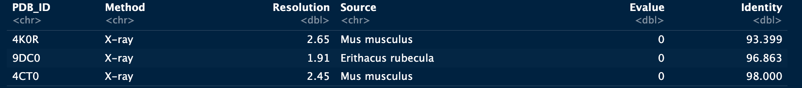

Q9.
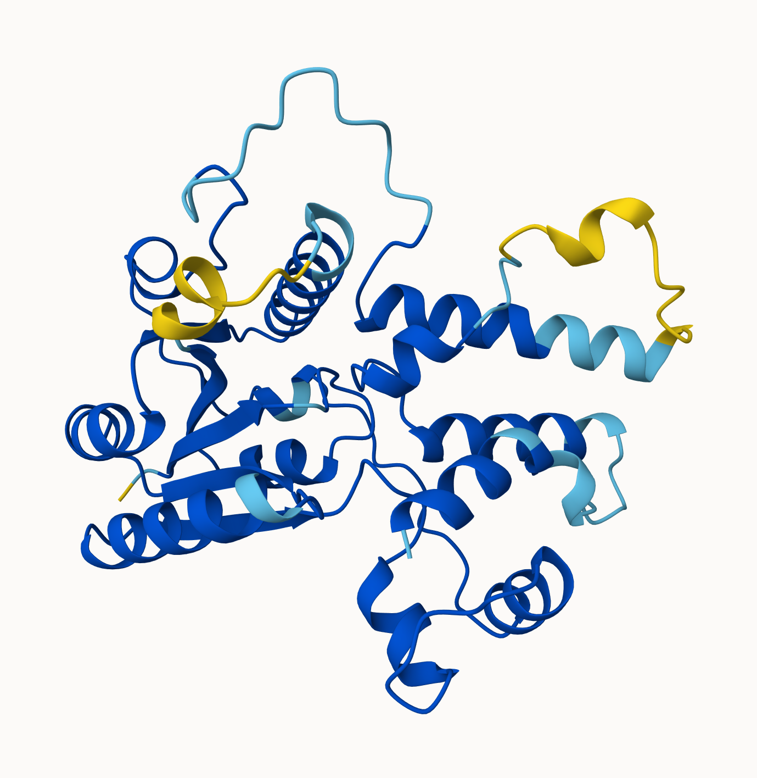
3D structural model of the Putative Cow CRY1 protein generated by AlphaFold. The model is colored by pLDDT confidence score.

Q10.
I performed a BLAST search of the ChEMBL database using the putative cow CRY1 sequence. The search identified Human Cryptochrome-1 (CHEMBL4296246) as a significant homolog (99.3% identity, E-value 0). The human homolog has significant data reported. I identified 9 bioactivity records (mostly EC50 measurements) and 1 binding assay. Additionally, ligand efficiency data (Binding Efficiency Index vs. Surface Efficiency Index) was available. A key associated compound is KL001, a carbazole derivative identified as a Cryptochrome stabilizer that lengthens the circadian period.

