Unit 02 Problem Set Submission Form

# Overview

|  |  |
| --- | --- |
| Your Name | Hongdi Li |
| Your SU Email | Hli248@syr.edu |

# Instructions

Put your name and SU email at the top. Answer these questions all from the lab. When asked to include screenshots, please follow the screen shot guidelines from the first lab.

Remember as you complete the problem sets it is not only about getting it right / correct. We will discuss the answers in class so it’s important to articulate anything you would like to contribute to the discussion in your answer:

* If you feel the question is vague, include any assumptions you've made.
* If you feel the answer requires interpretation or justification provide it.
* If you do not know the answer to the question, articulate what you tried and how you are stuck.

This how you receive credit for answering questions which might not be correct.

# Questions

1. Does a table consist of data or metadata? Explain.

**Yes, I think table is consist of data or metadata. A good example is we made a “state_lookup” table at beginning of the lab2, then we named the column “state_code”, and add 4 data in that column. For this reason, we would have a metadata “state_code” and four data which are “NY”, “NJ”, “PA”, “CT”. Thus, a table consist of data or metadata.**

1. Describe what happens when you attempt to insert 200 characters into a column with a data type of varchar (50)?

**The cell will only show first 50 letters and cut off the rest 150 letters.**

1. How do we enforce entity integrity over a table which uses a surrogate primary key?

**For example, we put AI radio button for the “customer_id” column so that it auto increments. Which means it is becomes surrogate key and for every data in column “customer_id” are unique and not null. We set it as primary, then we achieve entity integrity with surrogate primary key.**

1. Provide a screenshot of your completed **customers** table include columns, indexes and foreign keys.

1. Implement the **contractors** table as defined in the overview section. Include columns, indexes (pk/unique) and foreign keys. Provide a screenshot of the table structure screen in Adminer and include the columns, indexes, and foreign keys sections.

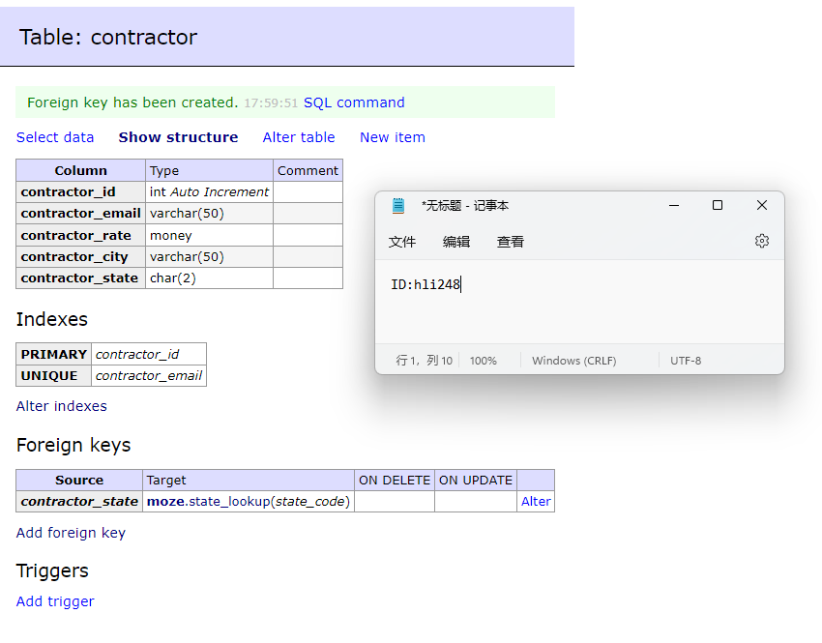

1. Implement the **jobs** table as defined in the overview section. Include columns, indexes (pk/unique) and foreign keys. Provide a screenshot of the table structure screen in Adminer and include the columns, indexes, and foreign keys sections.

1. Add 3 contractors to the **contractors** table and provide a screenshot of the Select data screen as evidence they were added.

1. Can you add two contractors with the same email address? Explain.

**No, the reason is email address is our natural key and which is unique constraints. Thus, for every email address in the column is unique.**

1. Can you add a contractor from the state of MA? Explain.

**No. The reason is in we add a foreign key references “state_lookup” table in the “customs” table. It is guarantee that contractor must come from the state exist in “state_code”, which are NY, NJ, PA, CT.**

# Reflection

Use this section to reflect on your learning. To achieve the highest grade on the assignment you must be as descriptive and personal as possible with your reflection.

1. What are the key things you learned through the process of completing this assignment?

**I learned how to make a table, add different key in Adminer. More, I understand how to use keys to connect different tables**

1. What were the challenges or roadblocks (if any) you encountered on the way to completing it?

**It's easy to do by just following the lab assignment prompts. I didn't encounter any difficulties**

1. Were you prepared for this assignment? What can you do to be better prepared?  
     
   **I think the SQL command part is interesting. Although the lab does not require us to check constraints. But I think the SQL command language should be well understood. I should try to get the check constraints part done**
2. Now that you have completed the assignment rate your comfort level with this week’s material. This should be an honest assessment: (choose one)  
     
   4 ==> I understand this material and can explain it to others.  
   3 ==> I understand this material.  
   2 ==> I somewhat understand the material but sometimes need guidance from others.  
   1 ==> I understand very little of this material and need extra help.

**4**