Manual for cellClusterSplittingApp_v0.2

This package is an implementation of a newly designed method for splitting the clustered cells in the segmentation. It requires inputting the raw data and the imperfect detection (binary mask). The basic idea of this method is to examine the significance of the gap in terms of intensity (the darker, the more significant) and geometry(the thinner, the more significant). We combined the two significance score into one P-value (e.g., object 1 & object 2 are separated by a gap with P = 0.03). Then, we applied thresholding on the P-value to decide which pairs of objects to be merged. (e.g., if the threshold is P = 0.05, the gap is significant, and the two objects should not be merged. But if the threshold is set as P = 0.01, then these two objects will be merged.) In this way, we can tune the degree of splitting.

How to use:

Installation: double click “cellClusterSplittingApp” the MATLAB App Installer



After installation you can find it in the “Apps” panel in MATLAB

Steps of using this package:

(1) Load data

Press the "Raw Data" button to load the raw data file.

Press the "Mask" button to load the binary mask to be refined.

Input the index of the Z slice to be processed (fill "1" if the input data is 2D)

(2) Run Splitting (test the significance of the gaps)

Input the Gaussian smoothing factor and then press run. This step can take some time. After finishing this step, you will see the result after region splitting on the right panel, based on the default threshold P-value = 0.05.

(3) Tuning

Change the slider of the threshold (-log10(P-value)) to get the desired degree of splitting. The text box below the slider shows the current thresholding of the p-value (significance of the gap). Use a smaller threshold (larger P-value threshold) will make the splitting more aggressive.

(4) Bulk Run

If the input is 3D data, press this button to run the whole Z slices with the current threshold.

Note on stopping the bulk run: Due to the limitation of MATLAB, there is no good way to directly kill the process. One way is to press the “Stop” button and wait until the current Z-slice is finished running.

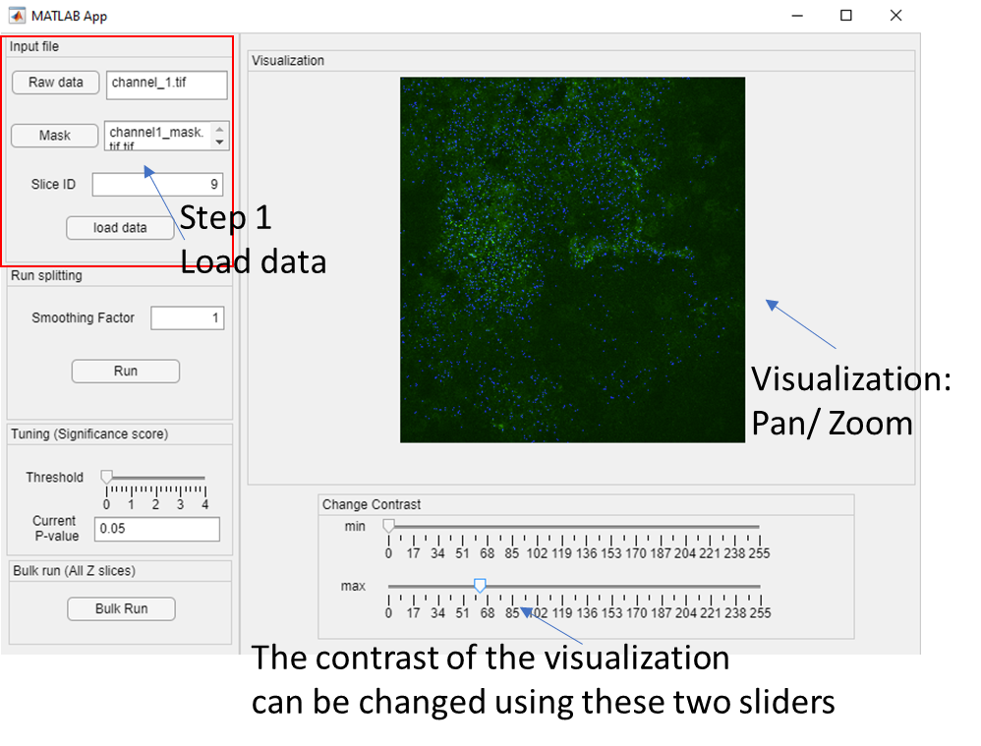

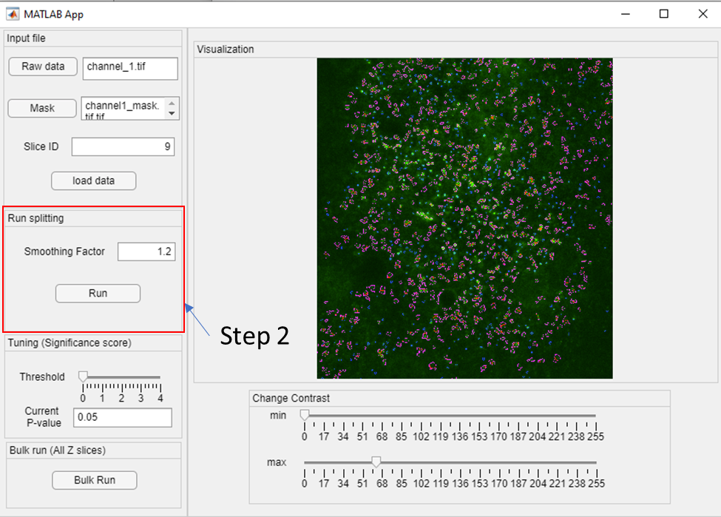

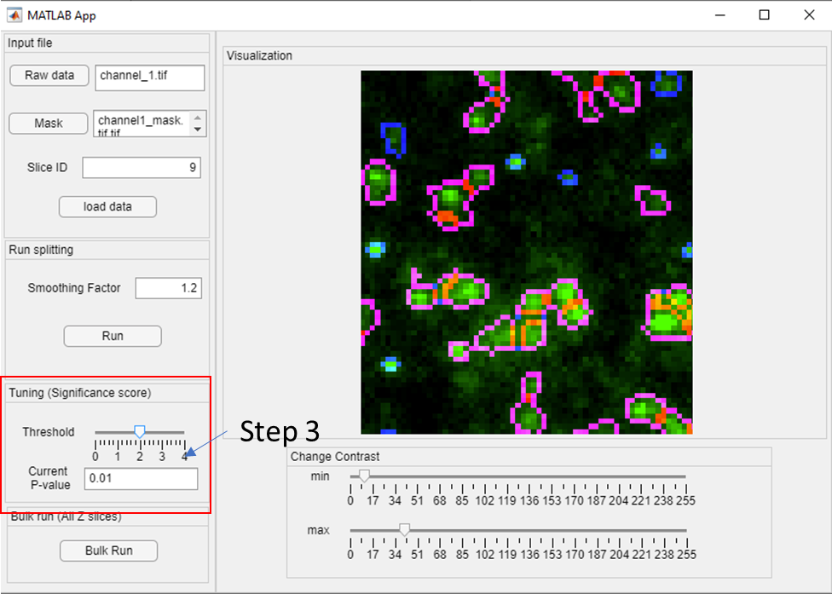

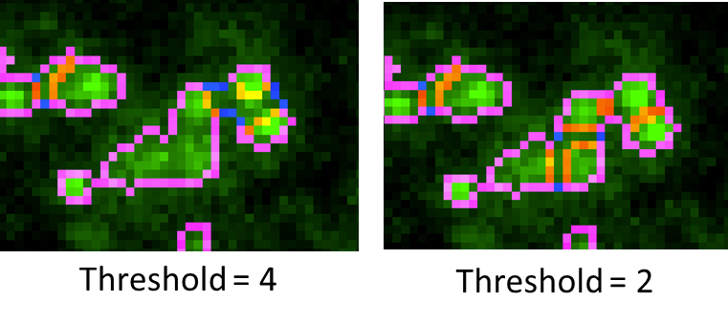

Above is one example showing the effect of tuning the threshold.