# Introduction

The following is the User Documentation of the functionality for Version 1.0 of the Symphony On-Ramping Module. The purpose of this On-Ramping System is to provide a streamlined method for submission of proposals to support contractors in submitting a complete proposal and to facilitate efficient Government evaluation of proposal submissions.

# System for Award Management (SAM) Registration

All Offerors will need to ensure that their SAM registration is set to public. In order to ensure secure registration in the Symphony system, information will be parsed from each Offeror’s SAM registration; this is not possible if the SAM registration is set to private. Offerors who fail to make their SAM registration public will not be able to register in Symphony and will be unable to submit a proposal in response to this solicitation.

# User Registration and Login

Note: If the company SAM record is Private, it will need to be made Public for purposes of Registering and then again at submission and evaluation time. This allows the system to verify data to allow for a quicker evaluation and ensure procurement integrity (i.e., ensuring offers are submitted by individuals authorized to do so on behalf of the entity). Offerors can always make the record private in between registration and submission and after an award is made for the solicitation for which they submitted an offer.

After Offerors are able to access the system, they should ensure that their SAM data is correct in the Proposal Assets link of Symphony, ensuring Offerors have time to make any corrections before submission.

## Registration Steps:

1. Enter individual email address. Note: if an individual is submitting proposals on behalf of multiple companies, they will need a unique email address for each company (DUNS) they are registering.
2. Enter the DUNS Number of the company that will be the Prime Contractor receiving the Award should they submit a winning proposal.
   1. Example 1: Single Prime Contractor (or Joint Venture Entity) registering to submit a proposal for their own company will enter their own DUNS (that of the Single Prime Contractor or the Joint Venture itself).
   2. Example 2: Subcontractor registering to submit proposal documents on behalf of a Prime Contractor will enter the Prime Contractor’s DUNS.
3. User will verify that the DUNS Number correctly matches the Company for whom they are submitting a proposal.
4. Complete the Registration by completing the information as requested.
5. Multi-factor Authentication will be required. Examples of tools that can be used for Multi-Factor Authentication include **but are not limited to**:
   1. Chrome Extension for your browser: <https://chrome.google.com/webstore/detail/authenticator/bhghoamapcdpbohphigoooaddinpkbai?hl=en>
   2. Authenticator for your smartphone:
      1. <https://play.google.com/store/apps/details?id=com.google.android.apps.authenticator2>
      2. <https://play.google.com/store/apps/details?id=org.fedorahosted.freeotp&hl=en_US>
   3. SMS: Choose your Cell Carrier, then enter your mobile number and a code will be sent to your smartphone.
6. Activation
7. If the user’s email matches the Government Business POC or Government Business Alternate POC as specified in the company’s SAM record, they will be activated to use Symphony.
   1. The first user registered to a specific Official Legal Entity will be required to activate subsequent users registering in Symphony regardless of their status as POCs in SAM, unless another user is assigned the role of Proposal Manager as detailed below.
8. This first user will automatically be placed in the Proposal Manager Role. This role can be assigned to another user after registration is complete. This user will have access to a User Administration tool when they login to the system.
9. If the user’s name does not match they will be allowed to continue their registration. They will then be informed that their account needs to be activated by the company’s SAM POC or registered Proposal Manager.
   1. They will be provided with the Government POC’s contact info and link to their email.

Tips:

1. Be careful not to override each other’s work.
2. Only the Proposal Manager or SAM POC can submit can submit a proposal package.

## Login

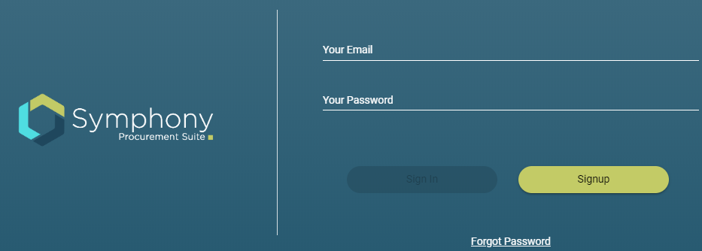

### Successful Login

Upon entering a valid User Name and Password combination the user will be prompted to enter an Authentication Code. After successful authentication the user will be sent to the Solicitations page where they can view all the solicitations available for them to propose.

### Unsuccessful Login

If the user does not enter a valid User Name and Password combination they will be requested to try again.

### Forgot Password

If the user does not remember their Password they will be able to click the Forgot Password and will be moved through the process for changing their password.

# Proposal Assets

## SAM Data

Offerors will be able to view their SAM Record as it will be submitted as part of their proposal. If the Offeror sees any discrepancy in the data, they have time to make the corrections directly through SAM. An Offeror’s SAM record will be automatically updated and saved at the time of proposal submission to be included in their proposal. For companies with private SAM records please see the note above under User Registration and Login.

## Points of Contacts (POC)

Users can add their proposal POCs to their submission and assign roles. Any user not assigned a role will be designated as staff. Only the Proposal Manager or SAM POCs can submit a proposal.

Proposal Managers will have access to the User Activation Button shown below.

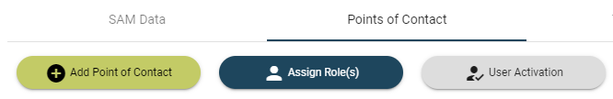

This will be used for approving all non-SAM POC members to grant them access to Symphony or to make their account Inactive. In order to change the status of a user, you must toggle their Status as shown below.

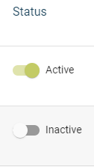

## Team Members

Users may add team members by adding their DUNS number and the supporting documents such as JV Addenda, Representations and Certifications for the partner member, etc. Note: Joint Venture members have different supporting documentation requirements than a Prime/Subcontractor CTA relationship. Based on how the Offeror was registered in the system, either a Joint Venture or Prime/Subcontractor CTA, they will be prompted to submit specific documents.

Offerors may utilize different team members for each Pool if desired.

## Projects

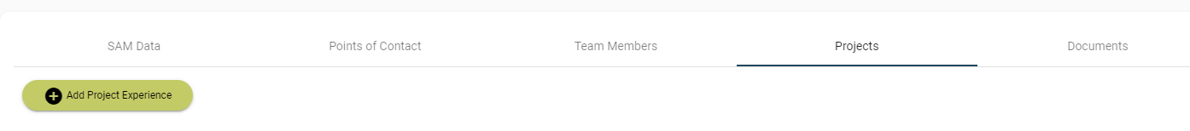

### Primary Experience:

Primary Experience Projects can be single award contracts and task orders. The Project experience form can be accessed via Proposal Assets or Add Project from a specific solicitation submission. These projects then can be used across multiple Pool submissions.

### Secondary Project Experience:

A Secondary project can be the same project used in a Primary Experience or Pool Qualification. Offerors will not be able to see the Mission Space entry unless they select Secondary.

Multi-Award IDIQ Contracts or BPAs can only be used for Secondary Project Experience. These are entered by Prime contractor for the Multi Award contract. Each Contract Vehicle must have two awarded Task Orders associated with the vehicle in order to claim points.

### Pool Qualifications

Project Experiences whose NAICS codes or Product Service Codes (PSCs) match the OASIS NAICS codes or PSCs can be used as Pool Qualification Projects. If the project is only a Pool Qualification, Offerors will be asked a limited set of questions.

### Supporting Documents

Supporting documents for each project should be labeled as specified in the Solicitation and uploaded into the project document upload area.

**Proposal References**

Each minimum requirement and scored element of an Offeror’s proposal requires a Proposal Reference so the OASIS evaluation team can easily identify where in the proposal the minimum requirement or scored element requirements are met. Please be as specific as possible when providing your proposal references (e.g., File name, page number, paragraph number, as applicable). Failure of the proposal to clearly identify where any requirement is met may result in the reduction of points or removal of a proposal from consideration.

## Documents

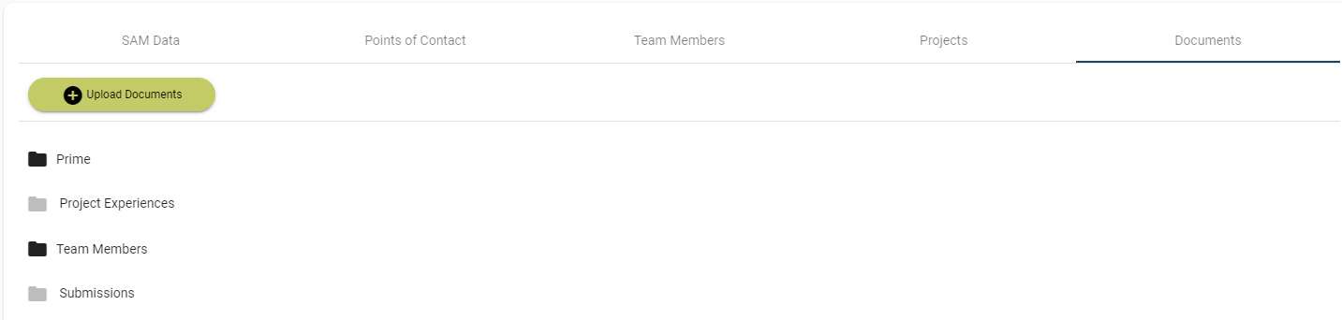

Documents for all the submissions will be uploaded and maintained under the Prime’s documents. Documents pertaining to each submission will be displayed in the documents submissions link. This is where Offerors may upload various documents not related to specific projects such as MRCLs, CTA Agreements, the Cost/Price spreadsheet, etc.

The Documents tab is also where Offerors will select their Systems, Certifications, and Clearances and upload applicable documents for each. See the image below.

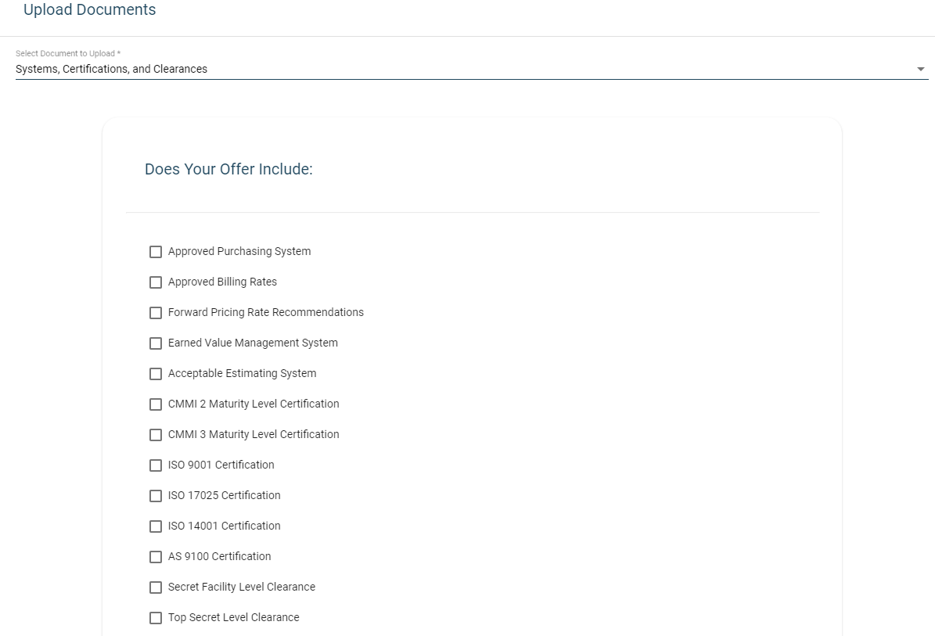

## Solicitations Page

Solicitations page allows the Offeror to choose one or more solicitations to build a submission package. Offerors can use the assets created in Proposal Assets across multiple submissions at their discretion. Each submission will be scored individually as detailed in the solicitation and your score will be displayed for you in each submission. To start a submission package, click on the respective Pool number.

## Scoring

Scoring for each Pool will automatically be generated by the system based on the Proposal Assets added to each Pool submission. Documents and forms completed in the documents section of the Proposal Assets will be added to all of the submissions automatically, and therefore points will be assigned to each Pool from these assets.

## Offer Submission

When an Offeror is ready to review their submission, they can click on Review on the Pool home page. After clicking Review, they will be shown a page with all the assets for that specific Pool submission. The Offeror can generate the SF-33 at this time, finalize their Submission, and Submit.

## Solicitation Questions

Offerors may ask solicitation questions from the Ask Questions button of the Offer Submission page in the upper right hand corner.

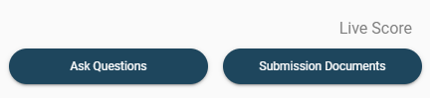

In the Ask Questions area, Offerors can input questions, review the questions, and submit questions. Be as specific as possible for each question, including Solicitation references, FAR references, CFR references, or any other applicable information as needed.

Enter your questions in the area shown below:

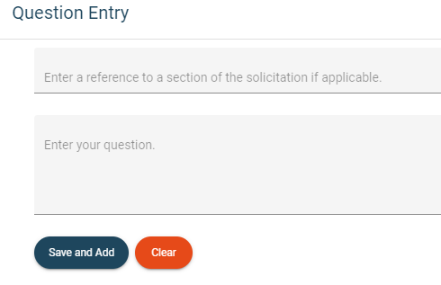

Once a user hits Save and Add, the question will appear in the Question Que, but still has not been submitted to the OASIS team. From here the user can edit, re-order, or delete the questions before submitting them to the OASIS team.

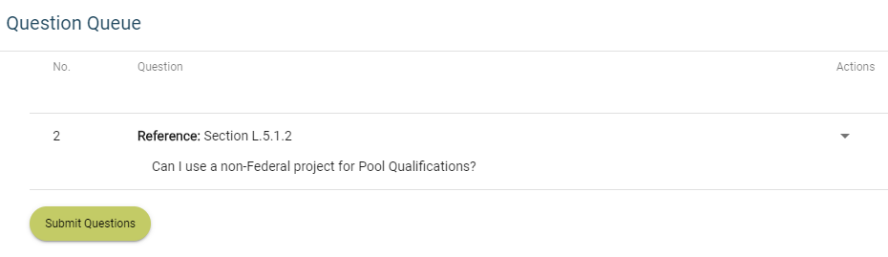

## Submit

After an Offeror has fully reviewed their submission, they should hit the Submit button. The Offeror will be directed to a page that confirms that they have submitted the proposal. An Offeror may go back in to their proposal at any time prior to the solicitation deadline in order to revise and re-submit the proposal. Note that Offerors may not submit their proposals until the amendment following submission of questions has been posted, as their proposal will not be able to acknowledge receipt of this amendment if it’s submitted prior to the amendment’s release.



# Help and Support



In the upper right hand corner of the Symphony webpage, users can find options for Home, Help, and Logout. The Help button here is for questions and technical problems related to the Symphony system itself. By clicking the Help button you will be directed to the page below. Offerors are cautioned not to use the Help button to submit questions regarding the solicitation itself, as those questions must be submitted through the “Ask Questions” link detailed above.

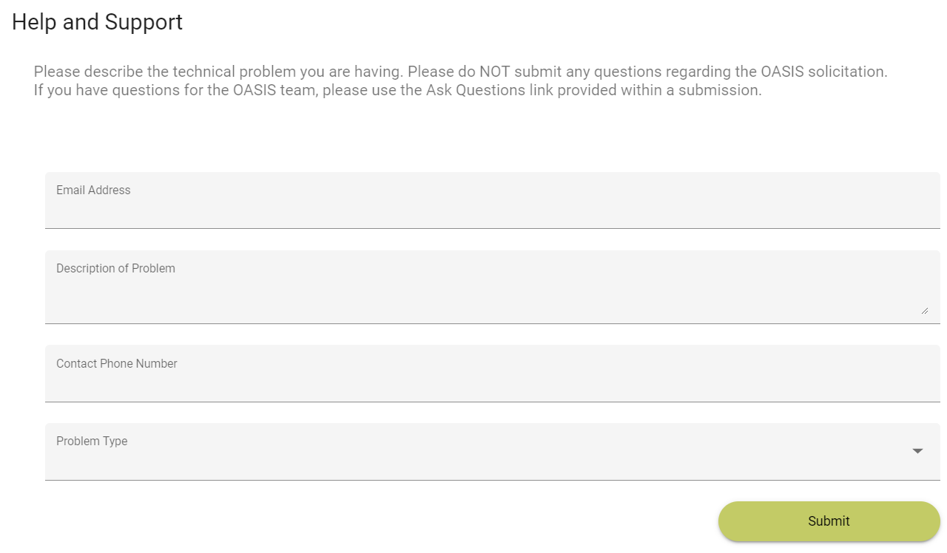

Enter the user email address, what the problem is, user phone number that the helpdesk may use to contact the user, and what type of problem it is, either Technical Help or Login Help. Please be as descriptive as possible. If a user is not getting the required assistance through the help feature of Symphony, the user may submit questions to the OASIS team using the Google Form at the following link <https://forms.gle/FfkgR6vu6jm6eEGn6>. Please only use the Google Form AFTER you have reached out via the help feature.