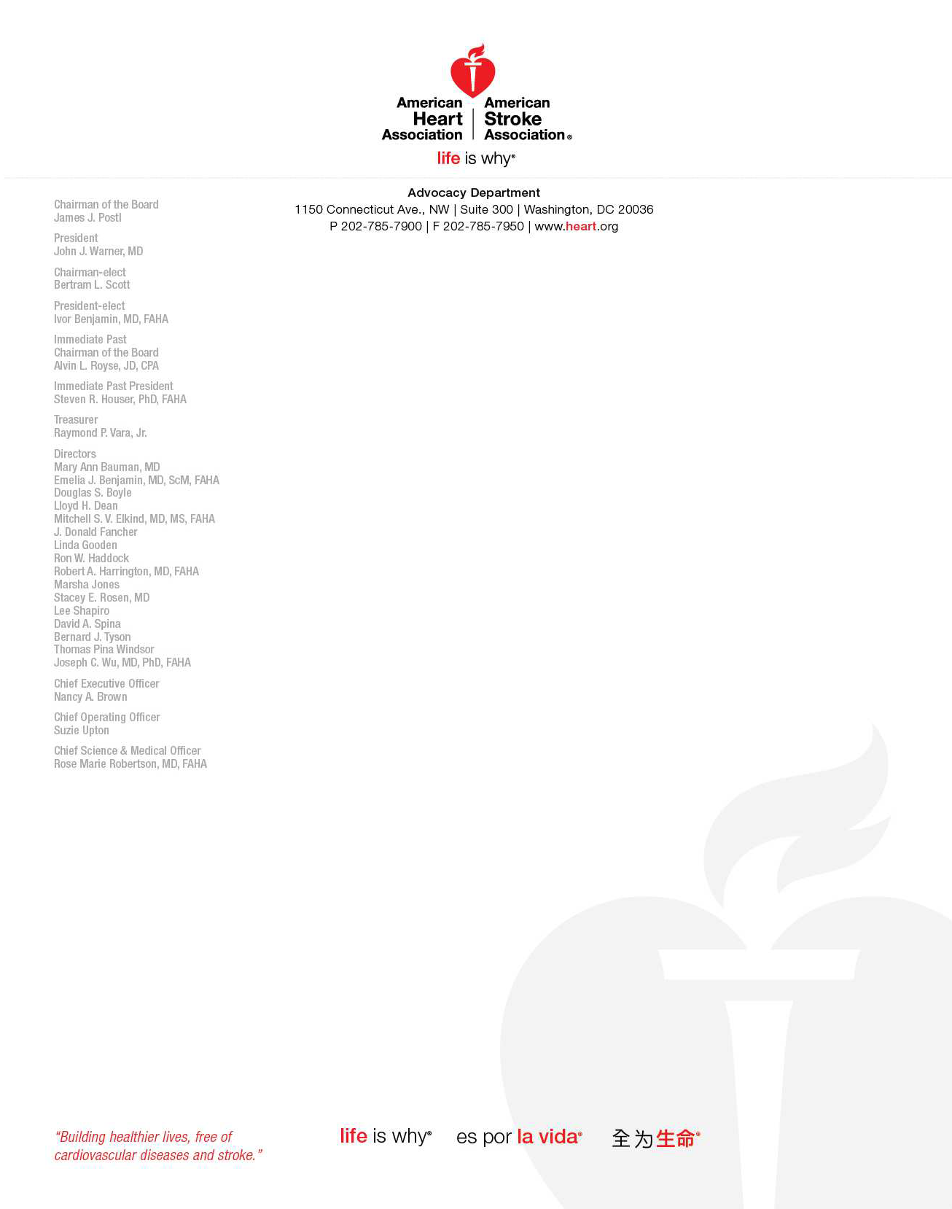

January 16, 2018

Seema Verma, Administrator Centers for Medicare & Medicaid Services, Department of Health and Human Services, 7500 Security

Boulevard, Baltimore, MD 21244–1850

# Re: Docket No. CMS–4182–P

Dear Administrator Verma,

On behalf of the American Heart Association (AHA) and the American Stroke Association (ASA), we appreciate this opportunity to submit comments on the Centers for Medicare and Medicaid Services’ (CMS) proposed rule, “Medicare Program; Contract Year 2019 Policy and Technical Changes to the

Medicare Advantage, Medicare Cost Plan, Medicare Fee-for-Service, the Medicare Prescription Drug Benefit Programs, and the PACE Program.”

The American Heart Association is the nation’s oldest and largest voluntary organization dedicated to building healthier lives free from heart disease and represents over 100 million patients with cardiovascular disease (CVD) and includes over 30 million volunteers and supporters committed to our goal. The association is concerned that the proposed change to CMS’ Part D formulary policy will inhibit enrollees’ timely access to the information necessary to make the best treatment decisions. Additionally, this proposed change comes at a time when CMS and the healthcare marketplace, overall, is expecting consumers to bear increasing responsibility regarding their healthcare decisions. Such patient empowerment requires high-quality information that is accessible and usable – ie, before and with adequate time for decision making to occur.

We lay out our specific concerns below.

# Expedited Substitutions of Certain Generics and Other Midyear Formulary Changes

Critical to the treatment regimens for many of our patients are pharmaceutical products. Ensuring that these products are accessible and affordable is imperative. Therefore, we can appreciate CMS’ desire to encourage the use of generic products when possible. Decisions about which particular drug to use for a particular patient’s condition and treatment are part of a deliberate

decision-making process between the patient and his or her provider. Timely, robust, easily accessible information about what products are available is vital to an informed decision-making process. It is for this reason that the AHA is so concerned by CMS’ proposed change to its Part D formulary policy.

In the proposed rule, CMS proposes to permit Part D sponsors to substitute a generic product for a brand product at any time throughout the year, without advance approval by CMS, and without direct prior notice to enrollees. The association’s *Statement on Drug Formularies1* outlines our position on the development, structure, and implementation of drug formularies. While the association supports generic substitution where appropriate, our position also lays out requirements for the type of, and timeline for, communication about such interchange to both patients and providers. It states that “these changes, as well as the alternative coverage options available to the consumer and reason for the switch, must be made known to prescriber *and* patient with adequate time (minimum of 90 days) for appropriate therapeutic interchange to occur.” This communication to both patient and provider is necessary to allow for any medically appropriate adjustments. While we appreciate the stipulation that the drug be offered at the same or lower cost sharing, cost is not the only consideration for a patient and provider when making decisions about a pharmaceutical treatment regimen.

Additionally, CMS focuses only on the safety concerns related to the substitution, pointing out that it does not believe generic substitutions pose any safety threats to enrollees. The proposed rule goes on to state, however, that since a safety harm is not posed, that no “abrupt change in treatment” would occur for the patient. While we agree that safety is of the upmost importance, we disagree that other factors could not result in this “abrupt change in treatment” for the patient. Patients may react differently to different formulations between a brand and generic product. Additionally, the patient will likely experience a disruption in the appearance (size, color, shape) of the actual pharmaceutical product. Ample time to prepare for this change is required in order to not risk potential non-adherence if the product appearance is confusing to the patient. For this reason, we do not understand and disagree with CMS’ proposed change from the current 60-day advance direct notice to no advance notice prior to the effective date of interchange. We encourage CMS to maintain its 60-day advance direct notice so that patients and their providers may have the information necessary to make the best treatment decision for them.

Thank you for the opportunity to comment on the proposed rule. If you have any questions about our comments, please contact Madeleine Konig, Senior Policy Analyst, at [madeleine.konig@heart.org](mailto:madeleine.konig@heart.org) or 202-785-7930.

Sincerely,



John Warner, MD

President, American Heart Association

1 American Heart Association/American Stroke Association on Drug Formularies. June 2015. Accessed January 12, 2018 at: [http://www.heart.org/idc/groups/heart-ublic/@wcm/@adv/documents/downloadable/ucm_483637.pdf](http://www.heart.org/idc/groups/heart-ublic/%40wcm/%40adv/documents/downloadable/ucm_483637.pdf)